SERVICE BEYOND BORDERS
Cervical cancer prevention
IN A DEVELOPING COUNTRY LIKE INDIA
August 14, 2014
SERVICE BEYOND BORDERS
4386 SCOTT CARPENTER DR, JACKSON, MI 49201 USA
A 501(3)© TAX EXEMPT ORGANIZATION

OBJECTIVE :
The objective of this cervical cancer prevention program will be to provide cytologic screening for the prevention of cervical cancer in areas of greatest need.

OVERVIEW:
In developing countries, there is a lack of effective screening programs for cervical cancer. In these countries, no clinically significant reduction in the incidence of cervical cancer has occurred during the past three decades. In developed countries, by contrast, there has been a major decline in cervical-cancer mortality after the introduction of large-scale cytologic testing.

Cancer of the cervix has been the second most important cancer in women in India over the past two decades. In 2012 cancer of the cervix accounted for 22.9 per cent of all cancers in women. The highest age specific incidence rate of 98.2 per 100,000 for cancer cervix was seen in the 60-64 yr age group. Since over 70 per cent of the Indian population resides in the rural areas, cancer of the cervix still constitutes the number one cancer in either sex. Based on the data of GLOBOCAN, the estimated number of new cervical cancers during 2012 in India was 122,844. The relative five year survival reported some time earlier averaged 48.7 per cent. In contrast the developed countries have an incidence rate of 17 per 100,000 with a mortality rate of 23.

Data specific to India for women with incidence and mortality shows that cervical cancer in the second most cancer to occur at 22.9% with mortality rate of 20.7%. * GLOBOCAN 2012 Data.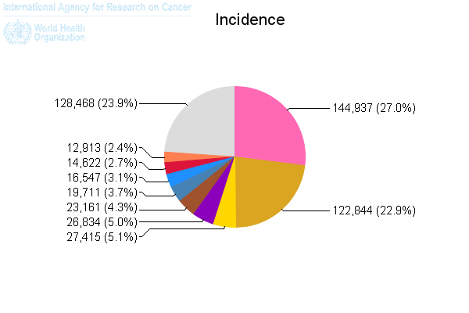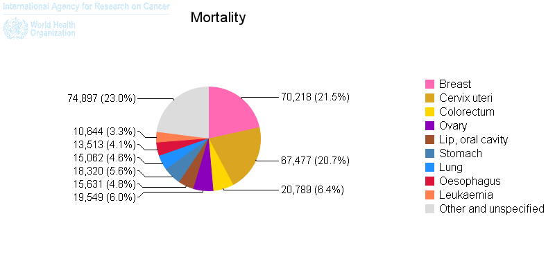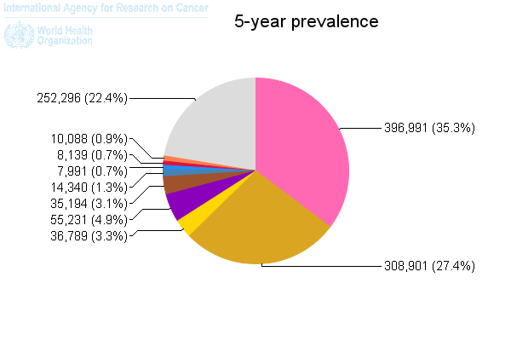

GOALS:
1. To provide access to underserved women to advanced cervical cancer screening methods at no cost.
2. To co-ordinate services for women who get diagnosed with abnormal cervical screening and cervical cancer.
3. To reduce the incidence of cervical cancer in areas of high prevalence.

PROCESS:
1. To identify blocks within a district and work in one block at a time
2. To use the Primary Health Center in the block as the access point for screening exams to take place.
3. To increase awareness among women in the selected area between the ages of 21-65 regarding cervical cancer prevention.
4. To perform cytologic screening using the liquid based method (pap smear) to all underserved women once every 3 yrs.
5. To maintain a pap smear tracking mechanism for the women to get screened.
6. To co-ordinate care for all women who have abnormal pap smears or cervical cancer.

BUDGET:
Expense for pathology for one pap smear: $10/pap
Plan to perform 100 pap smears per session (3 days): $1000
Equipment cost (speculums cost $1/pap, portable lights, etc.) $200
Cost of ancillary staff ($20/day for 1 person): $60
Printing costs (flyers, Cards for women, Rx pads): $100
Cost of banners and handouts: $200
Program Cost: $1160 per session of 3 days for screening 100 women, overhead cost: $400

In a previously unscreened population of women aged between 25 and 65 years, the
following percentages of abnormal results are likely: (WHO data)
• LSIL: 3–10%;
• HSIL: 1–5%;
• Invasive cancer: 0.2–0.5%.

REPORT OF OPERATION JANUARY 2015:

RANCHI CAMP:
The camp in Ranchi took place on January 10, 2015 at Sadar Hospital (Govt. hospital for the underserved population) with the help of the local authorities and was inaugurated by the Welfare Woman and Child Development Minister. The Camp was organized by the diligent efforts of the Women’s wing of the Indian Medical Association of Jharkhand who also contributed financially to the cost of organizing.

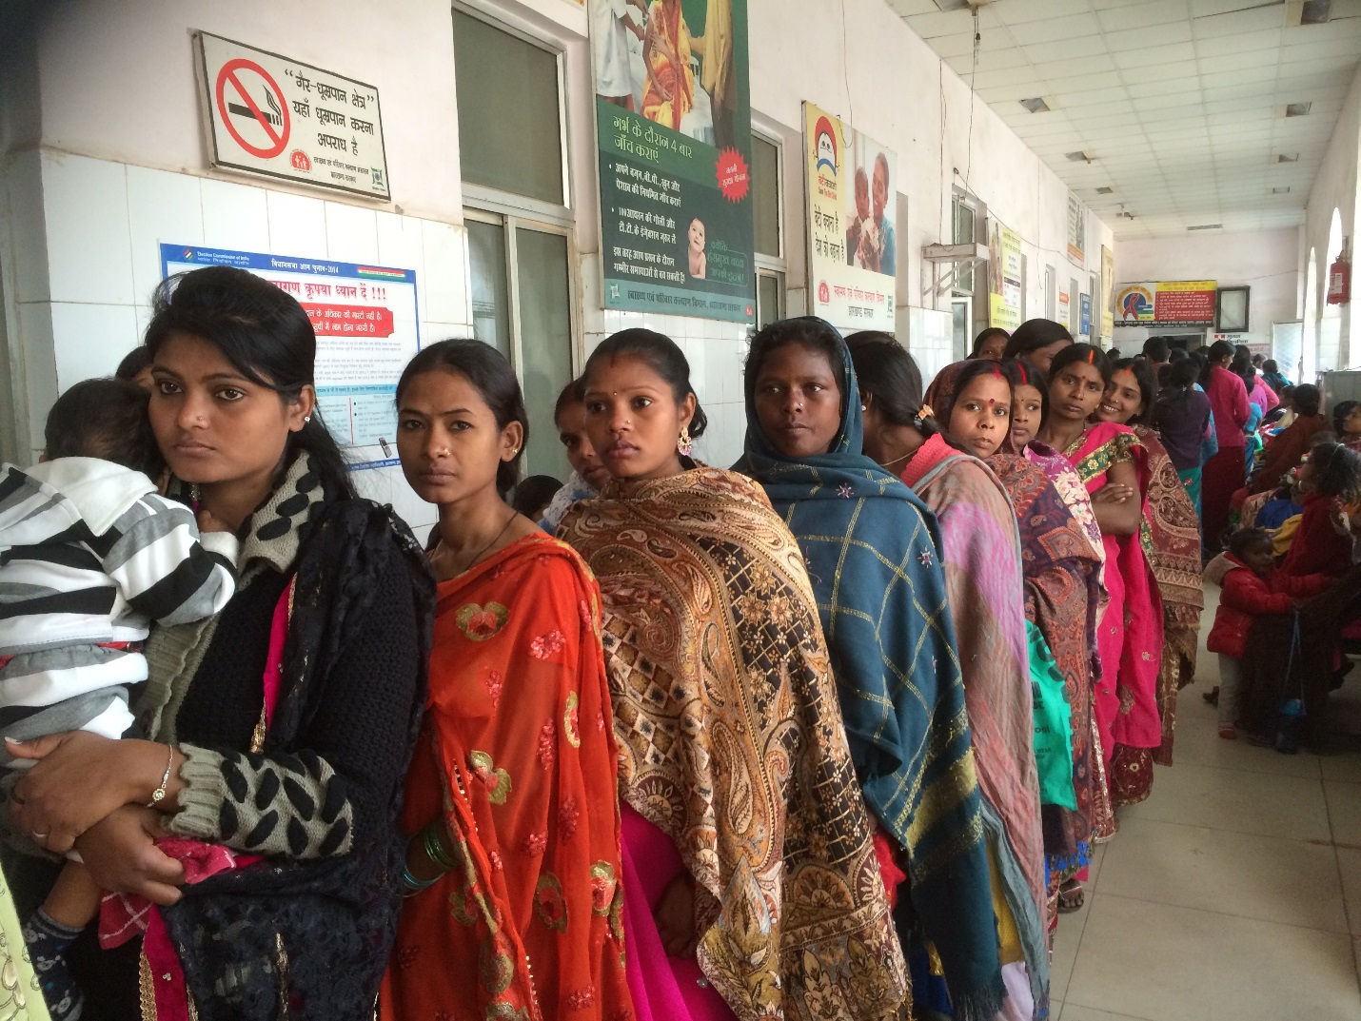

Local physicians of the Sadar hospital, nurses and nursing students volunteered on the day of the camp. Announcements were made in all the local newspapers a few days prior to the event and that enabled 100 women to register for the screening of whom 84 women received a liquid pap free of cost. The results of the test were distributed to most of the women who returned back and the rest was given to the gynecolology department of the hospital. There were 2 abnormal results who were referred to RIMS, Ranchi.

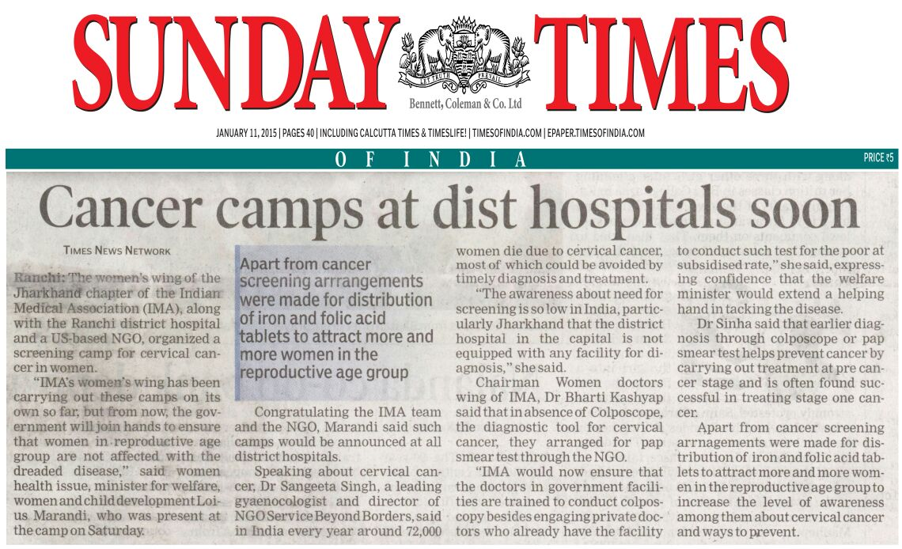

The liquid pap kits were supplied by the local laboratory at base price of Rs 500 ($10) per kit. We also contributed Rs.31000 ($500) towards the facilities and food costs (breakfast and lunch provided to the volunteers).
Narang Medical from New Delhi supplied the metal speculums which were delivered in Ranchi on the day of the event and have been placed in storage in Ranchi for future use. We have 100 metal speculums now (15 of those donated by Dr Bharti Sachadev, MI)
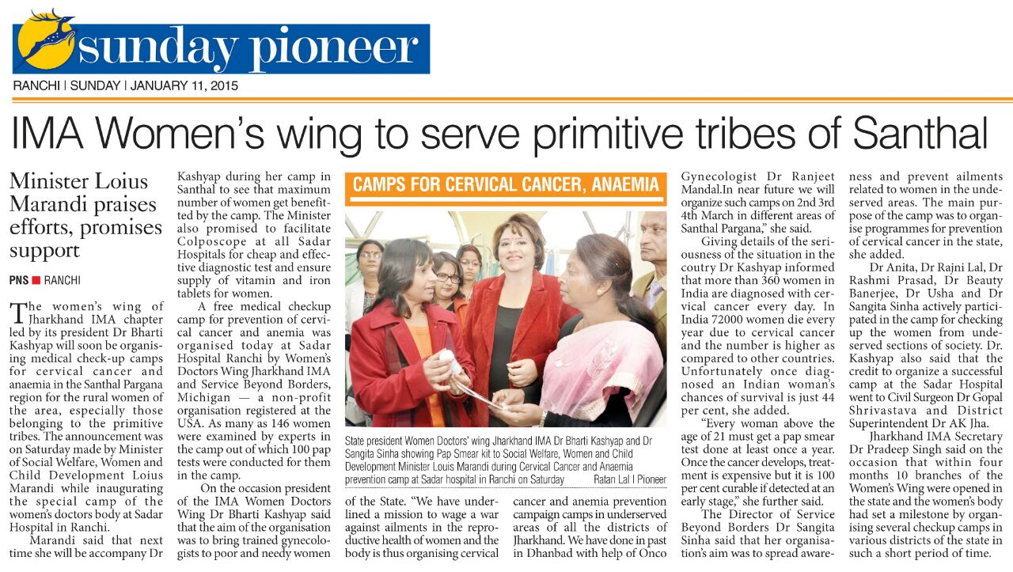
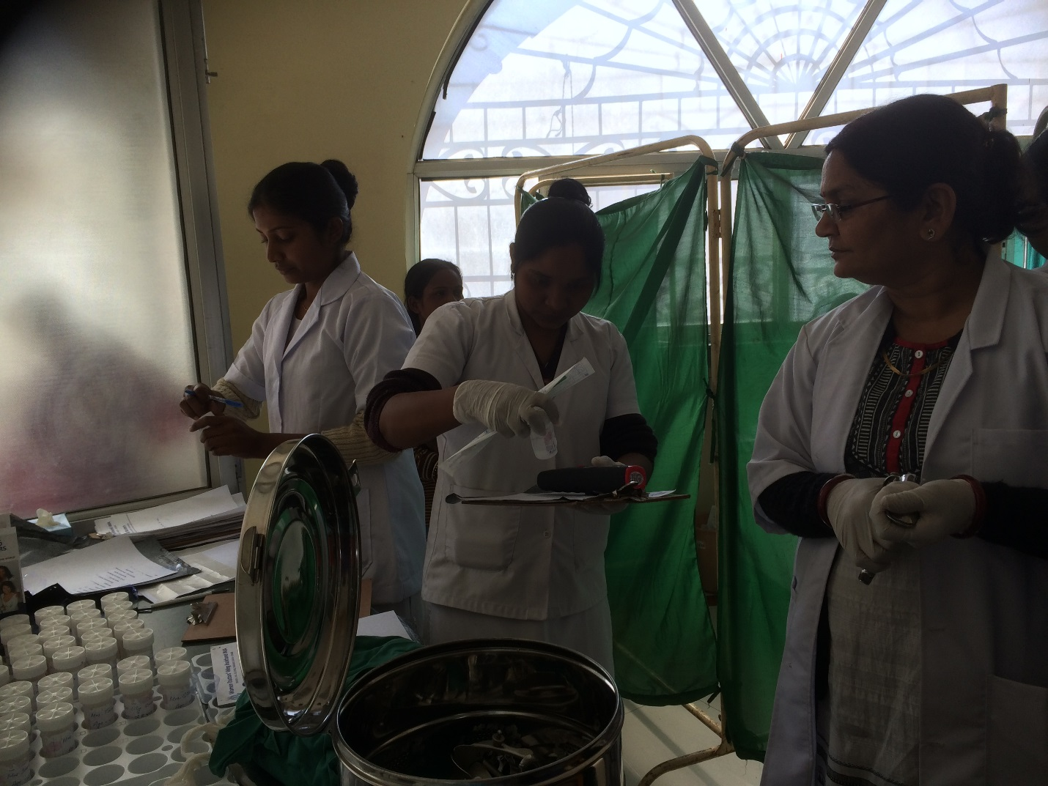
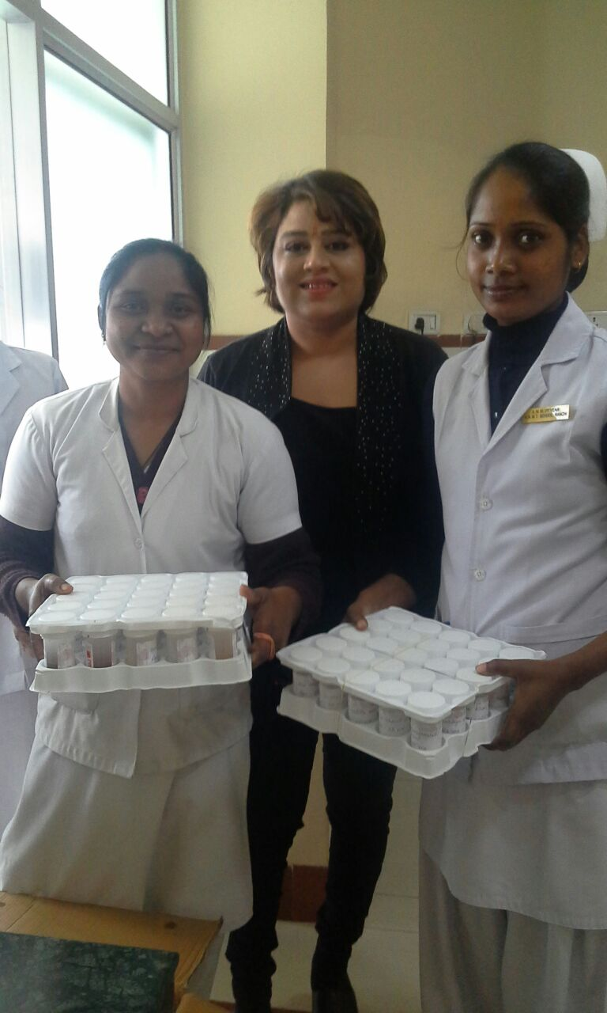
CAMP IN DELHI:
The camp in Delhi was organized with the help of Ivory Hospital, Noida who had advertised and supplied all the supplies and facilities at no cost to the organization.
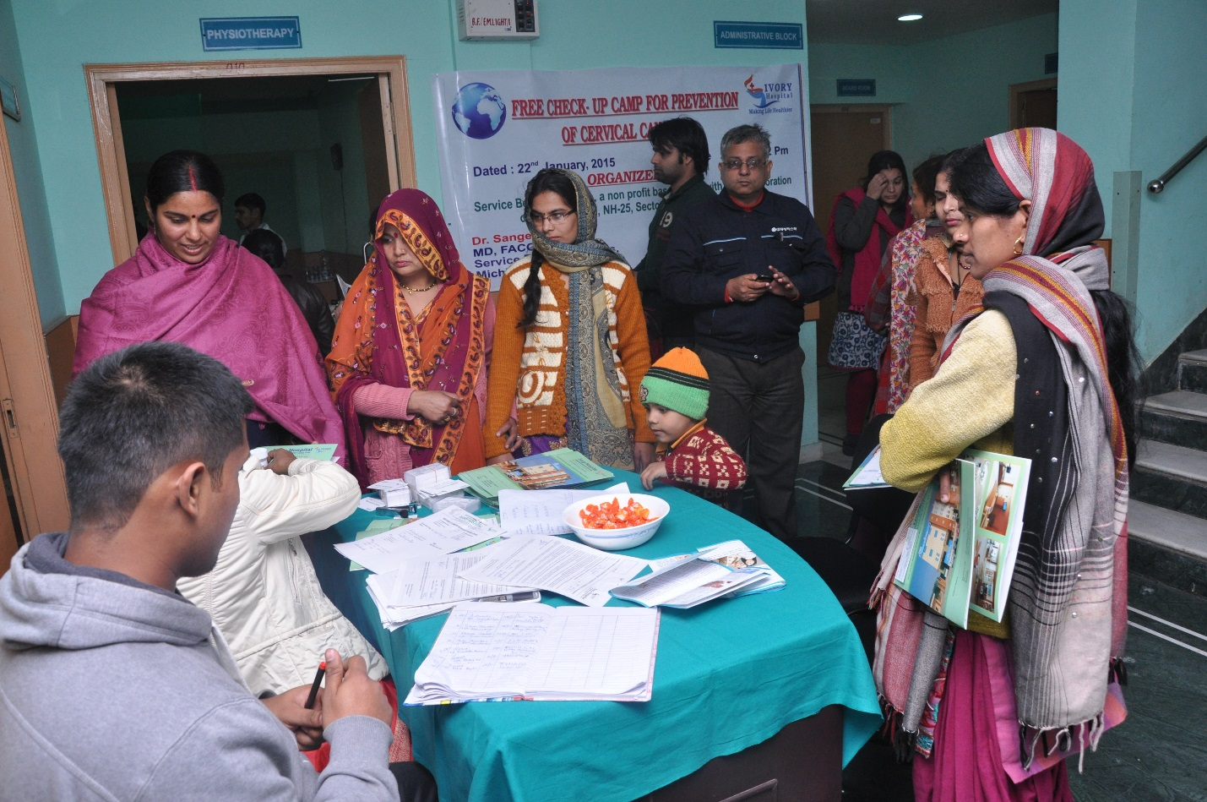

Due to bad weather on the day of the camp, the turnout was lower than expected, we were able to screen 53 women for cervical cancer.
We did pay for the liquid pap which was Rs 26,500 ($427) to the local pathology lab Oncquest.
Results of the pap revealed 2 abnormal results which was referred for colposcopy.

INCIDENCE OF ABNORMAL PAP : 2.9%

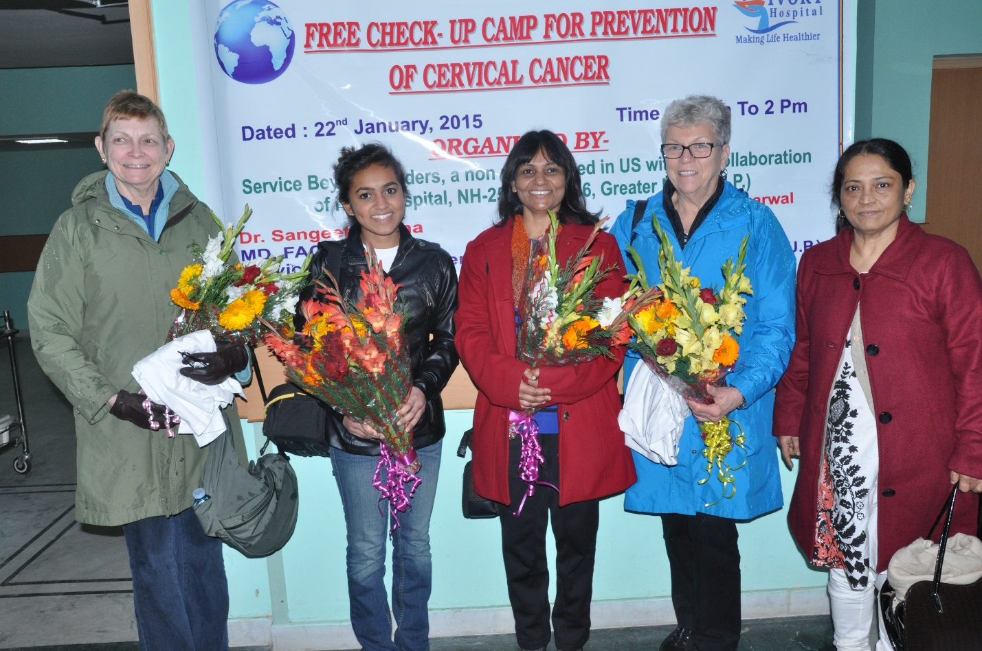

Ivory Hospital provided the space, instruments, all other equipment and staff as well as Taxi services for our team.
Abnormal pap smears to be referred to District Hospital for Colposcopy, LEEP, Cryotherapy or Cone Biopsy
Follow up Pap smears to be scheduled at the PHC at 6 months
Cancers to be also referred to the regional hospital/Medical college

District Hospital
The PHCs within the block will be the centers for screening women with Pap smears
Fix the days in the week when the Pap screening will be done
Display the dates (separate from regular OPD’s) prominently at the PHC
Notify all PHC staff and District Hospital
Assign trained workers/physician volunteers to perform the Pap smears
The HW-F fills in the screening cards and returns to women
Send out the pap smears to the local laboratory
Register to be maintained at the PHC
Results of Pap smears to be tracked

At PHC
Catchment area: 1 block
Target population: women aged 30-65
Use census list or population list at PHC to identify target women
Sensitize and motivate the target women
Trained healthcare workers (female) to identify and visit households and talk to women individually
HW-F to issue screening cards to women with their name, age and address
Inform women of the date of screening exam at the PHC
Maintain a register of women receiving screening cards

Community

