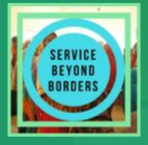
DONATION RECEIPT
Tax Record Form
Service Beyond Borders is a non-profit organization and is tax exempt under Section 501 (c) (3) of the Internal Revenue Code. We focus on helping make the world around us a better, happier place. It is our goal to educate, increase awareness and provide healthcare to women and children in areas in need.
Tax Record Form—Federal law provides that clothing and household items must be in good used condition or better for tax deductions. All values are assigned by the donor. Please keep this form as your donation record.
Visit servicebeyondborders.org for more information.

Name: _____________________________________________________________________

Address: _____________________________________________________________________

Donation (cash or merchandise) | Value

EIN: 46-2740627

