**[CoStar Insight](https://product.costar.com/home/news?label=CoStar%20Insight)**

Multifamily Developers Envision the Jersey Shore as a Year-Round Destination

Region’s Post-Pandemic Population Growth Spurs Apartment Boom

**By**[**Mateusz Wnek**](https://product.costar.com/home/news/author/45213edd4354ae80bafb0c95115e3c5a) **CoStar Analytics**

August 16, 2024 | 12:48 P.M.

The Jersey Shore sits along New Jersey’s Atlantic coast, spanning Atlantic, Cape May, Monmouth and Ocean counties. It has traditionally been synonymous with waterfront vacation homes and summer rentals, whose seasonal occupants have long descended on the area from Northern New Jersey, New York, Philadelphia and beyond. That's now changing.

Over the past few years, multifamily developers have been keen to take advantage of a growing population base, undeterred by elevated interest rates on construction loans and higher development costs. According to the Census Bureau, the Jersey Shore’s population growth of 1.3% between 2020 and 2023, the latest data available, outpaces North Jersey (-0.6%), Central Jersey (0.1%) and South Jersey (1.1%).

Multifamily construction starts have been increasing sequentially since 2021, with CoStar’s construction calendar showing the streak continuing for a fourth straight year in 2024. Over the past four years, an average of 1,040 units have broken ground annually across the Jersey Shore, roughly 52% higher than the 10-year pre-pandemic annual average of 686 units.

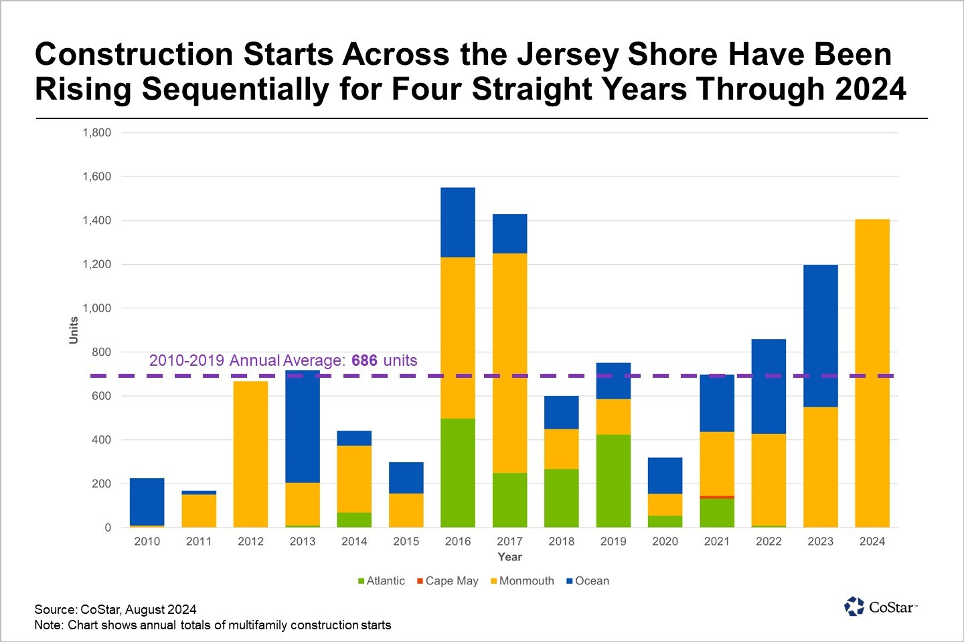

Taking stock of what’s been completed so far, the shore region has seen its apartment inventory expand by 2,820 units since 2020, or roughly 6%. During this period, Monmouth County has led the way, welcoming 1,361 new units, a tally corresponding to 5% inventory growth.

More than 59% of the units completed in Monmouth County can be traced to Morganville, an unincorporated community within Marlboro Township and Long Branch. In Morganville, developers targeted proximity to Route 34 and the Garden State Parkway, which run north-south throughout the area. In Long Branch, accessibility to mass transit appears to have been a key strategic consideration, with seven properties located less than a mile from the town’s NJ Transit train station.

It’s worthwhile to note that the Jersey Shore’s apartment boom is only at the halfway mark. An additional 2,700 units are already in the construction pipeline, promising to nearly double the output seen over the past five years. Approximately 1,400 of the units broke ground in 2024 alone.

The most active developer across the Jersey Shore is Kushner Cos., which is continuing to grow its Livana portfolio, a new apartment living brand launched in April. The company’s largest projects underway are [Livana Monmouth Square](https://product.costar.com/detail/lookup/10310574/summary" \t "_blank), a redevelopment of the Monmouth Mall in Eatontown that will bring 1,000 new units to the area, and [Livana Colts Neck](https://product.costar.com/detail/lookup/12788870/summary" \t "_blank), a 360-unit project that will be the township’s [first luxury apartment complex](https://product.costar.com/home/news/1467673675).

Kushner and others are positioning their newest offerings to attract renters looking to enjoy the Jersey Shore past Labor Day. To that end, market participants have noted they’re betting that the area’s quality of life and transit options will appeal to prospective renters. Amenity redesigns are also part of the pitch, with many upscale properties offering modern pools, spas, and health clubs to promote healthy living for full-time residents.