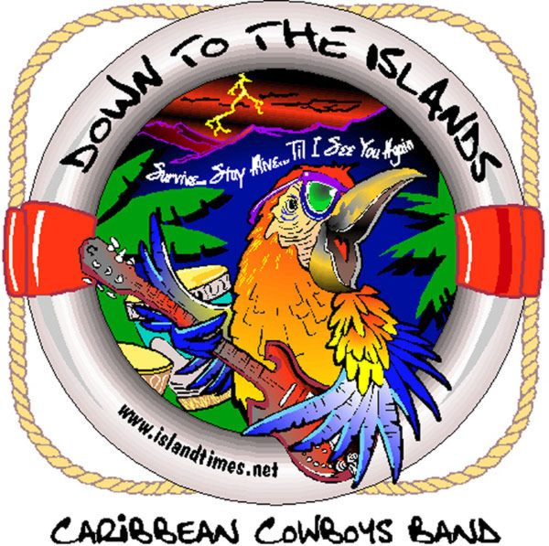
The Caribbean Cowboys Band
Fact sheet

Location: Asheville, North Carolina

Musical Genre: Classic, Trop & Southern Rock, Rhythm & Blues, Buffett, Beach, Reggae, Bluegrass, Country & Originals
Discography:
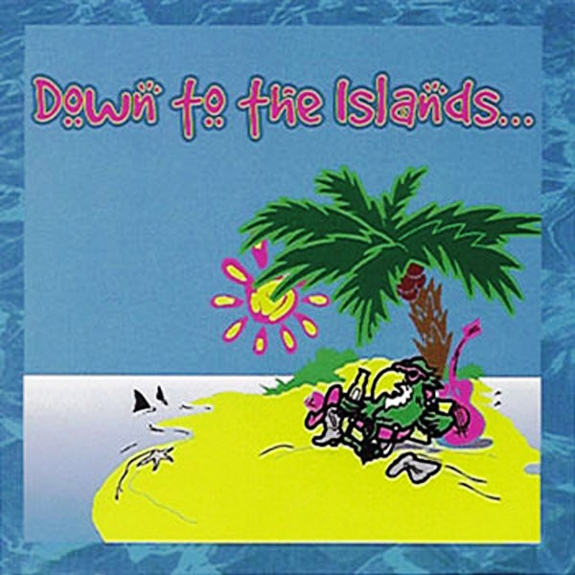
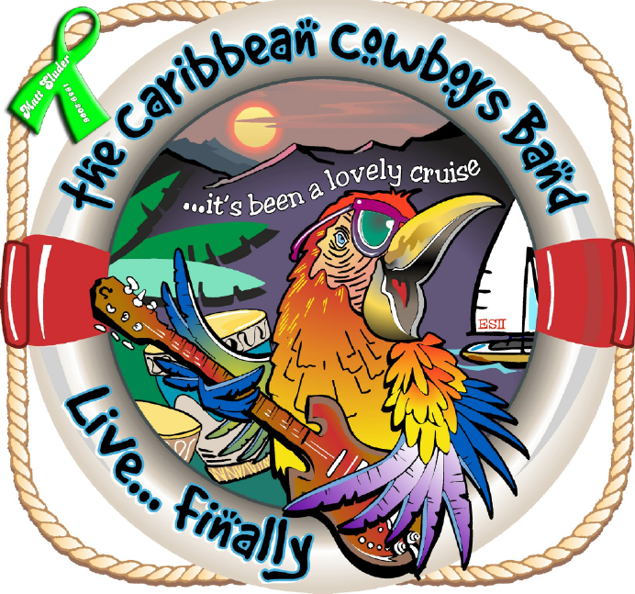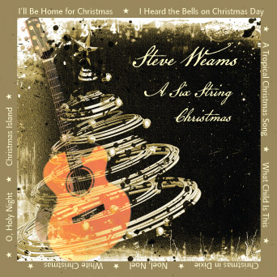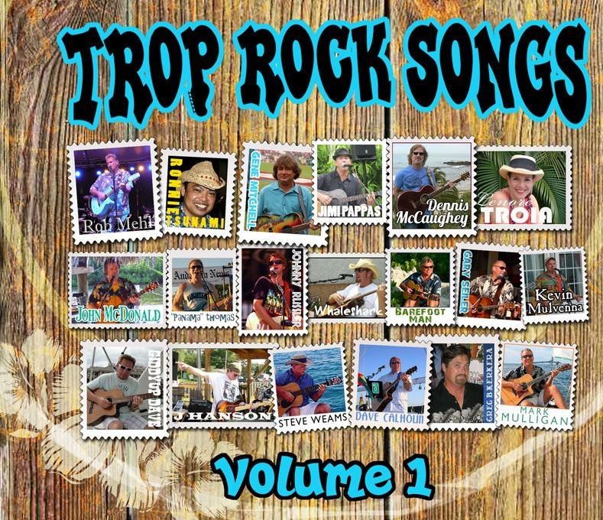

Down to the Islands, 1999
The Caribbean Cowboys Live ~ Finally 2007
Steve Weams, A Six String Christmas, 2008
Steve Weams “Bomba Shack” - Trop Rock Songs, Volume 1

Record Label: No Holds Records

Points of Interest:
Opened for & or shared the stage with Eric Burden and the Animals,
Dr. Hook, Skeeter Davis & Hwy 69, The Zack Brown Band, The Drifters (Four were Grammy winners & two are Rock & Roll Hall of Fame members)Greg “Fingers” Taylor, Scott Kirby, X-Coral Reefer Jay Spell, The Peter Mayer Group, Larry Gatlin, JoDee Messina, Jupiter Coyote, Cravin Melon, Antsy McClain & Tone Loc.

- Asheville Citizen-Times Poll 1995 “Most Popular Rock Band"
- Western North Carolina Mountain Xpress Readers Survey,
Back-To-Back 1999 & 2000 and 2011 “Best Local Band”
- Earth Day Asheville 2008 “2nd Place Best Latin/World/Reggae Band”

Books: Trop Rock Songs, Stories & Tales as told by the Singer/Songwriter by Andy Forsyth. Steve Weams – Chapter 56
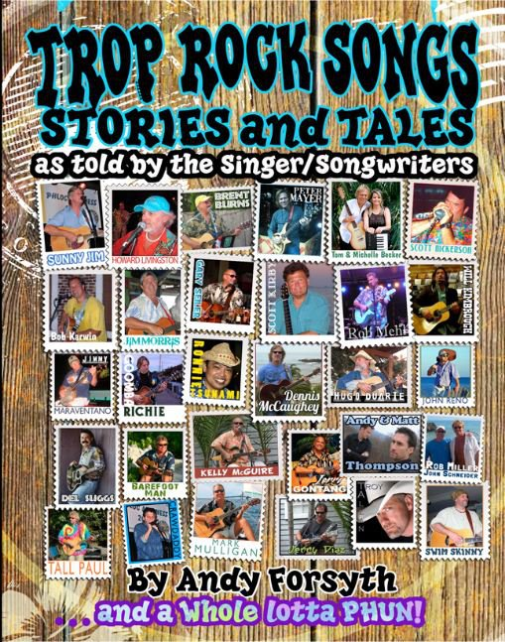
Songwriting Collaborations:
Steve Weams, Matt Sluder, Rick Phillips and Jack Nitterauer

Publishing: BMI

Artist Web Site: www.thecaribbeancowboys.com
www.facebook.com/thecaribbeancowboys

Artist Contact: Steve Weams
Office - 828-650-6400 or 828-684-0440 Fax - 828-687-1013
Email – steveweams@gmail.com

