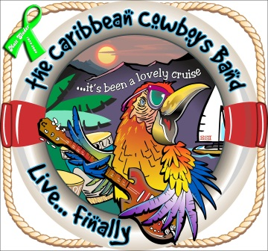
Steve Weams & the Caribbean Cowboys with 24 + years in the professional music business have assembled a variety of performances based upon different genres & event themes. Performances available from solo to a 7 piece band, suited for any audience, venue and budget…
www.thecaribbeancowboys.com www.facebook.com/thecaribbeancowboys
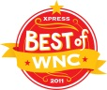
Steve Weams & The Caribbean Cowboys Band – WNC’s “Favorite Local Band” 1999, 2000 & 2011 One of the top 20 Jimmy Buffett tribute bands in the country providing songs about the island lifestyle from artists such as Jimmy Buffett, Zach Brown, Kenny Chesney, Scott Kirby with performances from NYC to Key West & thru the British Virgin Islands… The CCB can/will perform as this ensemble a little bit of all genres as requested. Don’t forget we still do the BEST Tropical, Island, Luau, Key West or Caribbean party anywhere!!!
The Mardi Gras Kings Tunes about New Orleans and the Mardi Gras Spirit…from Cajun to Country; Blues to Zydeco – It’s ALWAYS Mardi Gras and it’s ALWAYS A PARTY !!!
The Worn Out Weejuns Carolina “Shag” Music… Sample Set list - I Love Beach Music, Carolina Girls, Miss Grace, Tams Medley, Black Drawers, Stag-O-Lee, 60 Minute Man, Boogie Shoes, The Drifters Classics (5), CCB Beach Medley and many more to select from… Host your own SOS
Ol’ Red School House A Performance of Old School Country from artists like Merle Haggard (7), Johnny Cash (7) George Jones (5) Hank Williams (5) Hank Williams Jr. (4) Waylon & Willie (9) David Allen Coe (7)… Over 150 tunes available for a performance from Ol’ Red School House & we can also insert our current country songs if requested.
The Not So Blue Notes Over 40 songs to choose from Blues genres like Delta, Memphis, Chicago, Texas & Country Blues…. Sample Set List: Pride & Joy, Knock on Wood, Tore Down, Before You Accuse Me , Hey Bartender , Stormy Monday, Stag-O-Lee, Midnight Hour, Little Wing, Two More Bottles of Wine and more…
Red Eye Gravy Classic Bluegrass… Rocky Top, Man of Constant Sorrow, Blue Moon of Kentucky, Fox on the Run, Dooley, along with some lesser known songs like Feelin Only Felt in the Smokies, Peanut Butter Conspiracy, Morning Sky, Rocky Top Barbecue, How Mountain Girls Can Love… Over 30 from which to choose and continuing to add…
Veritable Plethora Originals obscure & eclectic songs from almost every music genre, featuring tight 3 & 4 part harmonies… concert quality.
Yasgur’s Farm An ensemble of songs which were played at WOODSTOCK, from artist such as Santana, Grateful Dead, Creedence Clearwater Revival, The Who, Blood Sweat & Tears, CSNY, Sha-Na-Na & Jimi Hendrix, Sly & The Family Stone with interesting facts & stories about the most important musical event in history. Even though it was long ago, we can take you there… A very popular Tribute show!
(We also do… 50’s/60’s Sock Hop; M*A*S*H Party & a great Old School Dinner Show/Dance – Vegas Style)
Steve Weams 828-650-6400 steveweams@gmail.com

