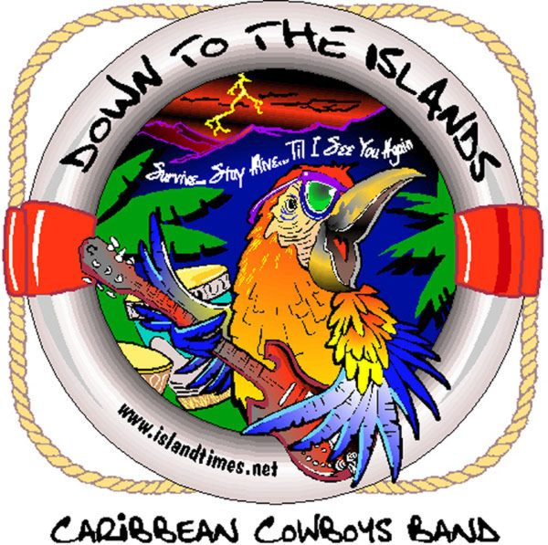
CARIBBEAN COWBOYS BAND
What the reviews say:

WEDDINGS & SPECIAL OCCASSIONS

“My Wife and I cannot say thank you enough for the performance and professionalism the band displayed at our wedding. Thanks to Steve, the band members and Gail for all the behind the scenes dedication that made each moment of the reception work to perfection. I want to share with you the overwhelming comments we received about how enjoyful the band was and the amount of fun that our guests had during our celebration. This was of course a reflection of the variety of music that was performed that represented all ages. Each song was played very well with such heart and soul placed into the performance. I would recommend Caribbean Cowboys for every reception that wants live music.”
Doctors Brian and Lisa Cherry, July, 07, Marriott, Greenville, SC

“Mac and I appreciate your band playing for our daughter’s wedding. Everyone raved about you & said they had so much fun & they just went on & on! Barbara and Marshall really appreciated and enjoyed it as well. A lot of our friends want to know if we can get your band down to Austin Texas.”
Mr. & Mrs. Mac Brown, Austin , Texas, Parents of the Bride
June, 07, Eseeola Lodge, Linville, NC

“The Caribbean Cowboys played for our 50th Anniversary Party in Blowing Rock in 2006 and they really helped to make the party lots of fun and a real success. Our guests were all ages, and it was amazing how the young and old all loved the music. Steve, the band leader, was great about getting everybody involved in the dancing...many of the older guests (who would probably not have danced) got out there and had a great time. Their music is awesome, and it's a great group of guys...we try to hear them every chance we get and would give them our highest recommendation!”
Shirley and Mel Harris Statesville, NC
“Thanks for playing our wedding. It wouldn’t be the same without you guys .” Peace, Danielle & Korey

FESTIVALS, CORPORATE - FUNDRAISING EVENTS, ETC.
“I wanted to thank you guys for an awesome party at the Orange Peel in Asheville. It is great to host a fundraiser with over 250 people dancing all night long. It says a lot about your band to be able to keep the music coming & maintain participation. This event was our 3rd annual 'Flip Flop Hop ~ Dancing for Down Syndrome”. Thanks for performing each year for this great cause. Your ability to include the kids into the evening means so much! Fins up!” Stephanie Gaddy, President, WNC Parrot Head Club, February, 2008, The Orange Peel
“My group (Blue Cross, Blue Shield of NC) loved having you at Palmetto Bluff in Bluffton, SC. I got nothing but glowing praise about your performance. Also, it was nice to meet your wife Gail and Spooner” Michele Decker, Daniel Entertainment Group

CARIBBEAN COWBOYS BAND What the reviews say:
“Just wanted to tell you how much we enjoyed your show Saturday. Everyone loved you guys. I have had several phone calls from people telling me how good you were. Thank you for your great performance and for being so easy to work with. Looking forward to seeing you again.” Paulette Masters, Gopher Hill Festival, Ridgeland SC
“Just wanted to let you know how much my friends & family enjoyed your show @ the Bele Chere Festival in Asheville NC this past week-end. It was truly a pleasure to see some “entertainment” in your show along with the incredible talent of all of the musicians. The Soggy Bottom Boy was our favorite. We purchased your CD and are enjoying it as well. Keep rockin in the mountains!” Trevor Cane, Atlanta GA
“Thank you for coming to play at our store during Parrot Stock! The staff was absolutely raving about how much fun it was.” Gina Knight, Manager, Jimmy Buffett’s Margaritaville, Charleston SC
“The Caribbean Cowboys Band came in to our view about 10 yrs ago when we heard them at the old Cider Mill Restaurant. We love Buffett as well as Rock & Roll, so this became a habit for us. We continue to look for venues where they play. In fact, we have the Cowboys entertain for our annual summer theme party “Cheeseburger in Paradise” which we host for friends, family & customers. They are a very important part of our events success & anticipation each year, as they play Buffett, Rock & Roll and allow guests to make requests. They are super and Steve Weams is a champ at keeping people involved.” Alice & Bill Miller, Beverly-Hanks Realtors, Arden, NC
“Thank you so much for your time last night for the Shelter from the Storm benefit at Magnolia’s . I greatly enjoyed listening to you band as I collected donations for the Red Cross. On behalf of the 1200 + people we have helped in Asheville alone, thank you for making this benefit concert so successful. I look forward to watching you perform in the future.” Bonnie Bloom, American Red Cross, Asheville-Mountain Area Chapter
“I saw your show at Fall for Greenville and loved your material and harmonies. Yours is the kind of music I listen to most often and I purchased one of you CDs and have really enjoyed listening to it … especially “Southern Cross” I look forward to hearing you guys again.” Michael Smith, Musician, Greenville, SC
“Just a quick note of thanks to you and the band for a fabulous job once again on Saturday night!! A great time was had by all in spite of the bad weather. We certainly appreciate you and the guys being a part of what we do and will be looking forward to having you with us again next year.” Vance Davidson Region A Partnership for Children, Sylva NC
“My daughter and I were in Key West @ Meeting of the Minds a couple of years back when you were playing at Dirty Harry’s . We enjoyed your music so much I purchases a CD and all of you signed it . She recently had the CD stolen and my wife contacted you and we sent a check for a new CD which we asked you all to sign again. The CD was signed and our check was sent back. I just wanted to thank you all and to let each one of you know how much this meant to me as a father and a fan of yours. What you did by sending the check back was outstanding and reflects the character of each one of you and your promoters. Please keep up the great work and music and thank you so very much for your time and unselfish consideration.” Barry and Cheryl Walker , Urbanna , VA
“It was a pleasure meeting you and the guys in Bluffton (especially Spooner!) We continue to get positive feedback from the client on the events last week, especially Saturday night. Please give our thanks again to the band for a great show. Our clients were very please. Take care.” Lynn , Event Planner
“Stevo ~ just wanted to let you know the Caribbean Cowboys were a giant hit with everyone. In fact, they want you all to return next year for The Annual Christmas party for the company. Ken & Susan Morris, Clemson , SC
“I didn’t get the chance to say thanks to you and the band on Saturday evening, so I want to tell you now just how much we appreciate you being a part of our fifth annual Slice of the Island Life party . We are just now doing the financial stuff, but it looks like we are going to have the most successful part to date for the donation we will make to the MS Society . Anyway, I wanted to thank you personally .” Mark H McKaughn, President, Parrot Head of the Triad
“I just wanted to write and tell you how much we enjoyed your show on October 26 at the Watershed, opening for Peter Mayer. It was our first time seeing the Caribbean Cowboys, and I’m positive that it won’t be the last! Your guys were fantastic! I was disappointed when you guys left the stage. Thanks for a wonderful time, and we’ll see you soon!” Jessie
“Just checking out your web site & decided to drop a line. Gave your CD to a couple of women I know who were going to support a friend in Key West last week at the Ernest Hemingway Look-A-Like Contest @ Sloppy Joe’s. It was a 1st trip for both of them & they were flying into Miami & renting a convertible to drive AIA. I told them to pop in the Caribbean Cowboys and play it loud all the way. When they got back to Columbus, Ohio, they knew every song by heart! And, by the way, their friend won the contest! We think about you often and really enjoy the CD. John Mathers, Columbus Ohio
“We continue to get very positive feedback that the 2009 Mardi Gras Ball was the best ever, by far. We certainly had our largest crowd! The silent auction was a great addition to the event. Thanks for your contribution to that. Hope this finds you well and kickin’. We definitely want to continue the tradition of having the Caribbean Cowboys as our entertainment!
Vance Davidson, Region A Partnership for Children, Sylva, NC

“Thank you so much for playing again at our annual Mardi Gras fundraiser Feb. 12, 2013! We met our fundraising goal of $20K this year, which is so exciting. We are so grateful for the great music and fun atmosphere you provide for our guests and this event helps us at St. Gerard House give more to our families in our community facing autism. Please feel free to stop by our place anytime – I’d love to give you a tour and show you some of the things we do here, you’re always welcome. Thank you again for your support. With gratitude,
Amanda, Assistant Director, St. Gerard House, Hendersonville, NC

”Special thanks to Steve Weams & the Caribbean Cowboys Band for participating in the 1st Annual Making Strides Against Breast Cancer 5K Event, October 2011, by being a $500 Pink Trophy Sponsor, presenting the Save 2nd Base Trophy to the team raising the most funds.”
Peggy Crowe, Community Manager, South Atlantic Division, American Cancer Society, Asheville, NC
“The Caribbean Cowboys” were wonderful at our “Paint the Bywater Pink” fundraiser for the 2012 Strides against Breast Cancer effort last fall. Steve and the guys are wonderful musicians with big hearts! I cannot wait until the 2013 event at the Bywater coming September, 2013!”
Bonnie Carlin, Event Chair, Making Strides against Breast Cancer, 2012

“What a great job the guys did on the 21st...Everyone enjoyed the band so much...Just checking and confirming with you on next year’s date.”
Pat & Tyree Harding, Buffalo Camp Christmas in July, Blowing Rock, NC
…..”Hey there Steve. Ok so I have really enjoyed having you guys play here. You guys are so much fun and I do love your sound.”
Harmony Blue, Brevard Brewing, Brevard, NC
“Thank you for a great night! I had several emails today of people saying-"Wow! That was fun!" You guys did great and I look forward to seeing you in June!
Dave Linn, Habitat for Humanity Event, February 2012 Rathskeller, Franklin, NC

