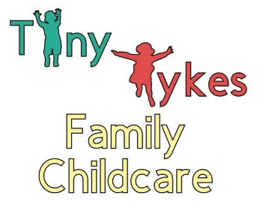
Application Form
Once this form has been received by the childcare, your child will be added to the Tiny Tykes Family Childcare waiting list. This does not guarantee your child a spot. Should a spot become available, you will be contacted. There is no fee required for this service.

Child’s Name: ____________________________ Applying For: Full Time Part Time
Preferred Start Date: ______________________ Days Attending: M___ T___ W___ Th___ F___

Gender: ____________________________ Birthdate: _________________________________

Address: ______________________________________________________________________

Phone: ____________________________ Email: ______________________________________

Parent/Guardian’s Name: ________________________________________________________
Occupation: ____________________________ Phone: ________________________________

Parent/Guardian’s Name: ________________________________________________________
Occupation: ____________________________ Phone: ________________________________

Other Children in Family (Name and Age):

Child 1: ________________________________ Child 2: ________________________________
Child 3: ________________________________ Child 4: ________________________________

Does Child Have Previous Childcare Experience? Yes No
Please Explain: _________________________________________________________________
______________________________________________________________________________

Parent/Guardian’s Signature: _____________________ Date: __________________________
Parent/Guardian’s Signature: _____________________ Date: __________________________

