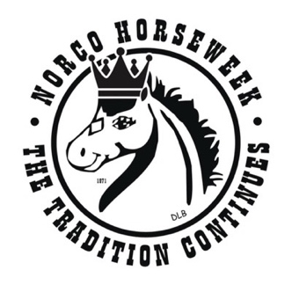
Support the
Miss Rodeo Norco Horseweek Pageant
by advertising in the
Miss Rodeo Norco Horseweek Pageant
Souvenir Program 2026
Promote your Business – Support a Pageant Contestant

Programs are digitally available during the Miss Rodeo Norco Horseweek pageant. The digital program contains contestant information and photos, reigning royalty photos and information, Judges and Pageant Committee information, advertisements, and much more.
The funds raised through advertising are used to cover the cost of contestant awards/ prizes and any other pageant expense. 100% of funds raised goes back to the contestants and queens.
An award will be presented to the contestant who raises the most funds from advertising and raffle ticket sales.
This is an advertisement in the MISS RODEO NORCO HORSEWEEK DIGITAL PAGAEANT PROGRAM; not the Horseweek Book or Rodeo.
Thank you for your consideration, The Miss Rodeo Norco Horseweek Pageant Director and Contestants
TO SUPPORT A CONTESTANT:
Please Complete this sheet and Submit with your Ad Content
LEASE
Please submit Content as early as possible so we may reserve your ad space. The final deadline for ad submission is April 1, 2026. Email advertisements/ Logos to Kristyannmiller@aol.com
Business is responsible for supplying ad, banner, and logo for advertisement. Banners are to be turned into the contestants and turned in to the director no later than April 8th, 2026
Contestant's Name: __________________________________________________________________________ Your Name: _________________________________________________________________________________
Your Phone Number: _________________________________________________________________________ E-Mail Address: _________________________________ Website: ____________________________________
Please indicate what size ad you are purchasing:
Miss Rodeo Platinum Sponsor: $1000.00 Full page color ad, Arena Banner during Horsemanship, Logo on Queen website, special announcement during pageant fashion show.
Arena Banner: $500.00 Banner will be hung in arena during Horsemanship Portion of Competition
1/2 Page Color ad: $300.00 Full Page Color ad: $500.00
Method of payment:
CHECK #___________________ (Payable to Norco Horseweek) CASH

