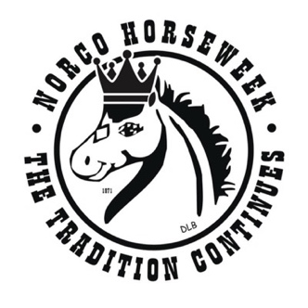

Miss Rodeo Norco Horseweek 2026 Rodeo Queens
www.MissRodeoNorcoHorseweek.com

Promote your Business – Support a Rodeo Queen

The Miss Rodeo Norco Horseweek Queens are seeking community partners to help sponsor their custom championship saddles, which are awarded as part of their year of service representing the City of Norco and the western lifestyle.
Your sponsorship directly supports the purchase of each Queen's saddle and helps recognize the dedication, hard work, and countless volunteer hours these young women invest in serving our community throughout their reign.
Sponsors will be recognized through the Miss Rodeo Norco Horseweek Pageant and on the Rodeo Queen website according to their sponsorship level. Every contribution, large or small, helps make a lasting impact on the lives of our Queens.
Thank you for investing in the future of our Rodeo Queens and for helping preserve the traditions, leadership, and western heritage that make the Miss Rodeo Norco Horseweek Pageant so special.
TO SUPPORT A CONTESTANT:
Please Complete this sheet and return to Queen
LEASE
Email Logos to Kristyannmiller@aol.com
Business is responsible for supplying banner, and logo for advertisement.
Rodeo Queen Name: __________________________________________________________________________ Your Name: _________________________________________________________________________________
Your Phone Number: _________________________________________________________________________ E-Mail Address: _________________________________ Website: ____________________________________
Please indicate what level of sponsorship you are purchasing:
Miss Rodeo Saddle Sponsor: $2000.00 Embroidered Logo on 2026 Rodeo Queen Jackets, Logo and business linked on Rodeo Queen Website Page, Banner at 2027 pageant during Horsemanship, framed Professional photo with the Queen and sponsored saddle.
Miss Rodeo Saddle Co-Sponsor: $1000.00 Logo on Queen website, Banner at 2027 Pageant, framed Professional photo with the Queen and sponsored saddle.
Banner at 2027 Pageant: $500.00
Method of payment:
CHECK #___________________ (Payable to Norco Horseweek) CASH

