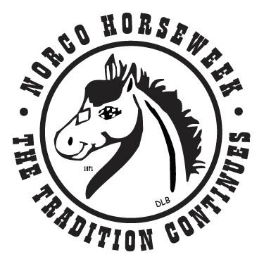
Miss Rodeo Norco Horseweek Personal Interview
This Form will be given to the judges to learn about you prior to your personal interview.
Must be typed in Calibri size twelve font.
Please Email form to Kristyannmiller@aol.com no later than Wednesday March 4, 2026
Please also bring printed copy to practice

Full Name: ________________________________________________________________________________

Age: Birthday: ________________________________________________________________

What is your favorite food? ___________________________________________________________________________

What is your favorite color? ___________________________________________________________________________

What is your favorite book? ___________________________________________________________________________

Name three words that best describe you:
________________________________________________________________
________________________________________________________________
________________________________________________________________
What do you like to do outside of horses?
________________________________________________________________________________________________________________________________________________________________________________________________________________________________________________________________________________________________________________________________________________________________________
Rodeo/ Horse related activities:
________________________________________________________________________________________________________________________________________________________________________________________________________________________________________________________________________________________________________________________________________________________________________
Why do you want to become Miss Rodeo Norco Horseweek?
____________________________________________________________________________________________________________________________________________________________________________________________________________________________________________________________________________________________________________________________________________________________________________________________________________________________________________________________________________________________________________________________________________________________________________________________________________________________________________________________________________________________________

Biography written in 3rd Person 100 words or less:
____________________________________________________________________________________________________________________________________________________________________________________________________________________________________________________________________________________________________________________________________________________________________________________________________________________________________________________________________________________________________________________________________________________________________________________________________________________________________________________________________________________________________
On Stage Song Choice:
__________________________________________________________________________________________
Description of gown written in 3rd Person 100 words or less:
__________________________________________________________________________________________________________________________________________________________________________________________________________________________________________________________________________________________________________________________________________________________________________________________________________________________________________________________________
Please attach (5) photos that you would like to share with judges.
Photos must be clothing appropriate, should represent you and your life outside of pageantry.

Photo Page Photos must fit onto this (1) page

