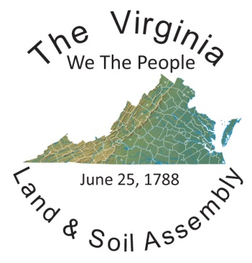

Baby Natal Record / Baby Deed Instructions
Which form do I need?

If your Child was born in a hospital prior to you becoming an American State National and has a Birth Certificate from the defacto, you will need to fill out a Baby Deed. Essentially you will deed your child back to the Land and soil and record the Deed to your LRO (Land Recording Office) record.
If you are an American State National and your Child will be born directly onto the Land and soil of Virginia, you will fill out the Natal Record. You should take your Natal record with you to the hospital and fill it out at the time of your natal event. We caution you against revealing your child’s name to the hospital staff as they are instructed to create the documents that traffic your child onto the Sea Jurisdiction against your wishes. You can fill out everything on the Natal Record accept the Name that you will be giving to your child.
Follow the example of the form attached to this document. It provides examples of all of the information that you will want to use on your Natal Record/Deed. This is really self-explanatory, just follow it step by step.
Parents can be the witnesses of the Natal Event or may use alternate witnesses, anyone who is witness to the child coming into the world, that knows the child is yours, born to you can be a witness.
Once you have completed your form you will need to take it to a local Public Notary (at your bank or even a UPS store-sometimes easier to work with) the Public Notary is notarizing the fact that you are the individual you say you are, that is it.
So now your form is completed and you have had it notarized, your next task is to send it to the Public Health Guardian on Virginia (currently Steven Warden – PublicHealth.Virginia@proton.me )You will need to scan your document and email it to him. Steven will autograph and put the Virginia Public Health Guardian Seal on your form. He will document for the Virginia Assembly that you had a child born onto the Land and soil or that your child has been deeded back to the Land and soil.
He will then scan your document and email it to one of our state Recording Secretaries who will record your record into the LRO (Land Recording Office). You will then receive an email with your Childs Natal Record.

