

INNOV4TE INDEPENDENT SCHOOL POSITIVE CONDUCT POLICY

|  |  |
| --- | --- |
| Effective from | Sept 2024 |
| Review date | Sept 2025 |
| Person Responsible | Carla Astbury |

**Our Vision**

To Bring All Learning Abilities, No Child Excluded. -Supporting all children and young people to fulfil their potential.

We BALANCE social, Emotional and Mental Health needs with raising aspirations; we understand that self-efficacy is not possible until basic needs are met.

**Our Approach**

We are systematic in our model yet bespoke in our approach.

Our principles remain the same with the caveat that each child and young person is different. We operate using a variety of models, theories and approaches. We are all trauma informed trained and recognise the tremendous detrimental impact adverse childhood experiences play in a young person’s life.

At Innov4te independent school we understand that young people learn best when positive, trusting relationships are built and this informs our approach to supporting, managing and changing behaviour.

We expect each learner to conduct themselves in a positive manner and expect staff to consistently acknowledge positive conduct through praise and rewards.

We understand the importance of feeling safe, our focus is to ensure all our learners feel safe and can develop positive and trusting relationships with all members of INNOV4TES community.

**Arrival**

On arrival to the provision each morning learners are welcomed into a positive atmosphere by staff who will be informally assessing the mood and needs of each learner.

At Innov4te independent school we believe in MASLOW before BLOOM and that meeting our learners’ basic needs of safety and belonging are paramount before turning to the challenging academic.

Once learners are greeted a member of staff, staff will lock the learners’ personal possessions and mobile phones away in a personalised compartment and stored securely, with only staff having access. Learners will be searched on arrival to ensure the safety of all learner’s staff and visitors.

**Learners will**

* Adhere to INNOV4TES positive conduct policy.
* Treat each other, members of staff and any visitors with respect.
* Respect the environment and not intentionally damage property or equipment.
* Arrive at Innov4te independent school on time and in uniform.
* Not have in their possession drugs, cigarettes, vapes, e-cigarettes, or any paraphernalia linking to these, alcohol or weapons anywhere on the premises.
* On arrival hand in mobile phones to the member of the safeguarding team.

**Staff have the Power to search for prohibited items without consent.**

Staff can confiscate, retain or dispose of a learner’s property, so long as it is reasonable in the circumstances. The law protects them from liability for damage to, or loss of, any confiscated items provided they have acted lawfully. This includes, but is not limited to:

* Knives and weapons
* Alcohol
* Illegal drugs
* Stolen items
* Smoking paraphernalia
* Fireworks
* Pornographic images

**Staff will**

* Treat learners and each other with respect.
* Model the conduct they wish to see in learners.
* Provide structured routines, planned, prepared and supervised learning.
* Ensure that classroom rules and consequences are displayed in each classroom, including the ACHIEVE points system.
* Challenge, calmly and consistently, any inappropriate conduct.
* Try to resolve conduct issues in their classroom themselves wherever possible.
* Seek help with positive conduct management strategies if their own are unsuccessful.
* Be clear and consistent with expectations of learners.
* Liaise with parents, guardians, professionals and roll schools regarding individual behaviour issues.
* Report any incident to the directors, log the incident on the code of conduct system.

All staff at Innov4te Independent school have a responsibility to respond to conduct that may be sexually inappropriate, staff will challenge any unacceptable or harmful behaviour, incidents will be recorded on Arbor and reported to the DSL who will investigate.

**Parents/carers will**

* Accept and support actions Innov4te independent school may take to help their child improve their conduct.
* Attend meetings with Innov4te independent school staff to agree strategies to support their child in improving their conduct.
* Discuss conduct issues with their child to find cause and seek solutions.

**Anti-bullying**

At Innov4te independent school we believe that every learner has a right to enjoy their learning and leisure free from bullying. We will not tolerate any behaviour that causes distress to any member at INNOV4TE.

We appreciate that all behaviour is communication and will seek to understand the route cause.

Bullying is a repeated action that is intended to cause someone else harm or upset. This can take place in several ways:

* Violent behaviour or physically hurting others.
* Sexual violence, such as rape, assault by penetration, or sexual assault (intentional sexual touching without consent)
* Sexual harassment, meaning unwanted conduct of a sexual nature, such as:
* Sexual comments
* Sexual jokes or taunting
* Physical behaviour like interfering with clothes
* Online sexual harassment such as unwanted sexual comments and messages
* Upskirting (including on social media), sharing of nude or semi-nude images and/or videos, or sharing of unwanted explicit content.
* Deliberate offensive language.
* Rudeness to staff and other pupils.
* Vandalism.
* Drugs or alcohol use in school.
* Continued disregard for staff instruction.
* Continued disregard for rules and or procedures.
* Theft from staff, fellow learners and premises

For further information please see our Anti bullying policy.

**Consequences**

These can range from

* Verbal prompts: At Innov4te independent school we believe learners should be praised in public (where appropriate dependent on attachment type) and reprimanded in private.
* Opportunities will be provided throughout for the pupil to correct their own behaviour.
* Internal intervention -This includes but is not limited to reflection and positive code of conduct mentoring.
* At Innov4te independent school we believe detentions and isolation are an ineffective way to manage behaviour as this time is unstructured and can have a detrimental effect on the learner.
* External interventions with external agencies this can include but is not limited to mentoring and counselling.

**Restorative practice**

Innov4te independent school focuses on positive relationships and collaborative teaching and learning, with classrooms developing as communities. It means that teachers and pupils commit to looking at positive alternatives to reactive punitive behaviour solutions (e.g. exclusions), because they are confident that the matter is being dealt with in a clear and explicit way, understood and endorsed by all.

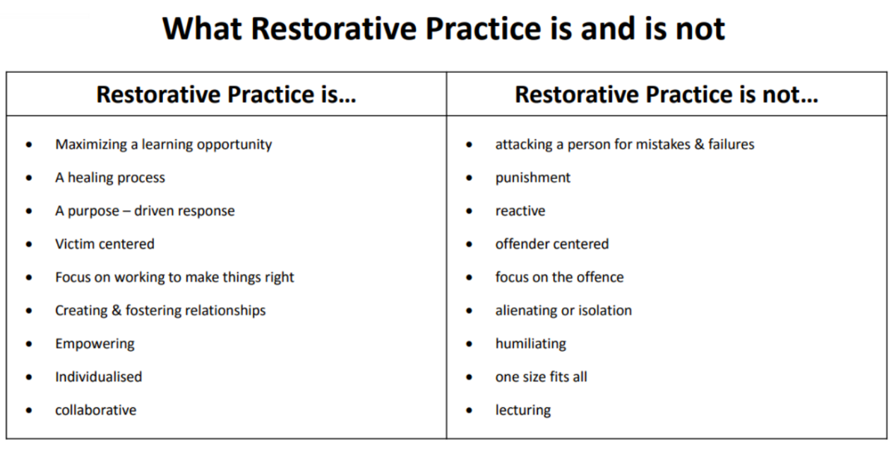

At all times staff, learners and parents/carers will liaise to ensure everyone has a clear understanding that the expectations at INNOV4TE are to support our learners to become emotionally balanced, resilient and fully participating citizens in society.

Where the positive conduct policy is not adhered to, interventions will be put in place promptly with the emphasis on developing self-esteem and self-regulation.

When a learner is unable to self-regulate members of staff will support and co regulate.

Parents/ carers will always be communicated with should there be the need for intervention.

Fixed term exclusion will be implemented in circumstances as laid out in the exclusions policy.

We understand the complexities of our learners and the reasons for the referrals to us and where possible we will utilise interventions and further support before implementing a fixed term exclusion.

We understand that when learners are familiar with a provisions behaviour policy and understand how they can be excluded from school they may intentionally engage in behaviours that result in a fixed term exclusion as a diversionary tactic, staff will support learners to make positive choices.

Should a learner receive a fixed term exclusion upon return to Innov4te independent school reparation, mediation and suitable interventions will be put in place to support the learner.

Termination of placement will only happen in the most extreme circumstances of gross misconduct as in line with our service level agreement which the referring provider will be aware of.

We believe in working tirelessly to understand the root causes of complex behaviour that challenges, however we are sensitive to balancing these needs with the needs of our other learners and the need to provide a safe environment for our learners and staff.

**Factors that need to be considered in applying sanctions.**

• The seriousness of the incident / behaviour, and its impact on others.

• The frequency of such incidents / behaviours by the child/learner. Consideration should also be given to the:

• Age and understanding of the child/learner.

• Any Special Educational Needs the child may have.

• The degree of peer or other pressure.

• Whether the incident / behaviour was perpetrated alone, or as a part of a group.

• The intention of the child.

• The child's emotional state.

• The circumstances preceding the incident.

• The impact of the behaviour on others and / or property.

•The interventions / strategies used by INNOV4TE and / or others to manage / change the learners behaviour.

**Power to use reasonable force.**

At Innov4te independent school restraint and physical force is always a last resort and we would always ensure all de-escalation methods are used to prevent any form of physical restraint. However, members of staff have the power to use reasonable force to prevent learners committing an offence, injuring themselves or others, or damaging property. Where there is a restraint, a Restraint Incident Form will be completed and held on the Learner file, this will also be logged on the conduct system.

**Learners conduct outside of the provision.**

What the law allows.

Teachers have the power to discipline learners for misbehaving outside of the school premises “to such an extent as is reasonable.”

Teachers may discipline learners for misbehaviour when the pupil is: taking part in any -activity which is organised by the provision and when or travelling to or from the provision or in some other way identifiable as a learner at the provision or misbehaviour at any time, whether or not the conditions above apply, that could have repercussions for the orderly running of the provision or poses a threat to another learner or member of the public or could adversely affect the reputation of the provision.

In all cases of misbehaviour, the teacher can only discipline the learner on school premises or elsewhere when the learner is under the lawful control of the staff member.

**Safeguarding and child protection**

The Designated Safeguarding Lead should be consulted in ***all*** incidences where positive conduct is not adhered to, and it concerns a child who is open to multi-agency support for safeguarding purposes.

For further information on safeguarding and child protection please see our child protection and safeguarding policy.

**Praise and rewards.**

We have high aspirations for our Learners academically as well as socially and emotionally, despite any challenges they may have faced previously in their educational setting.

Positive conduct should be acknowledged and rewarded to encourage further use of this type of conduct and reduce inappropriate conduct. Every member of staff is responsible for:

* Praise what the learner has done.
* Be specific with the praise (For example if a learner is usually late, but arrives on time, whilst punctuality is an expectation, we accept that there can sometimes be external factors that are beyond the learner’s control.)
* Avoid competition or comparison to other learners.
* Gain an understanding of what motivates the pupil and tailor the praise to suit. (For example, some learners will respond well to rewards whereas other may prefer a positive phone call home)
* Be mindful that not all learners will respond well to public praise, particularly those with specific attachment styles.

At INNOV4TE, we use the ACHIEVE system.

Learners can be awarded points ranging from 1-3. A learner will be awarded 1 point if there is some evidence of positive conduct, 2 if this is displayed for most of the lesson and 3 if displayed for the entire lesson.

Staff should ALWAYS support learners to achieve at least 1s in each area of the ACHIEVE system. This is a strengths-based approach and builds on positives.

(For example, should a child enter a classroom they will be given a 1 for attendance to that specific lesson.)

Other ways learners will be rewarded.

* Having work displayed around the provision.
* Certificates to acknowledge positive conduct or ACHIEVE points system.
* Positive contact home via text, telephone or email.
* Choice of afternoon timetabled activities.
* End of term celebrations
* Reward activities.

Learners will also have their conduct recognised through the directors’ award for outstanding conduct.

Positive conduct agreement

I will demonstrate that I am ready to learn by:

* Handing my belongings in at the beginning of my school day
* Following staff instructions
* Attending all my own lessons (including registration) and staying there unless I have permission to leave.
* Attempting to complete all work set.
* Accepting help from staff if I need it.
* Listening to staff without interrupting
* Expressing myself respectfully at an appropriate time
* I will not be under the influence of non-prescription drugs or alcohol.

INNOV4TE will:

* Offer a safe, friendly environment without being judgemental.
* Listen to me when I need to express myself.
* Differentiate work so that I can work independently.
* Log my positive behaviour, attitude and good work on the positive conduct system.
* Reward good behaviour and attitude.

I understand that I will be supported at INNOV4TE to become the best version of myself, so I am able to return to mainstream education or an alternative setting that is more suited to my needs.

|  |  |
| --- | --- |
| Learner name: |  |
| Learner signature: |  |
| Date: |  |