Name:
Date:
Kitchen Safety – Hazards and risks
Identify hazards and risks in a kitchen/ Understand why kitchen safety is important
Recognise different types of hazards:

Physical

Chemical

Biological

Starter Task- Spot the Danger!
Task: Kitchen Safety Picture
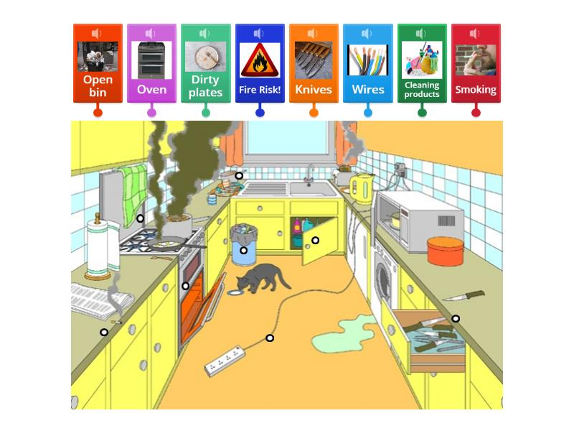

Questions:
Can you spot at least 3 things that could be dangerous?
What might happen if nothing is done?

Task 2: What Is a Hazard? What Is a Risk?

Hazard – something that could cause harm
Risk – the chance of harm happening
Safety – actions taken to prevent harm

Match the term to the correct example:

Example Hazard or Risk?
Wet floor _______________________________________
Someone slipping ___________________________________
Hot oven ____________________________________________
Burn to the hand ____________________________________________

Task 3: Hazard Categories Carousel- Introduce the 3 Types of Hazards
https://www.youtube.com/watch?v=DtneRNVMgVk
Physical Hazards
Knives
Hot pans
Spills on the floor
Chemical Hazards
Cleaning sprays
Detergents
Bleach
Biological Hazards
Bacteria on raw meat
Mould
Dirty hands

Learner Task: Sort the Hazards
Provide learners with hazard cards or a worksheet.

Instructions:
Sort each hazard into the correct category.
Work in pairs or small groups.

Example Hazards to Sort:
Raw chicken
Sharp knife
Oven cleaner
Spilled water
Dirty chopping board

Task 4: Safety Scenario Cards
Task: What Would You Do?

Example:
A student spills water on the floor and walks away.

Questions:
What is the hazard?

What is the risk?

What should be done to make it safe?

Plenary Task - Complete one sentence:
One hazard I might find in a kitchen is…

One way to stay safe in the kitchen is…

