INNOV4TE Independent School

Marking and Feedback Policy

|  |  |
| --- | --- |
| Effective from | Sept 2024 |
| Review date | Sept 2025 |
| Person Responsible | Carlo Franco |

**Contents**

Introduction 2

Aims and objectives 2

Principles of marking and feedback 3

Implementing the Marking Policy 3

INNOV4TE Independent School Marking 4

Appendix 1 4

Appendix 2 5

Appendix 3 5

# Introduction

Assessment at INNOV4TE Independent School takes place in a range of different ways for different subjects; however, all assessments embrace the principles outlined in this policy. Types of assessment carried out include, but are not limited to, the following:

### Aims and objectives

At INNOV4TE Independent School, learners’ work is marked, and feedback is offered, in order to:

* Show that we value the learner's work, and encourage them to value it too;
* Boost the learners' self-esteem, and raise aspirations, through use of praise and encouragement. The main objective of marking and feedback is not to find fault, but to help learners develop. If a learner’s work is well matched to their abilities, then errors that need to be corrected will not be so numerous as to affect their self-esteem;
* Give the learner a clear general picture of how far they have come in their learning, and how they can improve their work in the future;
* Offer the learner specific information on the extent to which they have met the lesson challenge, and/or the individual targets set for them;
* Promote self-assessment, whereby the learners recognise their difficulties, and are encouraged to accept guidance from others;
* Share expectations;
* Gauge the learner’s understanding, and identify any misconceptions;
* Provide a basis both for summative and for formative assessment;
* Provide the ongoing assessment that should inform our future lesson-planning

### Principles of marking and feedback

We believe that the following principles should underpin all marking and feedback:

* The process of marking and offering feedback should be a positive one, with pride of place given to recognition of the efforts made by the learner.
* Marking and feedback is the dialogue that takes place between teacher and learner, ideally while the task is still being completed.
* Marking should always relate to the lesson challenge and, increasingly, the learner's own personal learning targets.
* The learner must be able to read and, from time to time, respond to the comments made, and be given time to do so. Where the learner is not able to read and respond in the usual way, other arrangements for communication must be made.
* Comments should be appropriate to the age and ability of the learner, and may vary across year groups and key stages.
* Comments will focus on only one or two key areas for improvement at any one time.
* Teachers should aim to promote learner's self-assessment by linking marking and feedback into a wider process of engaging the learner in his or her own learning. This includes sharing the learning challenges and the key expectations for the task right from the outset.
* Whenever possible, marking and feedback should involve the learner directly.
* The marking system should be constructive and formative.
* For one-to-one feedback (teacher to learner) to be effective, sufficient mutual trust must be established.
* Feedback may also be given by a learning support, or through peer review.
* Group feedback is provided through plenaries too, and in group sessions.
* Feedback will help a learner to identify their key priorities for improvement and the progress they are making towards personal targets.
* Teachers will note errors that are made by many learners and use them to inform future planning.
* Marking will always be carried out promptly, and will normally be completed before the next lesson in that subject (although this may not always be possible for longer pieces of work).

### Implementing the Marking Policy

INNOV4TE Independent School has explicit rules that apply to all pieces of work (e.g. the date and WALT must be at the top),

The extent of the teacher's response to a piece of work is determined not by the number of errors found in it, but by the teacher's professional judgement. Consideration is given to what a particular learner is capable of, what the next learning stages involve, and what should now have priority. Learners should not receive the impression that things are right when they are not; on the other hand, they should not be discouraged from being adventurous for fear of having faults emphasised.

In order to encourage a positive response, any negative comments must always be followed up by a constructive statement on how to improve.

Verbal and written comments are often more valuable than marks or grades. We do not normally give marks or grades on pieces of written work.

Ticks are normal where work is correct, and crosses or a dot where errors have been made. Other symbols may be used once their meaning has been explained, e.g. an *‘sp’* for a spelling mistake.

Wherever possible, teachers should establish direct links between oral or written praise and the class or school rewards systems. At the same time, teachers should remember that stickers and stars in themselves do nothing to close gaps in understanding, or to bring about improvements.

When appropriate, learners may mark their own or another learner's work, but the teacher must always review this marking. Marking their own work is usually preferable, because when the teacher makes a point, the learners need to be able to relate it to their own efforts.

Learners should be encouraged to assess their work ahead of final marking, using prompt cards or success criteria. These cards can remind learner of their learning targets, or suggest common checks to perform (e.g. capital letters). This helps the learner to self-reflect at each step of the learning process

In addition, the l could learners indicate where they think a particular target has been achieved. Their learning partners might also check on their behalf, before the work is handed in, that a particular target has been met.

One-to-one discussions with a learner offer a valuable opportunity to review and evaluate the progress he/she is making, by highlighting successes and identifying the next learning points.

We have an agreed system of codes and symbols to support the verbal and written feedback we offer learners. (Appendix 3).

The marking will provide valuable feedback for the Teacher when planning and preparing the next lesson. This should be evident within the next lesson as Assessment for Learning.

# INNOV4TE Independent School Marking

Marking should be consistent during the lesson, and ongoing in order to best suit the needs of our learners. At the end of the lesson, Teachers should mark against the WALT, giving praise and identifying up to three errors within the work for feedback. With class sizes no bigger than 6 learners, teachers are expected to give regular verbal feedback throughout the lesson which should also be evidenced in learner ‘ACHIEVE’ sheets. Following the marking, teaching plans should be modified evidencing the assessment for learning to inform the planning of the next lesson.  
  
At the end of a topic learners complete an assessment for learning sticker (Appendix 2) which is based around growth mindset and self-assessment. Teachers will also complete a comment with 1 good thing about the work and 1 thing that needs to be developed.

### Appendix 1

|  |  |
| --- | --- |
| Colour of pens | |
| Teacher/Learning Support | Green |
| Learner work | Black/Pencil (Individual arrangements made if necessary) |
| Peer assessment | Purple |

### Appendix 2

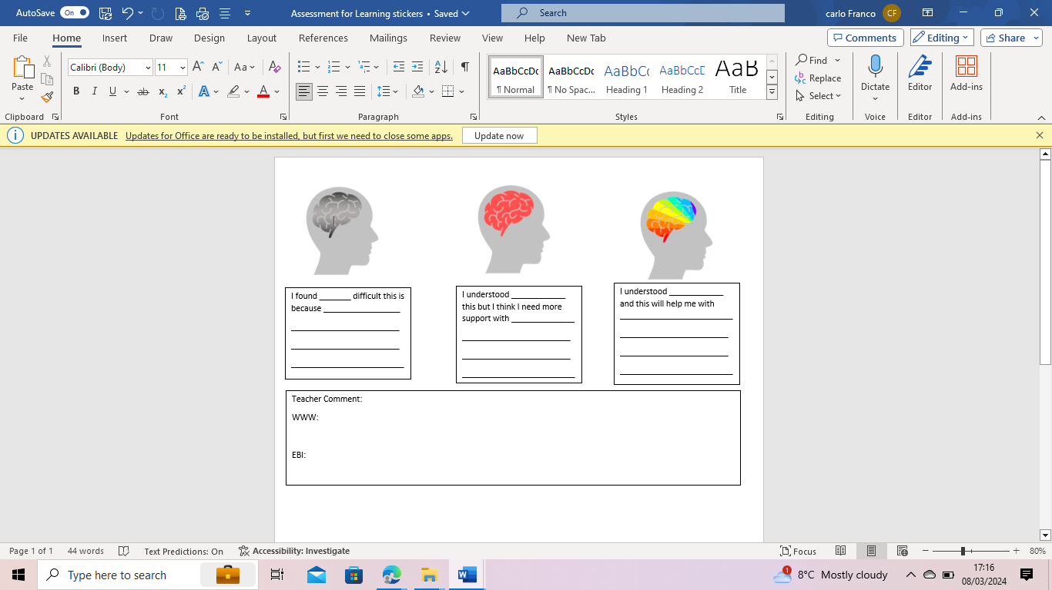

### Appendix 3

|  |  |  |  |  |
| --- | --- | --- | --- | --- |
| **Symbols used for marking** | | **Purpose** | **Teacher** | Learner |
| **Sp** | Spelling Mistake | Draws attention to a word which has been misspelled. | The teacher may highlight the misspelled word by underlining it; older learners are encouraged to work out which word is misspelled for themselves. | The learner responds by writing the correct spelling above the word. |
| **Hw** | Handwriting | Indicates that the learner could improve their presentation by practising a particular letter or handwriting join. | The teacher highlights the incorrect letter or join and models it at the end of the learner's piece of work. | The learner responds showing improvement in the following piece of work |
| **P** | Punctuation | This symbol highlights a problem with incorrect/missing punctuation and prompts the learner to make corrections. The symbol can also be used to indicate a problem with capital letters used for proper nouns (e.g. "derbyshire") or at the beginning of sentences and speech. | The teacher may highlight the problem area either by following the P symbol with the piece of punctuation which is missing, or may underline/circle the problem area. This is dependent on the learner's ability to spot and correct the error independently. | The learner responds by inserting the correct punctuation mark or correcting the capital letter. |
| **//** | A new paragraph is needed | This symbol shows the learner that a new paragraph should have started somewhere on the line where the symbol is placed. | The teacher highlights new paragraphs can begin when the subject of the writing changes, to show that the following events happen at a different time/place, or (when writing dialogue) to show that a different character is speaking. | The learner responds by writing a paragraph symbol // at the point where a new paragraph should have started. |
| **T** | There is a mistake in tense | This symbol shows that the tense (i.e. past, present or future) in a piece of writing has changed inappropriately. This often happens when a learner gets caught up in their writing and perceives the events happening as they write about them. | The teacher may highlight the incorrect verb to help the learner see where the problem is. Often in learner's writing, the incorrect tense then carries on through the remainder of the text. The teacher may only highlight the first instance to draw the learner's attention to this problem. | The learner responds by writing the correct verb above the incorrect one. |
| **H** | **A Homophone is incorrect** | Indicates that the learner has used an incorrect homophone. Homophones are words which sound the same (or nearly the same) as other words with different meanings and spellings, e.g. their, they're and there; where, wear, were and we're; new and knew, etc. | The teacher may highlight the incorrect homophone depending on the age and ability of the learner. Older or more-able learner are encouraged to spot the incorrect homophone for themselves. | The learner responds by writing the correct word above the incorrect one. |
|  |  | The 'person' in a piece of writing has changed inappropriately, e.g. a piece of writing in the third person has suddenly switched to the first person. This often happens when a learner gets caught up in their writing and perceives the events from their own point of view, as if they were a character, e.g. "He drew his sword and slashed at the dragon. The dragon roared, and I ran away." | The teacher may highlight the incorrect pronoun to help the learner see where the problem is. Often in learner's writing, the incorrect pronoun then carries on through the remainder of the text. The teacher may only highlight the first instance to draw the learner's attention to this problem. | The learner responds by writing the correct pronoun above the incorrect one. |
| **SxV** | **The subject and verb do not agree** | This is a tricky error - and it happens largely because of our great local dialect! Shape smiley    In writing, the subject of a sentence should agree with the form of the verb used, e.g. "The people were happy." Learner may sometimes write: "The people was happy." In this case, the subject of the sentence (the people) is plural, so we have to use 'were' not 'was'. | Depending on the learner's age/ability, the teacher may highlight the incorrect verb form to help the learner see where the problem is. | The learner responds by writing the correct form of the verb above the incorrect one. |
| **J** | **What you have done well** | The smiley is followed by a short comment or a list of things which the learner has done well in a particular piece of work. |  | The learner has the option of feeding back to the teacher with their own comments after the smiley. |
| **é** | **What you need to do to aim higher** | This symbol is followed by a short comment or a list of things which the learner could do to improve and move forward. Sometimes, this symbol provides an additional challenge task, or a task which allows the learner to practise/reinforce a particular skill. |  | The learner has the opportunity to respond either with their own comment, or to complete the extension/practice task set. |
| **WALTü** |  | Indicates that the learner has achieved a particular WALT in the piece of work.    WALT symbol is used at the end of the learner's work. In KS2, the learner writes their learning objectives at the top of most pieces of work (or they are printed on) and they are then ticked if they have been achieved. |  | The learner has the opportunity to respond by commenting on their learning - or asking for further help - at the end of the piece of work. |
| **VF** | **Verbal feedback has been given** | Indicates that the learner has received verbal feedback for this particular piece of work.    Sometimes - especially when the learner has been coached by their teacher - they may receive this symbol instead of (or in addition to) written feedback. |  | The learner may respond by writing their own comment at the end of the piece of work. |
| **1 Exc** | **An Excellence point has been awarded** | The learner has received an excellence point for this piece of work.  Excellence Points are one of the ways in which we celebrate our learner's successes. Learner's hard-earned Achieve Points are collected at the end of each week. Every Monday, in our awards assembly, the learner find out who has earned the most for the week. |  |  |
| **WS** | **You completed this with support** | Indicates that the learner had support while completing this piece of work. This support could be provided by a teacher or learning support. |  | The learner may write this symbol themselves, or it may be written by a member of staff. |