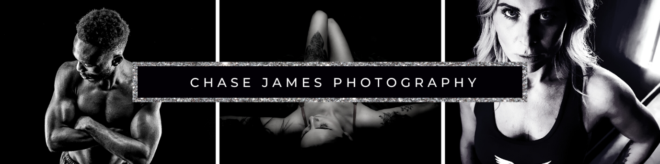
Boudoir Photography Consultation Form
Thank you for choosing Chase James for your boudoir photography session! Please take a few minutes to fill out this form so that we can tailor the experience to your preferences.
Client Information:
- Full Name:
  - First Name:
  - Last Name:
- Contact Information:
  - Phone:
  - Email:
- Address:
  - Street:
  - City:
  - Post Code:
- Preferred Method of Contact:
  - Phone
  - Email
  - Other (please specify):
Session Details:
- Preferred Session Date and Time:
  - Date:
  - Time:

- Location:
  - At Home :
  - Privately Booked Location (We can choose a location):
- Duration of Session: (Please specify)
  - 1 Hour
  - 2 Hours
  - 4 Hours
Photography Style:
- Preferred Style:
  - Classic
  - Glamorous
  - Romantic
  - Spicy
- Wardrobe Preferences:
  - Lingerie
  - Bodysuits
  - Robes
  - Casual wear
  - Other (please specify):
- Specific Poses or Themes You Have in Mind:

Comfort and Boundaries:
- Comfort Level:
  - Semi-revealing (Standard Boudoir)
  - Artistic nudity
  - Explicit nudity
- Areas of the Body You Want to Highlight or Avoid:

- Any Special Requests or Concerns:

Additional Information:
- How Did You Hear About Us?
  - Referral
  - Online Search
  - Social Media (specify platform)
  - Other (please specify):
- Is this session a gift?
  - Yes
  - No
- Would you be comfortable with sharing some of the photos for promotional purposes (with your identity protected if preferred)?
  - Yes
  - No
  - Discuss during the session
Agreement and Consent:
I, _________________, have provided accurate information in this form and understand that Chase James will use this information to plan and execute my boudoir photography session. I agree to adhere to the terms and conditions outlined by Chase James
Signature: ______________________ Date: ________________
Thank you for choosing Chase James! We look forward to capturing beautiful moments with you.

