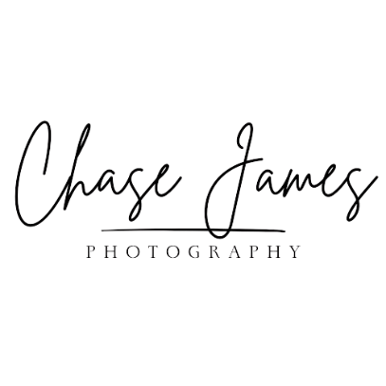
Paid Model Sign Up
Personal Details
Name –
D.O.B –
Age –
Phone Number –
Email Address –

Statistics
Height –
Dress Size –
Shoe Size –
Bust Size –
Cup Size –

Shoot Styles (What you wish to work up to – higher pay rates the more you do)
Boudoir –
Anonymous Nude –
Artistic Nude –
Adult Work –

Shoot Availability
Weekdays –
Weekends –
Days –
Nights –
Any days/times not available –

Consent
I hereby consent that my image rights are waived in favour of the commissioner of the photoshoot. I’m aware that these images may be used for marketing or advertising purposes. The commissioner will allow 5 photos to be sole rights to the model.

_________________________________________________________ (Sign Here)
_________________________________________________________ (Date Here)

Profile
Chase James is starting to profile their models. Would you like to be featured and have a profile created? This will allow easy access for commissioners to browse models. Chase James will request photos to build your profile.

(Yes) ___________
(No) ___________

All information shared between the model, photographer and commissioner are kept confidential.
Chase James is a registered member of the ICO. An authority on the protection and handling of sensitive information/content.

