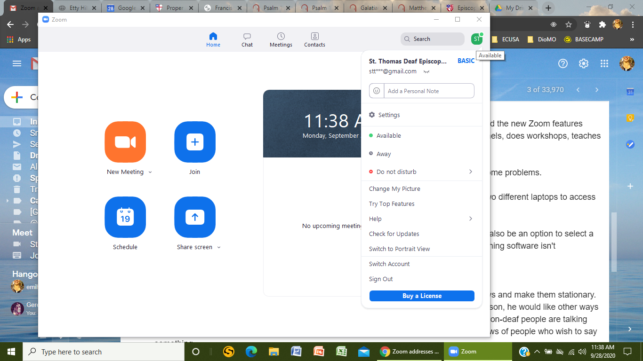

**2. Click here to find updates.**

**1. Click here for Menu to drop down.**

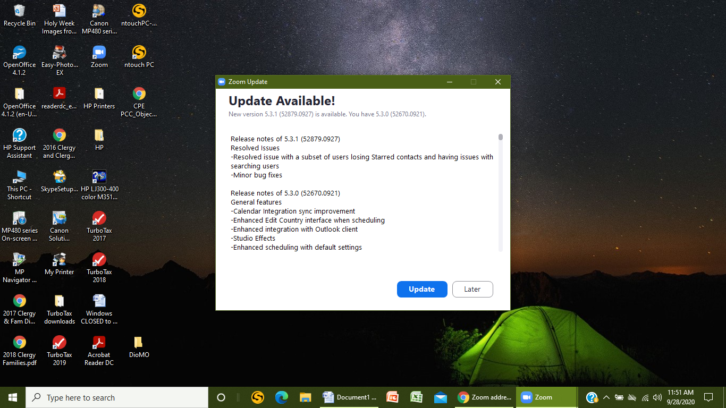

**3. Click here to a download updates.**

