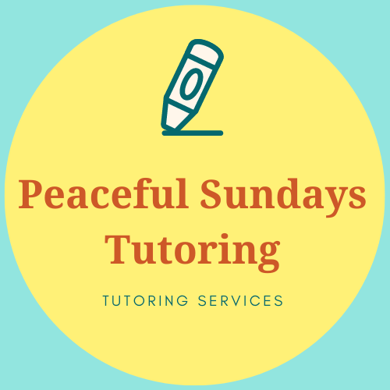

**Terms and Conditions for Peaceful Sundays Tutoring**

**Sessions**

Sessions at Peaceful Sundays Tutoring will be one hour long and are designed to complement what is being learnt in school or to prepare for exams.

You have paid for 1 hour of tutoring for your child which starts when I enter your door/ start the online call. I am happy to give feedback regarding sessions. If this is required, I will halt sessions ten minutes before the end in order to give you feedback.

**Client Obligations**

It is important for you to provide a quiet place for your child to work, free from interruptions and with access to suitable equipment. Sessions will begin promptly at the agreed time for the agreed duration. A link to the meeting will be emailed prior to the start time (if online).

Although I will bring a whiteboard and pens to each session it is a good idea for your child to have the following to hand:

* Something to write with
* Paper - squared for maths and lined for English. It might be a good idea to keep these compiled in a folder or exercise book
* If the session is online then a suitable device will be needed

**Payment**

The fees will be calculated at a rate agreed in advance between the Tutor and the Client on a per session basis and based upon the agreed arrangements. Payment must be made before the first lesson starts within the stated timeframe.

After the first session, all lessons need to be paid up front on a 4 or 6 -weekly basis, as agreed with the tutor beforehand.

We are a cashless business and take payment through PayPal and bank transfer.

**Cancellation Policy**

Unfortunately, as a small business, there will be no refunds given in the case of illness as your child’s place will be reserved.

**Safeguarding**

I have a DBS and am a member of the DBS Update Service.

I will never contact your child outside of sessions and the pupil must not make contact either, you are the conduit between myself and your child.

During lessons, you are welcome to be in the vicinity of the session.

**By Sending your child to their first session with Peaceful Sundays Tutoring you are accepting these terms and conditions.**