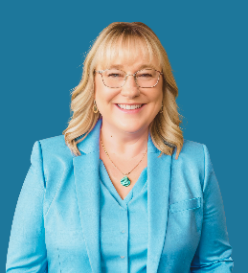  Sara Daniel, MSW, LCSW  Sara Daniel, LCW, MSW, is the Founder and Executive Director of Daniel Educational Services. For over 25 years, she has facilitated transformational change, specializing in supporting schools and child-serving organizations to achieve successful outcomes for all students, including those impacted by trauma and mental health challenges. Sara has worked with school districts, early care education centers, and child-serving organizations nationwide and has trained thousands of professionals in implementing Well-Being for All, Trauma-Sensitive Schools, and Workforce Resilience and Well-Being initiatives.  Sara previously served as Vice President of Education for a large child welfare and human services organization and as an administrator for a Milwaukee public charter school. She has been a senior coach and consultant for the Wisconsin Department of Public Instruction Trauma-Sensitive School Initiative and is the co-author of the Trauma-Sensitive Schools Learning Module Series. Using her instructional design expertise, she has developed numerous training curricula, including five distinct train-the-trainer certification programs.  Sara is a certified clinician and trainer in Dr. Bruce Perry’s Neurosequential Model of Therapeutics (NMT) and Neurosequential Model of Education (NME). She also led the Adverse Childhood Experience (ACE) Interface Master Trainer Project for the state of Wisconsin (2014–2019), promoting public education on ACEs and fostering self-healing communities. | 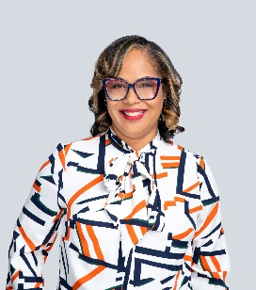  Kanisha Curry, MS  Kanisha is the Director of Organization Development and Culture for the Boys and Girls Club of Greater Milwaukee.  She is also a former special education teacher from Milwaukee Public Schools district serving students with significant social-emotional learning challenges. There she was named Teacher of the Year by the Metropolitan Alliance of Black School Educators.  Kanisha is a former leader at Wellpoint Care Network where she worked with many school districts on school-wide transformation in trauma sensitive schools. She has also worked in the staffing industry creating and implementing training and was responsible for the development of staff in areas of diversity and cultural competency.  Kanisha is a leader in advancing organizational change through trauma informed care, diversity, equity, and inclusion. She specializes in holding intentional space for crucial conversations and work that is needed guide people and organizations through the change process.  Kanisha has a Master’s Degree in Administrative & Instructional Leadership from the University of Wisconsin-Milwaukee and is certified in Human Resources Management and Instructional Design.    Kanisha is the founder of Kaykenal, Inc.
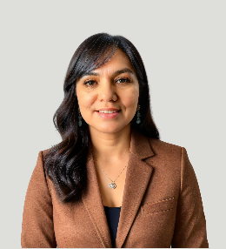  Yimma Davila Castro  Yimma is currently the Early Childhood Education Manager for Milwaukee Succeeds and has over nine years of direct experience in early childhood education as an owner and lead teacher of a family childcare center called Yimma's Bright Beginnings Daycare LLC. Through her leadership and commitment to excellence, this organization earned a 5-star rating from Youngstar, in recognition of its effective and high-quality programming. Yimma has extensive experience in early childhood education and is skilled in best practices, organizational management, staff development, training, and leadership.  Yimma moved to Milwaukee, WI from Tepechitlán, Zacatecas México in 2000. Her lived experience as an immigrant to the United States helps her to understand and empathize with the experiences of other Hispanic early childhood educators. This allows her to effectively engage in providing support and advocacy on behalf of this population. She is a trusted messenger who can connect and network with others easily to provide resources and support.  Yimma provides bilingual, Registry approved training to Early Childhood Educators. Topics include mental health and well-being, professional development, organization tools, policies, and contracts. She is the co-author of a curriculum called “Well-being for Early Childhood” which helps early childhood educators to understand stress and trauma in adults and children and provides strategies to respond effectively. This curriculum is currently being used to certify other trainers in Wisconsin.    Yimma graduated from MATC with an Early Childhood Education Associate Degree and is currently enrolled at UW-Whitewater pursuing an ECE Bachelor's Degree. Yimma is the Owner of Bright Translation and Consultation. |  |   Diana Billstrom  Diana, a dynamic Family Learning and Community Engagement Director, is renowned for driving positive change with a specific focus on addressing challenges experienced by communities facing systemic disparities. Born and raised in Mexico, Diana brings a unique perspective to her role. Through strategic engagement, cultural sensitivity, and a genuine passion for community service, she has become a respected advocate for creating a supportive environment for families within the community.  Her empathetic leadership style and commitment to measurable impact have led to the successful implementation of family programs that not only strengthen family relationships but also the community. Diana actively collaborates with stakeholders, organizations, and community members to create opportunities for Early Childhood Education leaving a lasting and wonderful impact on the lives of these individuals. Diana has extensive experience in supporting parents of children from infancy to adolescence. She has direct experience both in her former role as Data and Program Manager of HIPPY (Home Instruction for Parents of Preschool Youngsters) and her current role at Bay View community Center.  She has facilitated workshops on positive parenting, social emotional learning, healthy brain development, and coping with stress and emotions. She is certified in Nurturing Parenting, Be Strong Families Cafés, Mind in the Making and Wisconsin Breastfeeding Friendly Childcare Provider professional development programs. She also works directly with adolescents providing support on building healthy relationships, setting boundaries and self-care. She is the co-author of a curriculum called “Well-being for Early Childhood” which helps early childhood educators to understand stress and trauma in adults and children and provides strategies to respond effectively. This curriculum is currently being used to certify other trainers in Wisconsin. Diana has earned a Technical Degree in Commerce with a specialization in Business from the Universidad Tecnológica de Aguascalientes.

