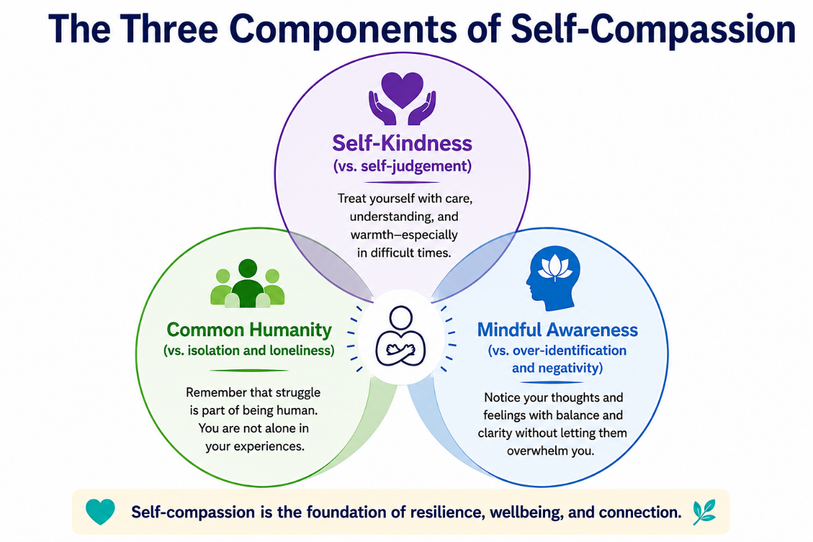
Self-Compassion Plan

Intention
Why do I want to practice self-compassion?

What is one area of my life where I want to be more compassionate with myself?

What would be different if I treated myself with more kindness?

Choose any or all of the options below to be part of your self-compassion plan.
Self-Kindness:
Being gentle and kind with myself, even during hard moments

☐ I will demonstrate using kind words to myself.
Examples

- I’ve got this. | - I am proud of myself.
- I can figure this out. | - I am smart.
- I look good today. | - I did awesome.

When I notice I'm being hard on myself, I will remind myself:
"My self-compassion statement:"

“____________________________________________________________”

When I am struggling, I will try to:
☐ Speak to myself with kindness.
- I've got this.
- This is hard, and I can get through it.
- I don't have to be perfect.
- I can learn from this.
- I am doing the best I can right now.

☐ Allow mistakes without shame:
- Mistakes help me grow.
- I don't have to have all the answers.
- I can learn without criticizing myself.
- What do I need right now?
Common Humanity:
Remembering that struggle is a normal part of being human.

☐ Offer myself comfort before criticism.

To remind myself that I am not alone, I will:
☐ Remember that everyone has difficult times.
☐ Normalize stress, mistakes, and difficult emotions:
Sample statements
- Everyone has difficult days.
- I am not alone.
- Growth comes through challenges.
- Being imperfect makes me human.
☐ Avoid shame, comparison, or isolation:
A helpful reminder statement for me:
“_____________________________________________________________”

Mindfulness
Noticing thoughts and feelings without judgement
☐To help me notice my feelings, I will do a self check-in. ___________________ times

per day. This will occur (during mealtimes, bedtime): __________________________

When emotions run high, we will try to:
☐ Pause before reacting
☐ Name the feeling(s)
☐ Take a few slow breaths
☐ Listen to my thoughts without fixing or problem solving.

Repair After Difficult Moments

After I make a mistake or experience a setback, I will:
☐ Pause and regulate
☐ Acknowledge my feelings
☐ Take responsibility when needed

☐ Remember that I did the best that I could at the time
☐ Practice self-forgiveness

My personal repair plan: ____________________________________
___________________________________________________________________

My Personal Self-Compassion Supports
What helps me be compassionate toward myself?
___________________________________________________________________
What makes it harder?
___________________________________________________________________
My warning signs that I need more self-compassion
☐ I'm criticizing myself.
☐ I'm feeling overwhelmed.
☐ I'm comparing myself to others.
☐ I'm feeling ashamed.
☐ I'm withdrawing from others.
☐ Other:

My go-to self-compassion strategies
☐ Positive self-talk
☐ Deep breathing
☐ Mindfulness
☐ Movement
☐ Taking a break
☐ Journaling
☐ Talking with someone I trust
☐ Spending time in nature
☐ Listening to music
☐ Other:

My Personal Self-Compassion Commitment
When I experience difficult moments, I will strive to treat myself with the same kindness, understanding, and patience that I would offer someone I care about. I will remember that struggle is part of being human, notice my feelings without judgment, and choose actions that support my wellbeing.

___________________________________________________________________ Signature

___________________________________________________________________
Date

