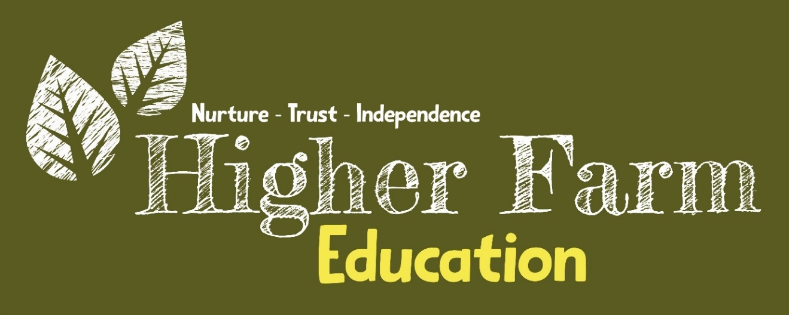

Curriculum
Policy

Written by: | Rob Stevenson | Date: December 2024
Last reviewed on: | New
Approved by: | A.Powell
Next review due by: | December 2025

Aims
Our curriculum is designed to ensure that learners receive a variety of opportunities in provision; with a clear focus on practical ‘hands on’ learning to allow them to be successful in a City and Guilds qualification up to Level 3. This will be supported by functional skills where required, personal progress units, employability units and activities to promote social interaction and well being.
Intent
At Higher Farm Education, we recognise that traditional education does not work for everyone. Many young people can feel disconnected, lacking confidence, and worrying that "school is not for them." This often leads to disengagement, which can be made worse by unmet social and emotional needs, hindering both progress and happiness.
Our curriculum is designed to offer a dynamic, practical, and hands-on experience, tailored to each individual learner. It is built on trust, with an emphasis on developing strong, meaningful relationships that foster engagement. We have high expectations for every learner, regardless of their background, circumstance, or need. We nurture a culture of inclusion, based on the belief that every day is a fresh start—each learner has the opportunity to reset and grow.
Inspired by the stunning panoramic setting of our farm, our curriculum is guided by our principles of human ecotherapy. The presence of our equine and farm animals provides a safe, therapeutic, and uplifting environment that supports both learning and emotional well-being. Here, learning includes the social and emotional skills necessary for a successful transition to adulthood. By being part of a community, learners collaborate and grow together.
Higher Farm Education empowers each learner to strive for independence and employability. Through practical vocational qualifications, functional skills development, and a robust pastoral support system, we help them build a strong sense of achievement and success. Our curriculum lays the foundation for learners to aspire to ambitious futures, equipping them with the tools to pursue meaningful careers and lead fulfilling lives.
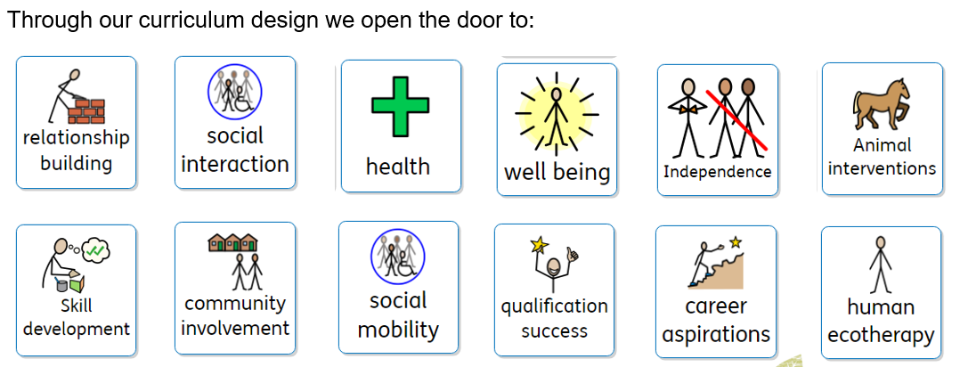

Implementation
At Higher Farm, we implement our curriculum through a structured and supportive process that begins with a smooth transition and induction phase. During this period, each learner is introduced to the unique farm environment, enabling them to settle into their new learning setting. This is key to building trust and creating a foundation for future success.
We start by gathering baseline information to develop a detailed learner profile. This profile captures each learner’s strengths, needs, and aspirations, forming the basis for their bespoke individual development plan. These plans are personalised, setting clear targets and activities that are designed to meet the learner’s academic, social, and emotional needs.
Inclusive practices are central to our approach, ensuring that all learners, whether working individually or in small groups, receive tailored support and assessment. This inclusive framework helps foster engagement, enabling every learner to work at their own pace while progressing toward their goals.
Our curriculum is designed to be practical and relevant, ensuring that activities and lessons are connected to real-life career pathways. By engaging in tasks rooted in real-life experiences, learners not only strengthen their functional skills but also gain a clearer understanding of potential career options, helping them prepare for further education, employment, and greater independence.
This holistic approach ensures that each learner at Higher Farm is actively engaged in meaningful, hands-on learning activities. By supporting learners to meet their personal goals and achieve their EHCP outcomes, we create a pathway toward successful completion of vocational qualifications, personal growth, and the confidence to transition into adulthood and the working world.
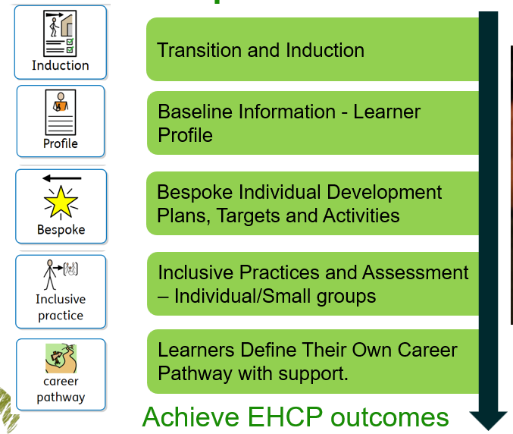
Impact
The impact of the curriculum at Higher Farm Education is demonstrated through its ability to empower learners to develop meaningful relationships, overcome barriers, and contribute positively to their learning community. By focusing on individualised learning and practical hands-on experiences, learners build the confidence and skills they need to reach their full potential and flourish in both academic and real-life contexts.
Our curriculum improves learner outcomes by encouraging (re-)engagement and motivation towards learning. Learners who may have previously disengaged from education are reconnected to the learning process, gaining the drive and enthusiasm to succeed. Through bespoke support and an inclusive approach, we help learners overcome challenges and remove barriers that may have limited their progress in the past.
At Higher Farm, the development of strong relationships between learners, staff, and other professionals is key. These relationships, built on trust and mutual respect, create a positive learning environment where everyone is supported and valued. As learners grow, they make meaningful contributions to both their own success and the success of the wider community.
Our curriculum also promotes social mobility by focusing on developing essential life skills, communication skills, and fostering greater independence. Learners leave Higher Farm equipped not only with vocational qualifications but also with the skills needed for adult life. This enhances their ability to transition into further education, employment, or independent living.
Ultimately, our curriculum delivers improved outcomes, stronger relationships, and enhanced life skills, empowering learners to take control of their future and contribute positively to their families and community. Higher Farm Education creates an environment where learners are not just taught—they are supported in growing into independent, confident individuals who make a real impact in their own lives and the world around them.
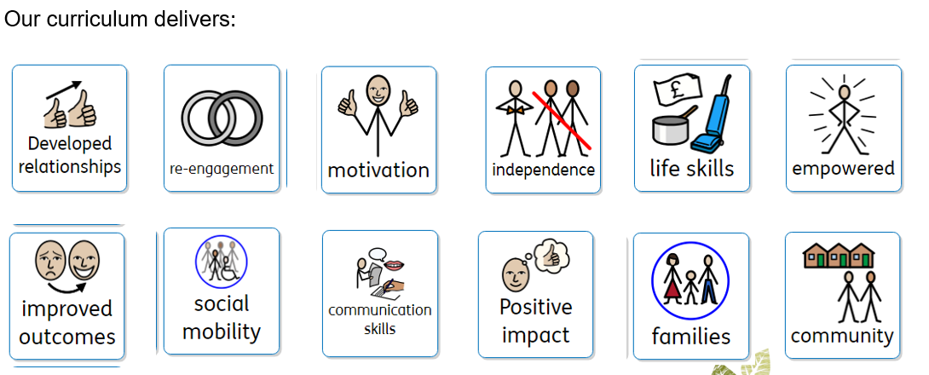

Monitoring
This policy will be reviewed annually and updated as deemed necessary.

