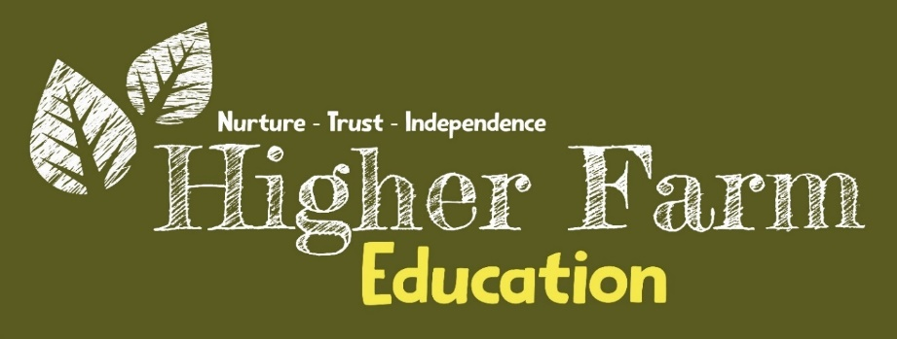
PHOTOGRAPH AND VIDEO CONSENT FORM
Data protection rules came into force in 2018. To ensure that educational provisions are meeting the new requirements, we need to re-seek your consent to take and use photographs, short films and video images of your child.
At Higher Farm Education we take all matters relating to child safety very seriously. This includes the use of images of learners. Photographs and videos can be motivating for the learners involved, provide a good opportunity to promote the work of the provision and are invaluable tools for professional training. However, provisions have a duty of care towards learners, which means that learners must remain unidentifiable, reducing the risk of possible inappropriate contact.
Higher Farm Education follows these rules:
- Where media can be accessed externally, for example the provision website, newsletters and social media pages:
- if the learner is named, we avoid using their photograph; and
- if their photograph is used, we avoid naming the learner.

- Where showcasing examples of learner’s work with accompanying photographs around the provision, we will use only a learner’s first name.
- If showcasing video work to an external audience, we take care to ensure that learners aren't referred to by name on the video, and that learners’ full names aren't given in any credits at the end of the film.
- We would only ever use images of learners in suitable dress.
- Staff are not allowed to take photographs or videos of learners on their personal equipment. Staff will use the provision’s digital equipment.
We would like your consent to take photographs, films and other digital images of your children and to use them in the sorts of ways described above. If you are not happy for us to do this, we will accommodate your preferences.
You may also change your mind at any time in the future by emailing – enquiries@higherfarmeducation.co.uk please ensure this email is acknowledged, calling the provision directly or coming in to speak to a member of the team.
Please mark YES or tick in the boxes where you are happy to give your consent.

PHOTOGRAPHS
I am happy for photos of my child to be used by the provision, examples of such use include: Yes No

- on the website
- on the provision’s social media
- in other children’s workbooks as evidence of a learning activity
- in the provision prospectus or staff manuals
- in promotional materials produced by the provision

I am happy for photos of my child to be displayed in the provision examples of such displays include: Yes No

- to showcase learners’ work and raise attainment standards
- to celebrate achievement
- to record an event
- to support the curriculum

VIDEOS

I am happy for the provision to take videos of my child, examples of such videos are: Yes No

- group films of activities or working with animals
- learning activities as an individual or in a group
- special events such as trips or visits
- I am happy for videos that include my child to be used by the provision; examples of such use include:
- on the website
- on the provision’s social media
- for internal professional training

I am happy for photographs of my child to appear in the local newspaper
Yes No

NAME OF CHILD___________________________________________

NAME OF PARENT OR GUARDIAN_______ ______________________

SIGNATURE OF PARENT OR GUARDIAN ________________________

DATE _________________________________

YOU MAY WITHDRAW YOUR CONSENT AT ANY TIME

If you change your mind on any of the options above, please contact the provision:
enquiries@higherfarmeducation.co.uk

Please note it may not be possible to remove images once published under previously given consent.

