4-Way Tea 5-Way Tea
Slippery Elm Bark | Marshmallow Leaf | Peppermint | Chamomile | Nettles
Colitis, IBS and Crohn’s disease | Digestive Issues | Stomach problems | Insomnia, stress and anxiety | Allergies
Constipation and chronic diarrhea | Respiratory Conditions | Respiratory problems/Asthma | Stomach problems | Respiratory Problems
Neutralizes excess stomach acid | Hacking cough | Allergies | Allergies | Arthritis
Sore throat | Sore throat | Stress and anxiety | ADD/ADHD | Anemia and fatigue
 | Pain |  | Diabetes | Pain and inflammation
** Information on the traditional uses and properties of herbs are provided for educational use only, and is not intended as medical advice. Every attempt has been made for accuracy, but none is guaranteed. Many traditional uses and properties of herbs have not been validated by the FDA. If you have any serious health concerns, you should always check with your health care practitioner before self-administering herbs. **
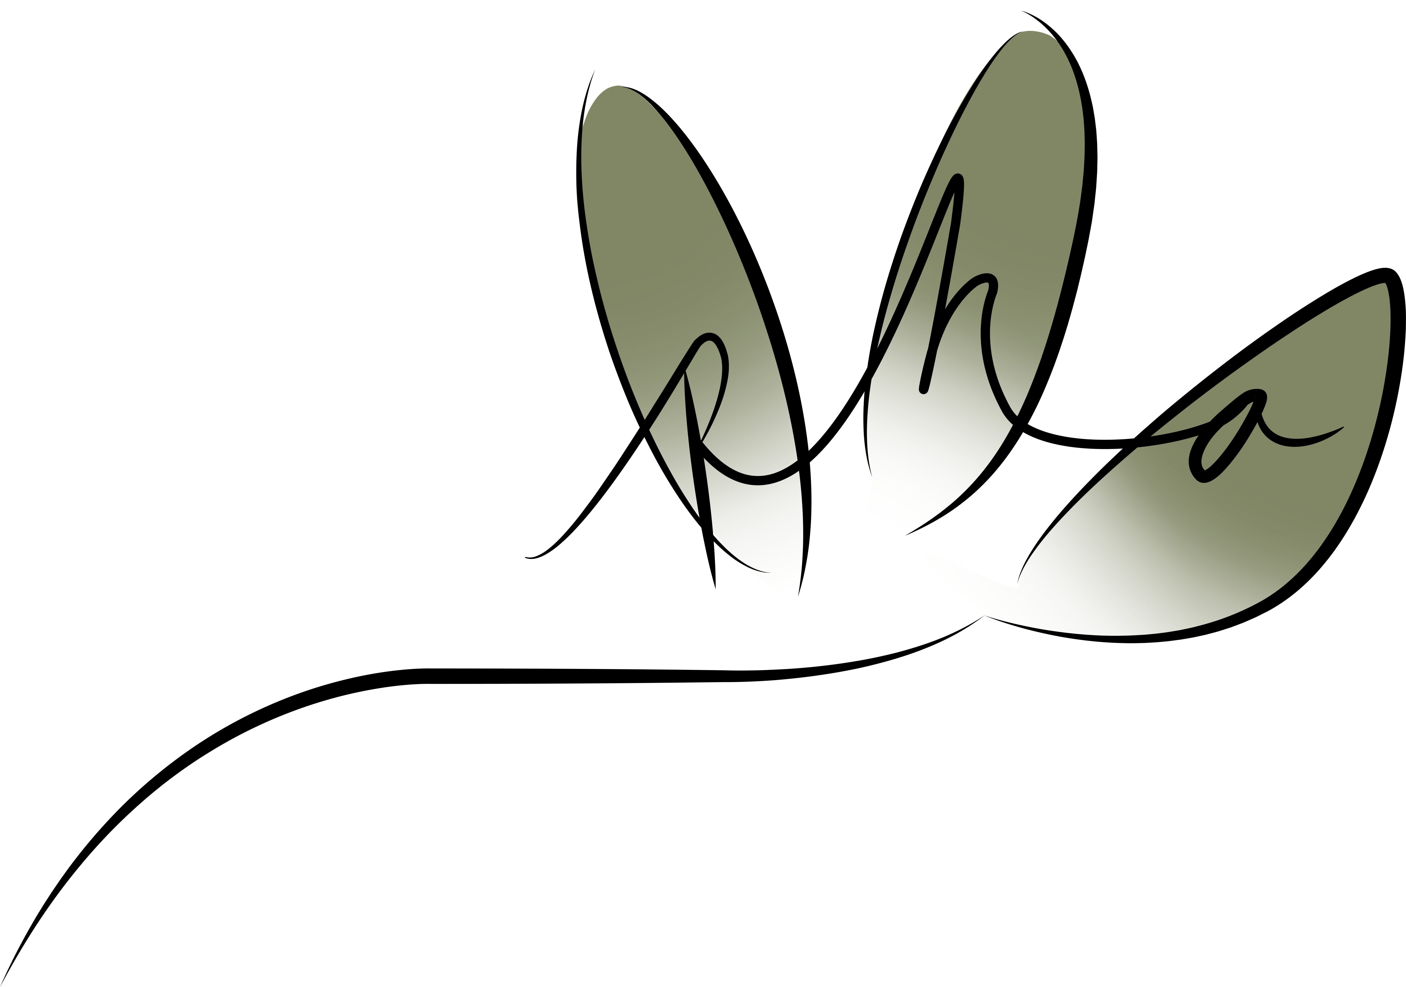Prime Herban Apothecary (909)732-0099

