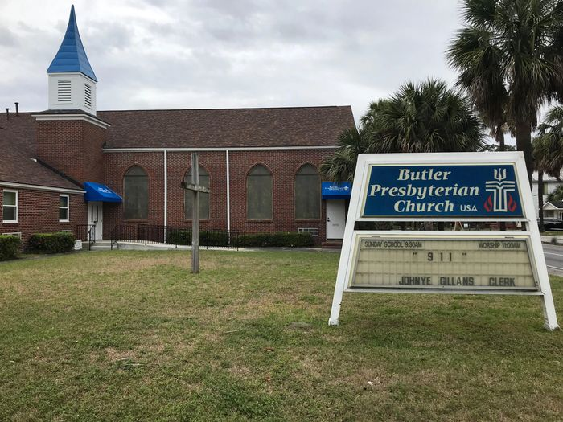
Join us in person, Easter Sunday, April 17th @ 11:00AM
Social distancing guidelines will be followed.
Please bring your mask and enter through the main Victory Drive Street entrance.
WE LOOK FORWARD TO SEEING YOU!

