YOU ARE INVITED TO
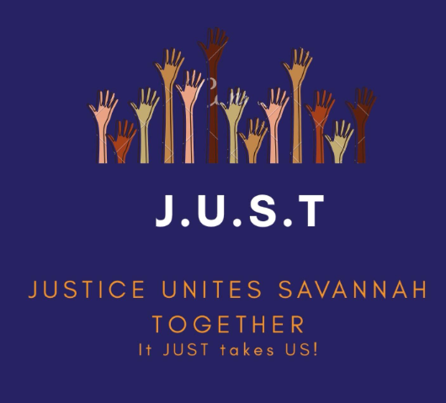

THE NEHEMIAH ACTION
MONDAY, MAY 2, 2022
Johnny Mercer Theater in the
Savannah Civic Center
Registration begins at 6:15 p.m.
Receive your free tickets from one of the many houses of worship who are taking a part in this for the Savannah Community.

Actions to be highlighted:
AFFORDABLE HOUSING
CASH BAIL ISSUES
J.U.S.T. Justice Unites Savannah Together
It Just Takes Us!
This organization is formed by many houses of worship in the Savannah Area based on Micah 6:8 to compel people to act in times of injustice:
“Do justice, love mercy and
walk humbly with God.” Micah 6:8
There are 21 religious denominations in this
organization. It is one body of the city to insure
justice, reconciliation and diversity. 1 Corinthians 12:14 states:
"For as the body is one and hath
many members, and all the members of that one body, being many, are one body;
so also is Christ.”
The group’s main goal is to take on social justice reform in the Savannah Area.
There is strength in numbers! We encourage you to attend the Nehemiah Action to show your support and people power for the social issues we face in Savannah.
Let your light shine to help and show someone that there is Hope. Make your voice heard.

