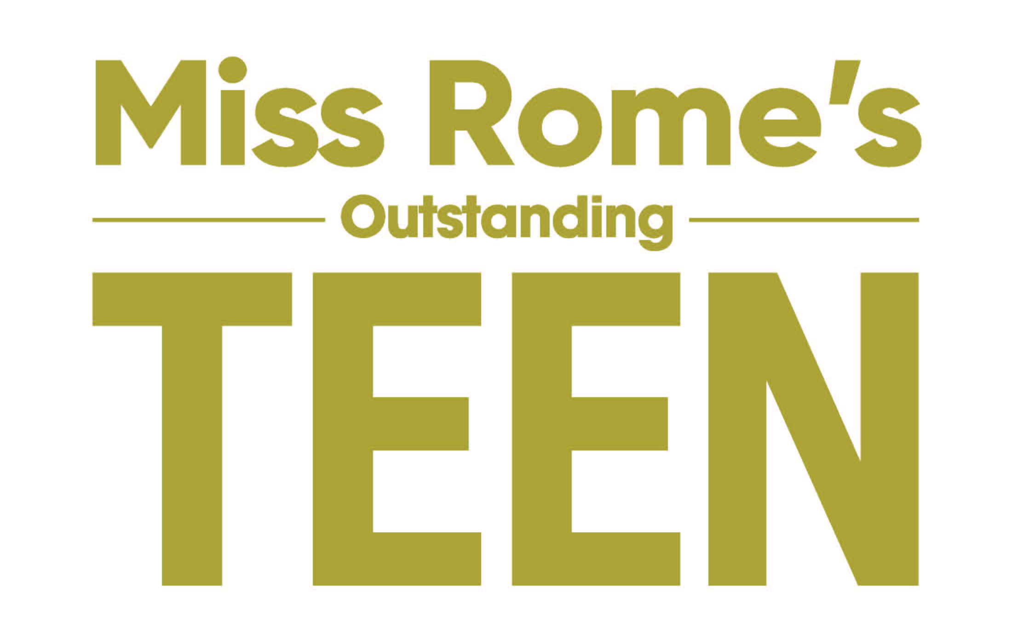
APPLICATION

NAME: _____________________________________________________
(as you wish it to appear in the newspaper, in the program, on social media)

HOME ADDRESS: _______________________________________________
TELEPHONE: (CELL) _______________________________________
E-MAIL ADDRESS__________________________________________
PARENT'S NAME______________________________________

SCHOOL NAME & YEAR IN SCHOOL:_______________________________

IF YOU HAVE NOT YET GRADUATED HIGH SCHOOL, ENTER THE DATE THAT YOU WILL GRADUATE FROM HIGH SHOOL: (for example, May 2023) _____________________________

DATE OF BIRTH:______________________________

TYPE OF TALENT_______________________________
(dance, vocal, etc.)

SOCIAL IMPACT INITIATIVE TITLE:____________________________________

EMAIL TO: Andrea Pitts, Executive Director
missromegacompetition@gmail.com

Other contact information:
Andrea Pitts, Executive Director
22 Saddle Mountain Road
Rome, GA 30161
(cell) 706-766-4887

