THE SIMPLE VIEW OF READING – A FORMULA FOR SUCCESS

Reading comprehension is the end goal of reading. The Simple View of Reading is a research- validated framework that indicates the two major components that are necessary to reach the end goal of reading comprehension: language comprehension and decoding. The formula was proposed by Gough and Tunmer in 1986 and serves as a broad reference to the complexity of reading and what is required for the assessment and teaching of reading. Nonetheless, many educators have not heard of the Simple View of Reading.

Being able to understand text, including the individual words and their meanings, requires a range of mental operations which all play a role in the Simple View of Reading. The Simple View of Reading formula that shows that reading comprehension is the product of strong decoding and strong language comprehension: D (Decoding) x LC (Language Comprehension) = RC (Reading Comprehension).



**What Exactly is Decoding?**  
The act of reading in its simplest form is the decoding of words. It is the ability to match sounds to symbols, to segment a word sound by sound, and then blend the sounds to form the word. To read fluently, readers need to be able to break the alphabetic code (sound-symbol correspondence) automatically.

**What Exactly is Language Comprehension?**  
Language comprehension is deriving meaning from spoken words when they are part of a sentence or other discourse. It is different from the skill of decoding because language is continuously learned over a lifetime and may never be fully mastered given the infinite number of words and phrases in English.

**What Exactly is Reading Comprehension?**  
Reading comprehension is deriving meaning from print. Comprehension is not a single skill. “It is a complex of higher-level mental processes that include thinking, reasoning, imagining, and interpreting” (Kahmi, 2007).

The Simple View of Reading is supported by scientific research. Understanding this formula and relationship helps educators by pinpointing where to target reading instruction and serves as a framework for helping students progress in reading based on assessment of students’ strengths and weaknesses in each domain: decoding and language comprehension.

Simply put, when students are unable to decode words to get the written word off the page, there will be no reading comprehension. When language is missing and students are unable to derive meaning from spoken words, there will be no reading comprehension. Students need to be able to understand the words (language comprehension) and decode the words (decoding) and if one of those components is weak, reading comprehension will be negatively impacted.

USING THE FORMULA FOR SUCCESS IN THE CLASSROOM

The Simple View of Reading formula has implications for evidence-based reading instruction in the classroom. Teaching reading aligned with the body of research that comprises the Science of Reading is critical to positively impacting student outcomes.

Consider a student who has strong decoding skills, but lacks background knowledge; will the student have strong reading comprehension? If a score of 0 means no skill or ability and 1 indicates very strong skill or ability, this student would have a 1 in decoding and 0 in language comprehension. The answer is no, reading comprehension will not be strong because 1 X 0 = 0.

What if a student has been exposed to language and has built background knowledge to have strong language comprehension ability, but lacks knowledge of letter sound correspondences necessary for decoding; would this student have strong reading comprehension? The answer is no, because 0 X 1 = 0.

Think about a student who can decode one-syllable words, but lacks phonemic awareness skills (i.e. the ability to identify and manipulate sounds), and has difficulty decoding multisyllabic words (0.5 for decoding). This student has some background knowledge of science topics, but needs to build background knowledge in other topic areas (0.5 for language comprehension). Would this student be able to understand a grade level story about the Solar System? The goal is D (1) x LC (1) = RC (1), but this student’s formula is 0.5 x 0.5 = 0.25. Therefore, this student would have a difficult time reading and understanding a grade level text about the Solar System because the product of decoding and language comprehension is only 25%.

Consider a student who has 0.80 in decoding and 0.80 in language comprehension, which according to some standards would be considered proficient at 80% in each. Would the student be able to comprehend a grade level text to answer questions to score at the proficient level for reading comprehension? The goal is D (1) x LC (1) = RC (1), but this student’s formula is 0.80 X 0.80 = 0.64. This student profile may be deceiving because even though each domain is higher, in reality, reading and understanding grade level text to score at the proficient level may be challenging for this student because the product of decoding and language comprehension is only 64%.

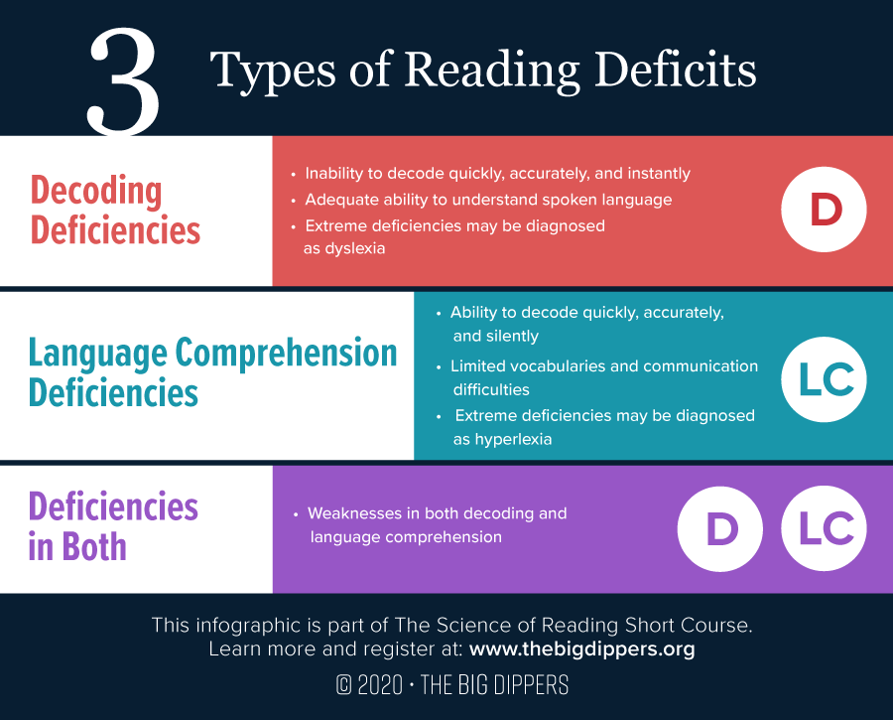

The Simple View of Reading is a research-validated formula that can lead to success. We must teach students to decode expertly as early as possible and provide students with strong content knowledge in many domains to develop adequate language comprehension abilities. The Simple View of Reading formula makes it clear that strong reading comprehension cannot occur unless both decoding skills and language comprehension abilities are strong. The tenets of [Structured Literacy](https://www.thebigdippers.org/general/science-of-reading-and-structured-literacy/), including systematic, cumulative, sequential, diagnostic, and explicit instruction are required by beginning and struggling readers in order to achieve their maximum reading potential. By applying an understanding of the Simple View of Reading, educators should be prompted to dig more deeply to determine the root problem hindering reading comprehension: decoding, language comprehension, or both.

Sources:

Gough, P. and Tunmer, W. (1986). Decoding, reading, and reading disability. Remedial and Special Education, 7, 6–10.

Kahmi, A. (2007). Knowledge deficits: The true crisis in education. [ASHA Leader](https://www.researchgate.net/journal/ASHA-Leader-1085-9586) 12(7):28-29 DOI:[10.1044/leader.FMP.12072007.28.](http://dx.doi.org/10.1044/leader.FMP.12072007.28)  
The Big Dippers Science of Reading Short Course. (2021, April 9). Module 2: Structured literacy. <https://www.thebigdippers.org/the-course/>

https://www.thebigdippers.org/general/the-simple-view-of-reading/#:~:text=The%20Simple%20View%20of%20Reading%20formula%20that%20shows%20that%20reading,is%20the%20decoding%20of%20words.