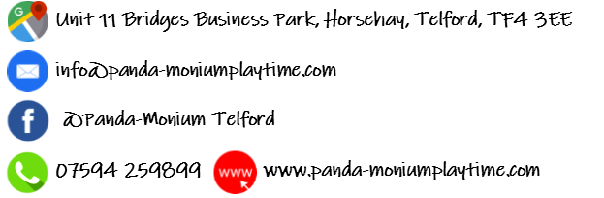
Party Hire Enquiry
Your Name
Your Phone Number
Your Email Address
Childs Name
Age of Birthday Child
Date/Time of Party
Party Type? | Playtime Party or GO Wild!
Expected Numbers
Food? | Hot and Cold Buffet?
Adult Platter?
Additional Comments
Please complete and send back to us at info@panda-moniumplaytime.com

