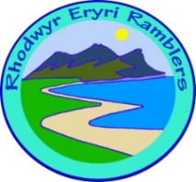 | Eryri walks – Risk Assessment / Register  Use for each walk to understand the risks and steps you need to take  to stay safe before leading a group walk. Keep for 3 weeks.

Leader: |  | Walk Title: | Walk Date: | Recce/Risk/Date
Possible hazards | Who's at risk? | Ways to control the risk |  | Checked
Transmission of COVID-19 through close contact / meeting other people | Walkers, members of the public – risk of spreading COVID-19 | Plan the walk and location for a less busy time and place |  | ◻
 |  | Travel: Consider car parking (car sharing not permitted), limited public transport and also limited availability of toilet facilities |  | ◻
 |  | Advise walkers to maintain physical distancing of 2metres from others – this is everyone’s responsibility |  | ◻
 |  | Check your 1st aid kit and carry a face covering, gloves and sanitiser in case of incidents |  | ◻

Register

 | Name | Phone (for NHS contact tracing)
1
2
3
4
5
6
7
8
9
10
11
12
13
14
15

By following these simple rules, we hope that members will be happy to join your walks in the knowledge that we are taking good care of them whist Covid 19 threat remains.
Note: We do not advise using the Ramblers App for the register- it is insecure and violates GPDR V3

