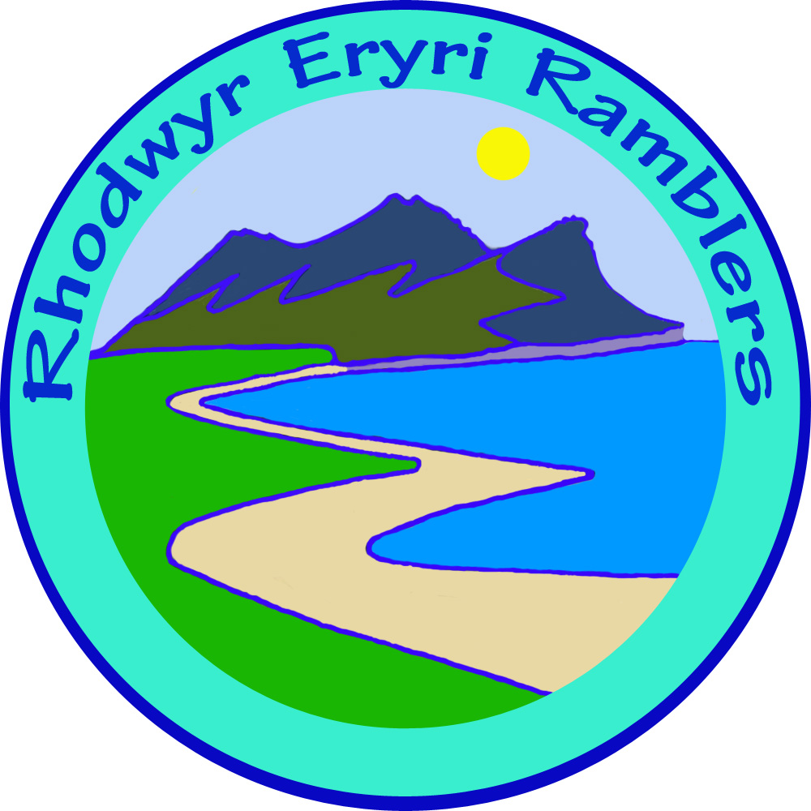 | ERYRI Ramblers  Walk Proposal | 2021 v4

Walk Title:
Leader
Date | 2021  Please post a note on Facebook near the time commenting upon the weather, feel free to notify a change of date if the weather is unsuitable.
Start time | 09:30 / 10:00 /
Brief description
Grade | A / B / C / D
Meeting place
Grid Reference | SH
Distance miles
Number of Walkers
Approximate duration | Please give approximate duration e.g., 4/5 hours, 5/6 hours etc.
Photo attached? | Please attach a .jpg photo representative of your walk.  If you don’t’ have a photo one off the web will do or your route,  or even your face!
Privacy - volunteer's personal contact details: HQ have agreed that it is not necessary to provide your personal phone number (a confidential list has been sent to members).

Dogs: N.W. Area Committee agreed that dogs are not allowed on walks except assistance dogs.

Please return to walkeryriramblers@gmail.com

