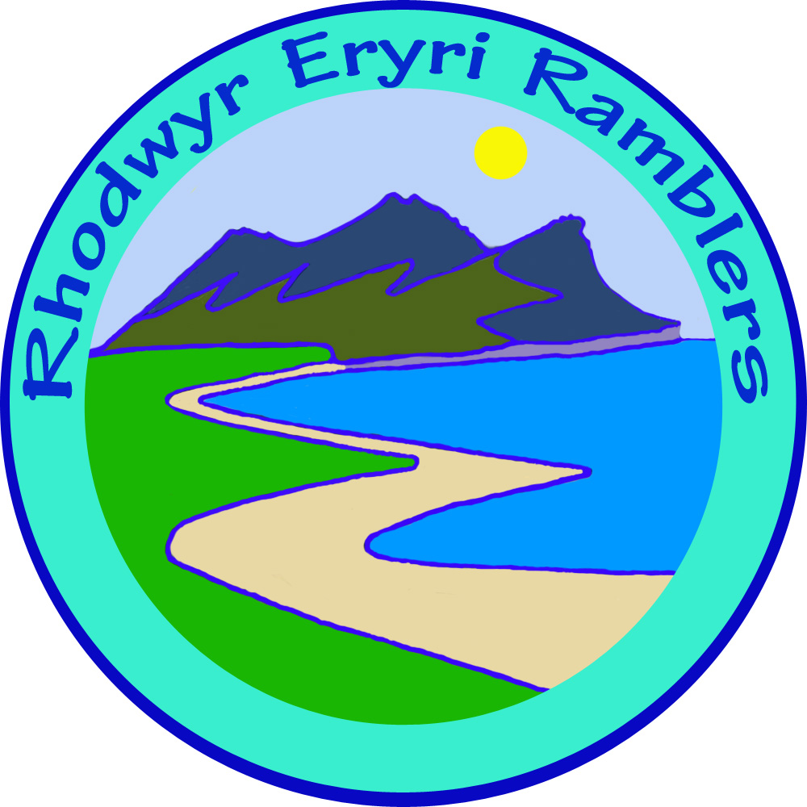 | ERYRI Ramblers  Walk Proposal | Spring 2021 v3  Jan - June 2021

Walk Title:
Leader
Phone No.  (## Please see privacy note below ##) | Yes / No / In Walks Book only / in Book and Website
Day and date of walk  (If you have an alternative date it would be helpful with the scheduling) | 2021  (Tim Taclo: please try to avoid Tuesdays)
Start time | 10:00 / 09:30 /
Brief description
Grade | A / B / C / D
Meeting place
Grid Reference | SH
Distance miles
Dogs permitted | No / Yes on short lead only
Screenshot / map of proposed route (optional)

Please return to roymilnes1@gmail.com or post to Heli, Aberdaron. Pwllheli, Gwynedd. LL53 8BP
Thank you. Roy

## Privacy - volunteer's personal contact details:
Your telephone number will be shared publicly on the world wide web. Because we at Eryri have made it easy for people to contact us via the website or Facebook, HQ have agreed it is not necessary for you to give out your personal phone number. Alternatively you can limit it to the Combined North Wales Walks Booklet. Please indicate your preference.

