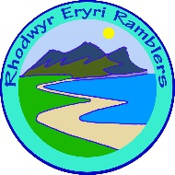 | ERYRI Ramblers  Walk Proposal | 2026

Leader
Walk Title
Grade | A+ Technical / A Strenuous / B+ Strenuous / B Moderate / C+ Moderate / C Leisurely / D Easy
Distance | Miles/km
Approx No. hours
Date | 2026
Start time | 09:30 / 10:00 / 10:30
Starting place:  Grid Ref:  Postcode:  /// W3W: | SH | I can find Postcode and W3W refs if you don’t have them – BUT providing them helps me!
Height climbed | Feet / Metres
Number | Including Leader
Description
Photo attached? | Please attach a photo if you don’t have one no problem, I’ll find one off the web
A day or two beforehand, please send an advisory email to all participants to inform them about conditions and to aid car sharing.

Text version for phones/tablets:-

Title:
Grade:
Distance:
Hours:
Date:
Time:
Starting place:
No. Walkers:
Description:
Height:
Photo?

Please return to -matt.nobles@protonmail.ch Thanks Matt 07941 803687

