Trombone Warm-Up 2018

Dr. Natalie Mannix
Trombone Professor, University of North Texas
Natalie.mannix@unt.edu

The Warm-Up

- Not just for warming up – for maintaining your fundamentals. The most important part of your daily routine. It can vary in length, but should incorporate all aspects of your playing to set yourself up for the rest of the day. How you play the first 10 minutes of the day, is how you’ll play the rest of the day.

- Reinforces good habits (slide technique, posture, embouchure, air and intonation), so they become second nature.

- Prevents injury.

- Gets your mind involved in the physical practice.

Keep a tuner and a mirror in front of you. Work on good pitch and correct embouchure while warming up. This will set you up with good habits for the rest of the day.

- Breathing

Air is everything. Good use of air takes pressure off the lips which improves sound and keeps chops healthy.

Tension is the brass player’s worst enemy. Breathe with a relaxed body and no pause between inhale and exhale.

Project air past the instrument, not to the mouthpiece.
Do the following air exercise by projecting air through the instrument without producing a sound.

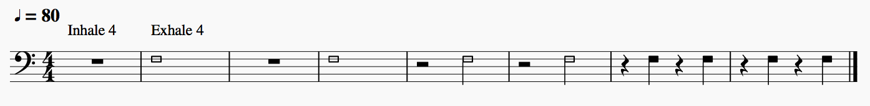

- Sound

You are only as good as your sound is, on every note, in every register.

Start with a perfect sound concept in your head. If you don’t have one, listen to enough recordings until you can hear it. Then try to imitate it on every note. Always play warm up exercises with good intonation, breathing and slide technique.

Connecting registers
Start with the middle register and work your way out. Glissando half notes, no tongue.

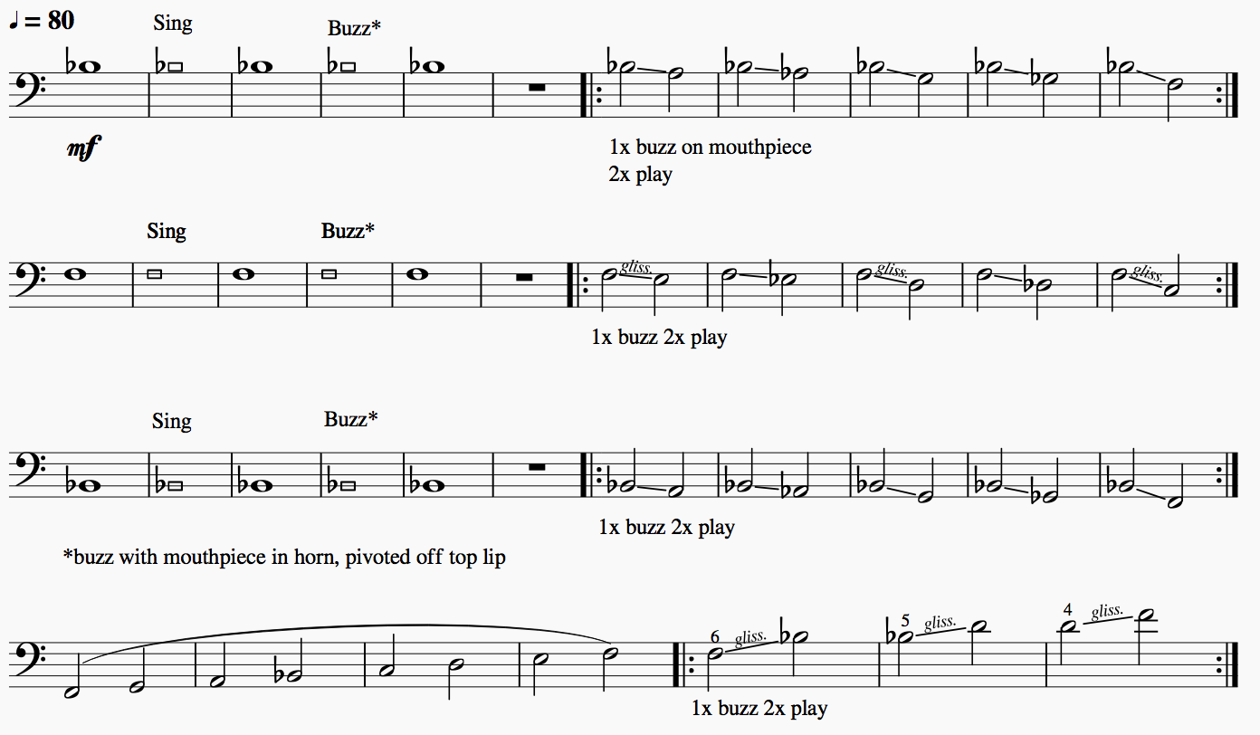
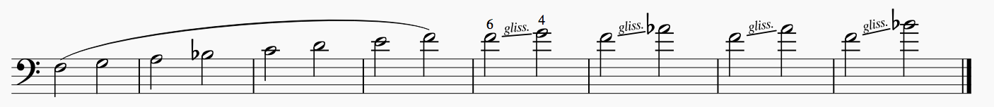

Air Flow and Range
Play with smooth, even air to avoid “bumps”. The air should be identical to the previous gliss exercise.

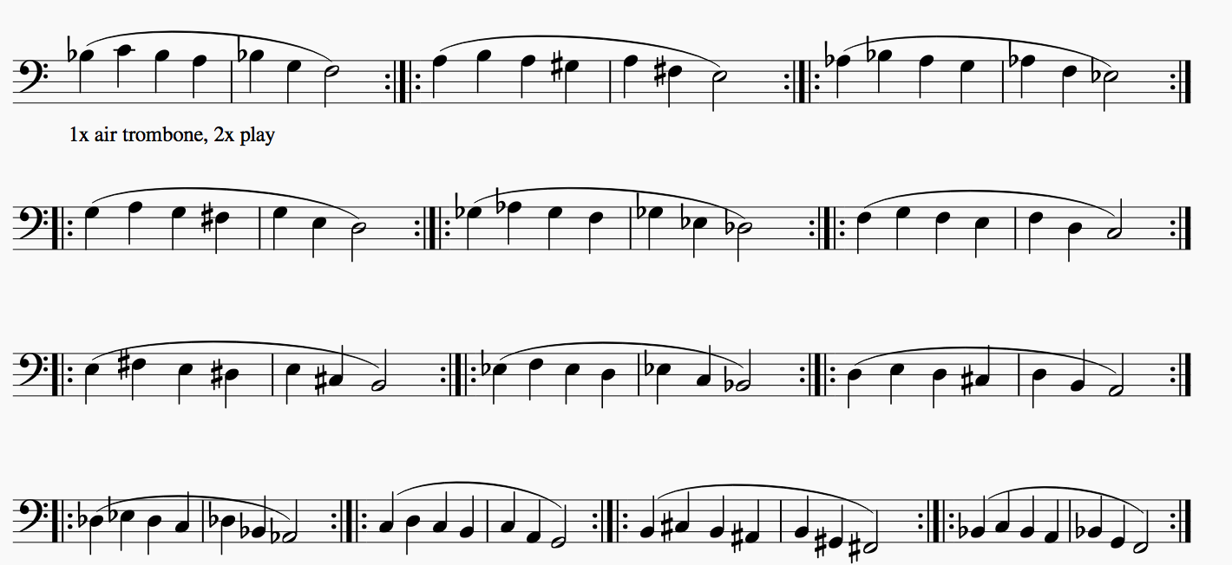
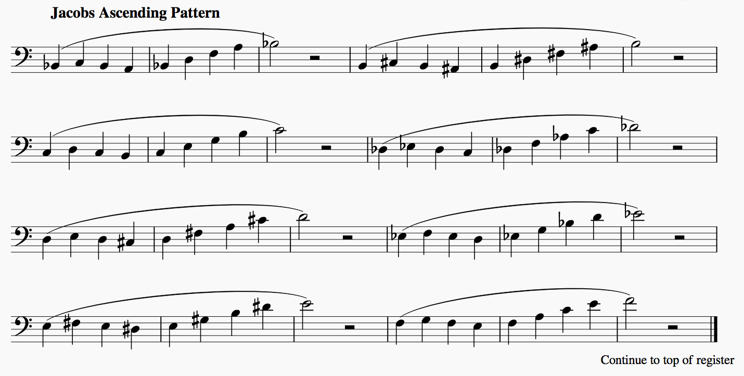

- Flexibility

Lip slurs continue to reinforce proper airflow while increasing flexibility and facility. Start
with slow slurs and move to fast slurs. Play slurs in every register. Smooth air, without bumps.

Slow Slurs
1.
2.
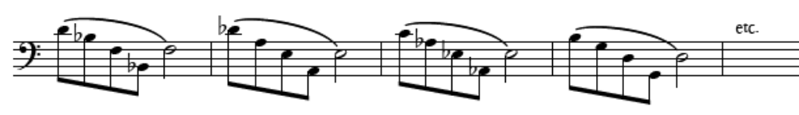
3.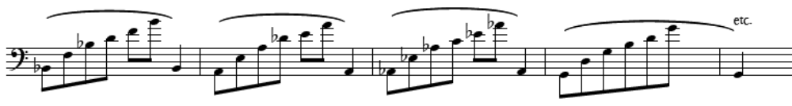
4.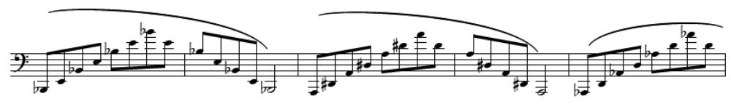

Fast Slurs

Continue down by half step into trigger positions if possible.
1.
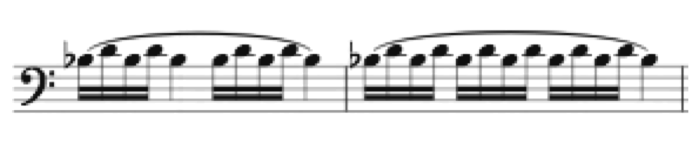
2.
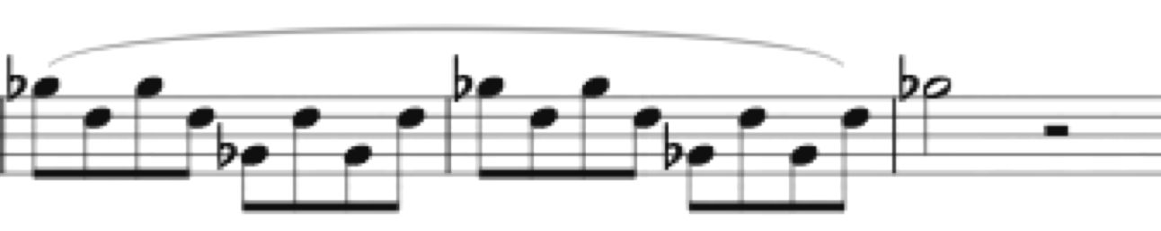

IV. Song

The point of practicing is to make beautiful music, so do it while you practice. Use the horn to sing.

Play with smooth air and phrase shaping.

Play the following melody in different registers: down an octave, in tenor clef, up an octave, tenor clef down an octave, tenor clef down two octaves. This helps establish aa beautiful, lyrical sound in every register.
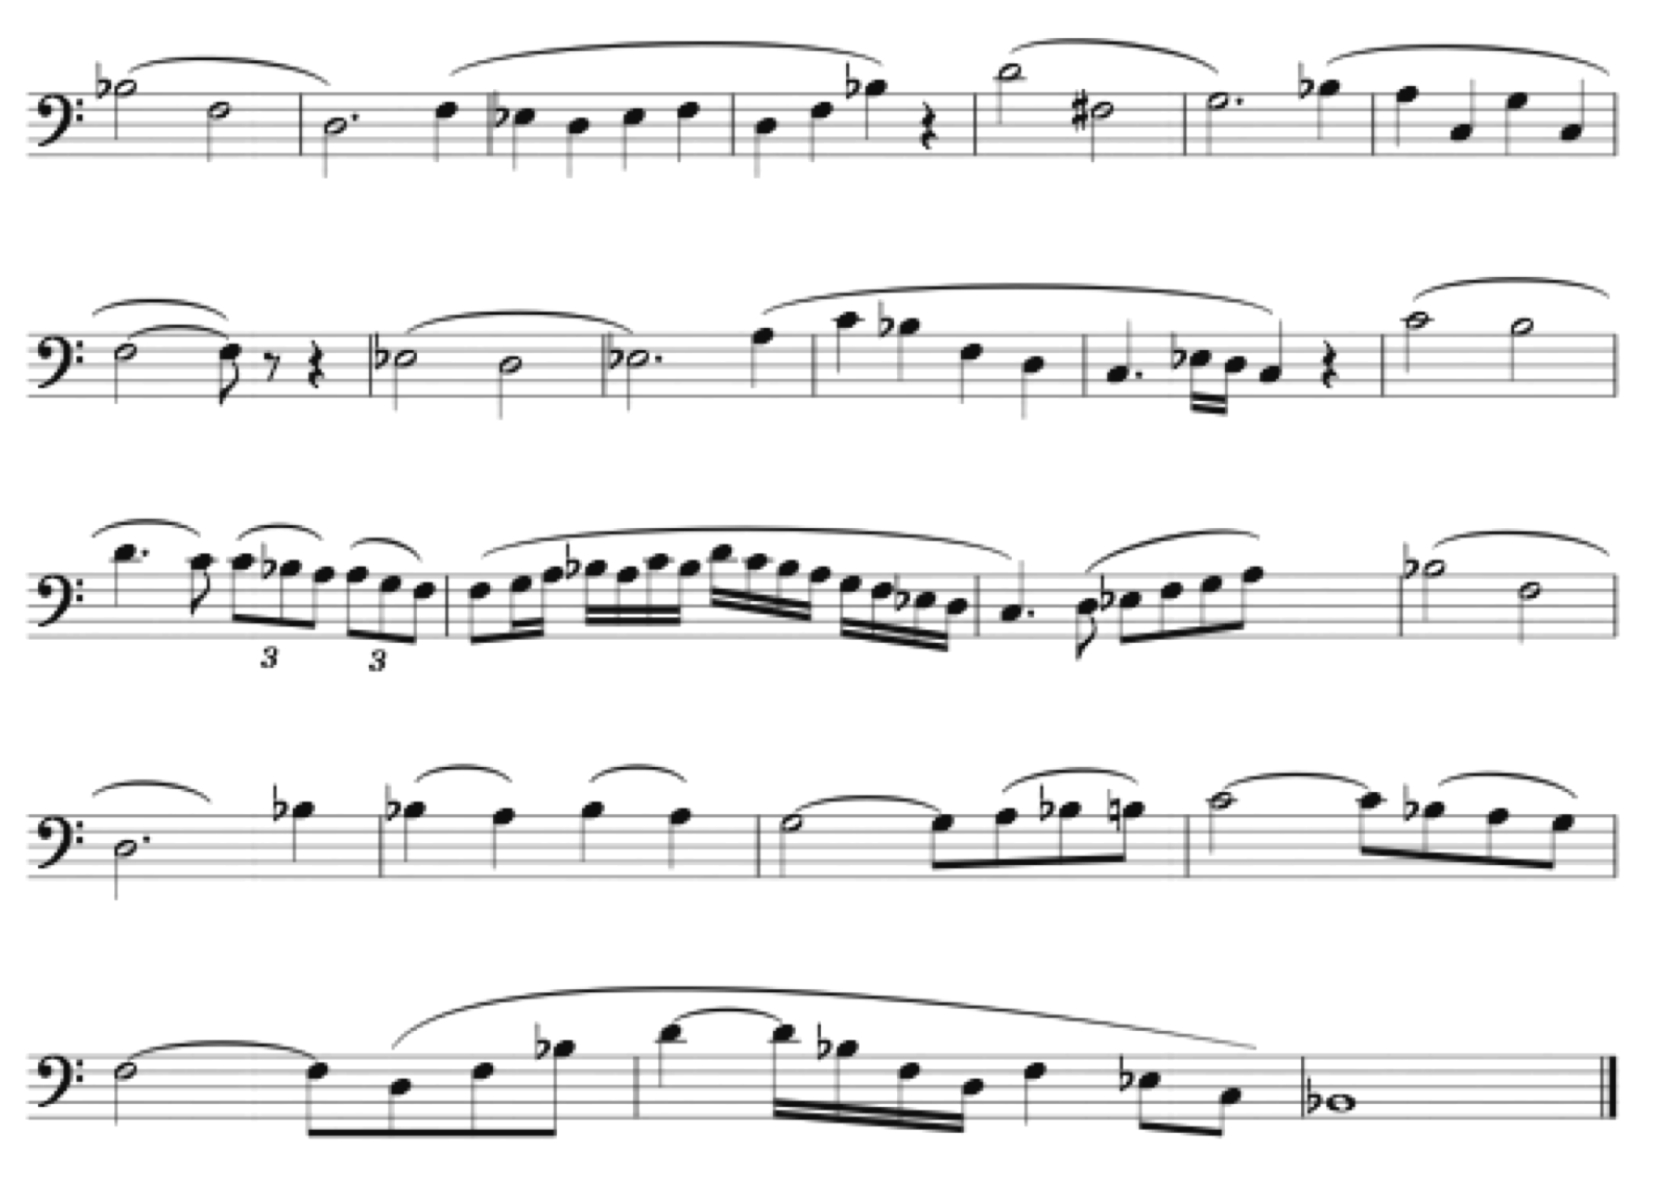
- Articulation

Keep long air moving forward and the tongue quick and light. Syllables are useful to find proper tongue placement. Think “Tee” for high notes, “Tu” for middle range notes and “Toh” for low notes. Start with a simple tongue and air coordination exercise. Do in different keys and registers.

Air starts the note, not the tongue. Keep a healthy flow of air behind every articulation.

Check your embouchure in a mirror. Make sure corners are firm, chin is flat and that you aren’t moving your jaw while articulating, especially in the low register.

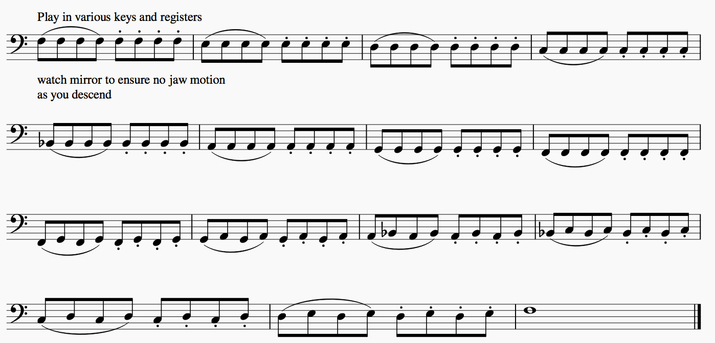Quick tongue and range expanding exercise:

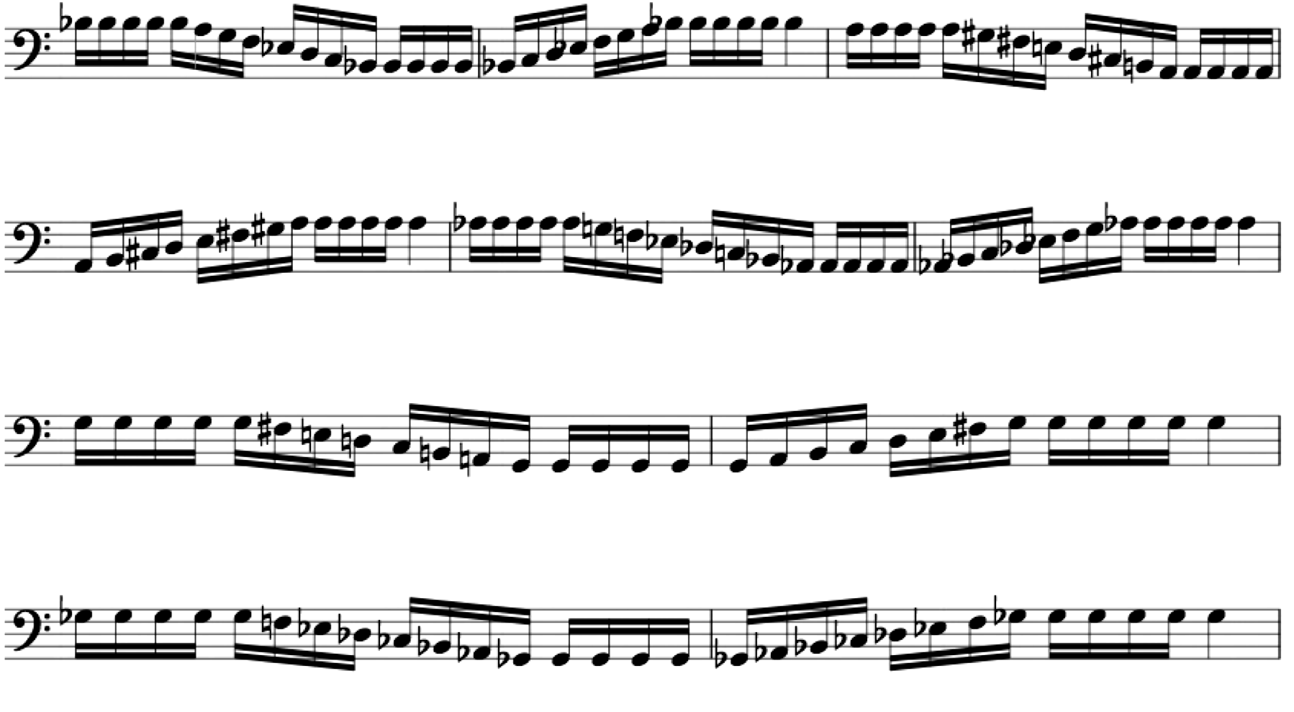

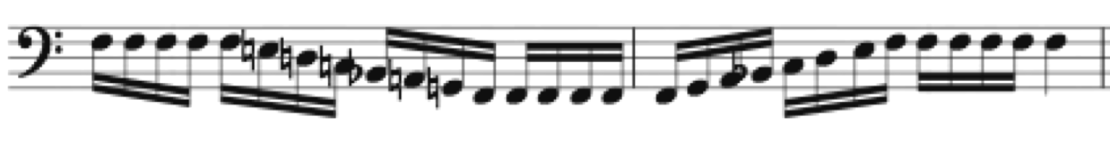
also play ascending

VI. Technique

Intervals
For accuracy

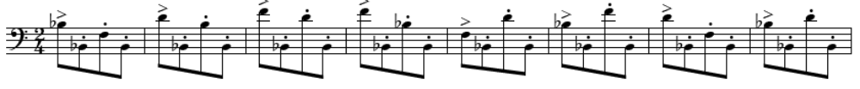
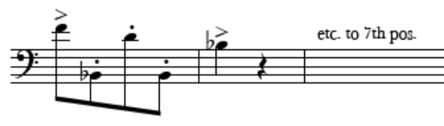
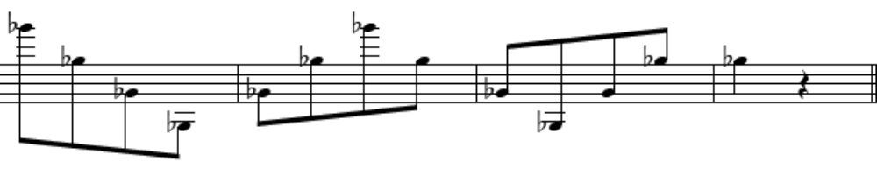

Scales: Practice 3 major and 3 minor scales a day

Relaxation and Cool Down

Play with no tongue. Make sure that your mouth and throat are completely relaxed and the tongue rests at the bottom of the mouth.

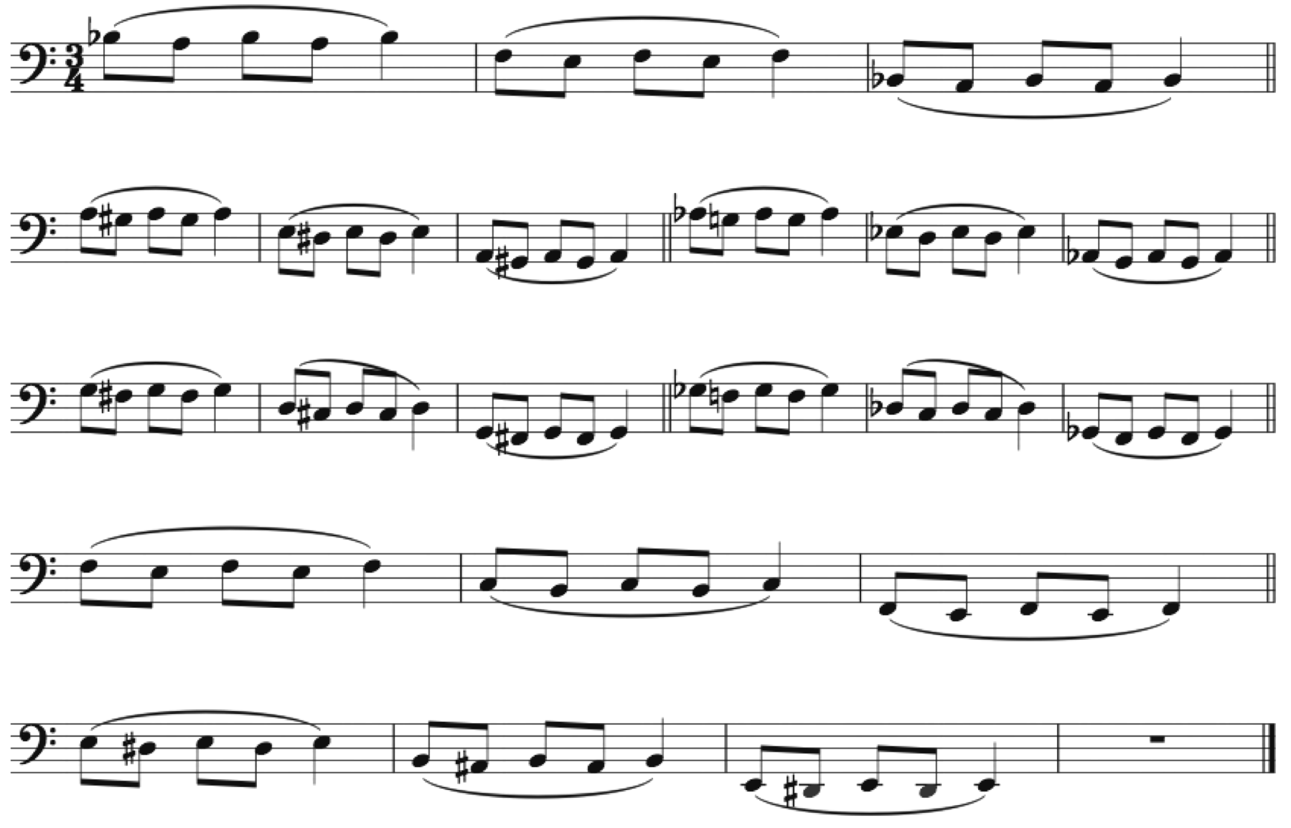

Further Words of Wisdom:

Playing a beautiful phrase is more important that playing technically perfect.

When performing, don’t focus on selling yourself, sell the beauty of the music instead.

Practice every aspect of playing every day. High, low, loud, soft, legato, articulated, clefs, flexibility, vibrato, multiple tonguing, etc. Spend the most time on the things you need the most improvement.

Your range is only as good as your sound – a high or low note that doesn’t sound good is useless.

When choosing music for auditions, play what showcases your abilities. Don’t play something that you think will impress the panel.

Every note you play in a phrase goes to or comes back from somewhere. Always play with this in mind. Musical expression is a personal choice, not an optional one.

