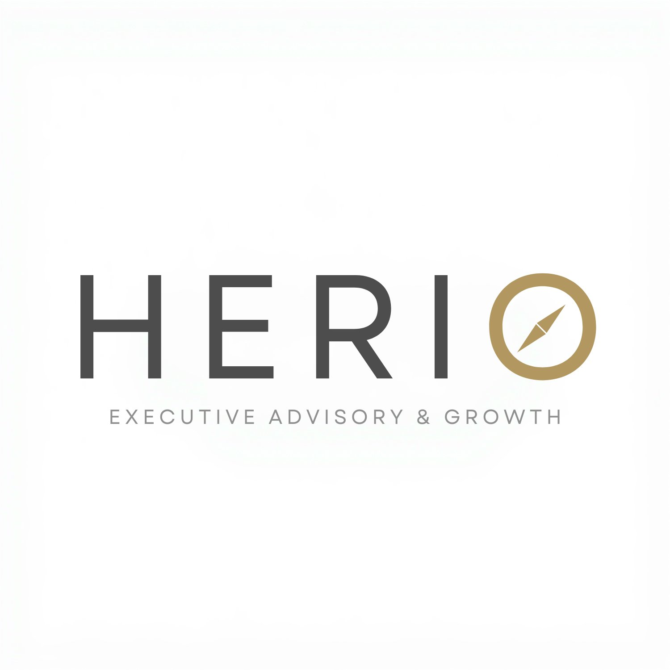
CLIENT INTAKE FORM
Executive Advisory & Growth | Vietnam – Singapore Corridor

Complete this form to help us understand your goals and context before our first conversation. There are no wrong answers. The more specific you are, the more useful our first conversation will be.
COMPANY & CONTEXT

1. Company name

2. Industry / sector

3. Company origin / headquarters

MARKET & OBJECTIVES

4. Target market
□ Vietnam □ Singapore □ Both
5. Primary objective — what are you trying to achieve in this market?

6. What does success look like in the first 6 months?

7. Desired outcomes — what do you need on the ground?
□ Clients □ Distributors □ Partners □ Local team □ Combination
CURRENT SITUATION

8. Current market presence — are you already operating in Vietnam or Singapore?
□ No presence yet □ Early stage □ Active but looking to scale
9. Legal entity and structure — do you have a registered entity in the target market? Do you need support with this?

10. Existing partnerships or relationships in the market, if any

11. Who will drive this internally?
□ Founder □ Sales lead □ Regional director □ Not yet decided
TIMELINE & INVESTMENT

12. Timeline — when do you want to be active in the market?
□ Immediately □ Within 3 months □ Within 6 months □ Exploring / no fixed date
13. Budget range for market entry and advisory support
□ Under $2,000/month □ $2,000–$5,000/month □ $5,000–$10,000/month □ Open to discuss
14. Anything else you want us to know before our first conversation?

Return this form to:
gauthier@heriovietnam.com
Or connect on WhatsApp: +84 39 791 0894
www.heriovietnam.com

