0411 190 574  hello@envisionconnection.com.au | PCYC Broadmeadow  Young Rd &, Melbourne Rd  Broadmeadow NSW 2305
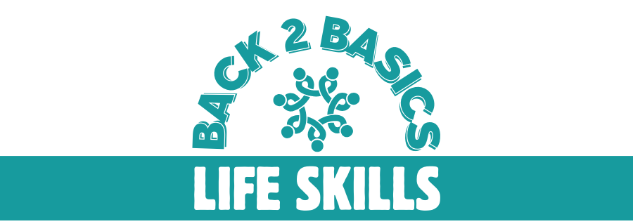

PARTICIPANT INTAKE FORM

PERSONAL INFORMATION

Full Name
First Name
Middle Name (Optional)
Last Name -

Preferred Name
(If different from above)

Date of Birth

Gender
☐ Male
☐ Female
☐ Non-Binary/Other

Do you have a NDIS Plan?

☐ No, I do not have a NDIS Plan

☐ Yes, I have an NDIS Plan

Please provide details below:
NDIS Participant Number:
Plan Start Date
Plan End Date

NDIS Plan Goals

1.

2.

3.

4.

5.

6.

Do you have a Plan Nominee?
☐ Yes
☐ No
If yes, please provide Plan Nominee details below

Full Name
Contact Details
Relationship to Participant

How is your NDIS Plan Managed?
☐ Plan Manager
Please provide Plan Manager contact details:

Organisation
Phone
Email

☐ Self-Managed
☐ NDIA Managed

Please specify category of available for this program:
☐ Core (Assistance with Daily Life - Assistance with Access to the Community)
☐ Capacity Building Improved Daily Living
☐ Capacity Building Finding and Keeping a Job

ADDITIONAL INFORMATION

Do you identify as Aboriginal / Torres Strait Islander?
☐ Yes
☐ No
☐ Prefer not to say

Religious and/or Cultural Requirements

Address

Unit/Number
Street
Suburb/City
State

Postal Address (if different from above)

Unit/Number
Street
Suburb/City
State

Contact Information
Mobile Number
Phone Number
Email Address

Preferred Method of Communication
☐ Phone call
☐ Text/SMS
☐ Email

Emergency Contact

Name
Relationship
Phone Number

General Practitioner
Doctor Name
Practice Name
Address
Phone Number

Is there a Guardianship and/or Administration order in place?
☐ No
☐ Yes

Please provide details

PARTICIPANTS UNDER THE AGE OF 18 YEARS, UNDER GUARDIANSHIP OR IN THE CARE OF FAMILY OR CAREGIVERS PLEASE COMPLETE BELOW:

Parent/Guardian Full Name
First Name
Middle Name (Optional)
Last Name

Primary Carer
☐ Yes
☐ No

Relationship to Participant

Lives With Participant
☐ Yes
☐ No

Participant Emergency Contact
☐ Yes
☐ No

Parent/Guadian Address
Unit/Number
Street
Suburb/City
State

Parent/Guadian Postal Address (if different from above)
Unit/Number
Street
Suburb/City
State

Parent/Guardian Contact Information
Mobile Number
Phone Number
Email Address

Preferred Method of Communication
☐ Phone call
☐ Text/SMS
☐ Email

Disability and Medical Information

Nature of Disability / Diagnosis
☐ Physical Disability
☐ Intellectual Disability
☐ Sensory Disability
☐ Mental Health Condition
☐ Other (please specify below)

Please Provide a Brief Description of your Disability

Do you have any Allergies or Medical Conditions we should be aware of?
(Please specify any allergies or medical conditions)

Support and Services

Current Support Services
(Please list any support services you are currently receiving including therapy and core supports e.g. Physiotherapy, Behaviour Support Specialist, OT, Support Worker, Support Coordinator, Psychosocial Recovery Coach etc)

Service:
Support Coordinator / LAC / School Liaison contact
Name or Organisation
Address
Phone
Email
Frequency of Support

Service:
(Occupational Therapy, Core Daily, Core Community Access, Behaviour Support, Speech, COS, LAC etc)
Name or Organisation
Address
Phone
Email
Frequency of Support

Service:
(Occupational Therapy, Core Daily, Core Community Access, Behaviour Support, Speech etc)
Name or Organisation
Address
Phone
Email
Frequency of Support

Service:
(Occupational Therapy, Core Daily, Core Community Access, Behaviour Support, Speech etc)
Name or Organisation
Address
Phone
Email
Frequency of Support

Service:
(Occupational Therapy, Core Daily, Core Community Access, Behaviour Support etc)
Name or Organisation
Address
Phone
Email
Frequency of Support

Additional Specialised Support Required
(Please specify any additional support you may need while participating in the programs offered)

☐ Behaviour Intervention through developed Behaviour Support Plan
Please provide to Back To Basic Life Skills Program prior to acceptance and ensure Behaviour Support Practitioner details are listed above

☐ Allergy Management Plan
Please provide to Back To Basic Life Skills Program prior to acceptance

☐ Meal Management Plan
Please provide to Back To Basic Life Skills Program prior to acceptance

Assistive Technology
(Please specify any equipment currently in use e.g., wheelchair or other mobility, hearing or visual aids, sensory, communication devices etc)

Goals and Aspirations

What do you wish to achieve for yourself in doing this program e.g. life skills, social, employment

Life skills
☐ Self-Care
☐ Domestic (making your bed, dishes, laundry, cleaning)
☐ Cooking / Food Preparation
☐ Money Management
☐ Travel Training
☐ Time Management
☐ Job Preparation
☐ Resume Writing
☐ Job Ready Presentation
☐ Interview Skills

Other Areas of Interest: Tell us something about you that you would like us to know -
(Please list any other areas of interest or skills you wish to develop)

What foods do you like – and What foods DON’T you like ?

How do you best respond to receiving instructions? E.g; ongoing prompts, direct instructions, spoken to softly, visual

What games and activities, sports do you like to play?
e.g. Chess, Jenga, basketball, crafts, gaming

Attendance

What are your preferred days of attendance?
NB: We are currently only offering this program on Tuesdays from 9:30 am – 2:30 pm.
We will be offering additional days based on demand.

☐ Monday
☐ Tuesday
☐ Wednesday
☐ Thursday
☐ Friday

Consent and Signature

Consent
I hereby consent to participate in the Back to Basics, Life Skills Day Program With A Difference and agree to the use of my personal information for program purposes only, and for the safety of you and the safety of the staff who are supporting you. I understand that I can ask to see my records and receive a copy if I so choose. Records will be archived for a set period of time according to policy and procedures.
To the best of my knowledge, the information provided here in this participant intake form is true and accurate.

☐ Yes
☐ No

Signature
Participant Name
Participant Signature
Date

Parent / Guardian / Plan Nominee Signature (if applicable)

Parent / Guardian or
Plan Nominee Name
Parent / Guardian or
Plan Nominee Signature
Date

Office Use Only

Date Received
Received By

Notes

