## 

Aviation Experience 2020

Students will learn about the basics of flight, and will develop **communication** and **decision-making skills.** They will learn how to act under pressure and to take **responsibility** for their in-flight actions, enhancing their own **leadership skills** in the process. **You will learn to takeoff fly straight and level and then to a safe landing!**

The highlight of this program will be a demonstration flight - takeoff, climb, cruise, descent, approach and landing in a real aircraft from Republic Airport so students can put their newly learned skills to use (just like a real pilot in the real world).*

What Did You Do This Summer?

## 

In just 4-weeks (8 sessions)

we will take you from here…

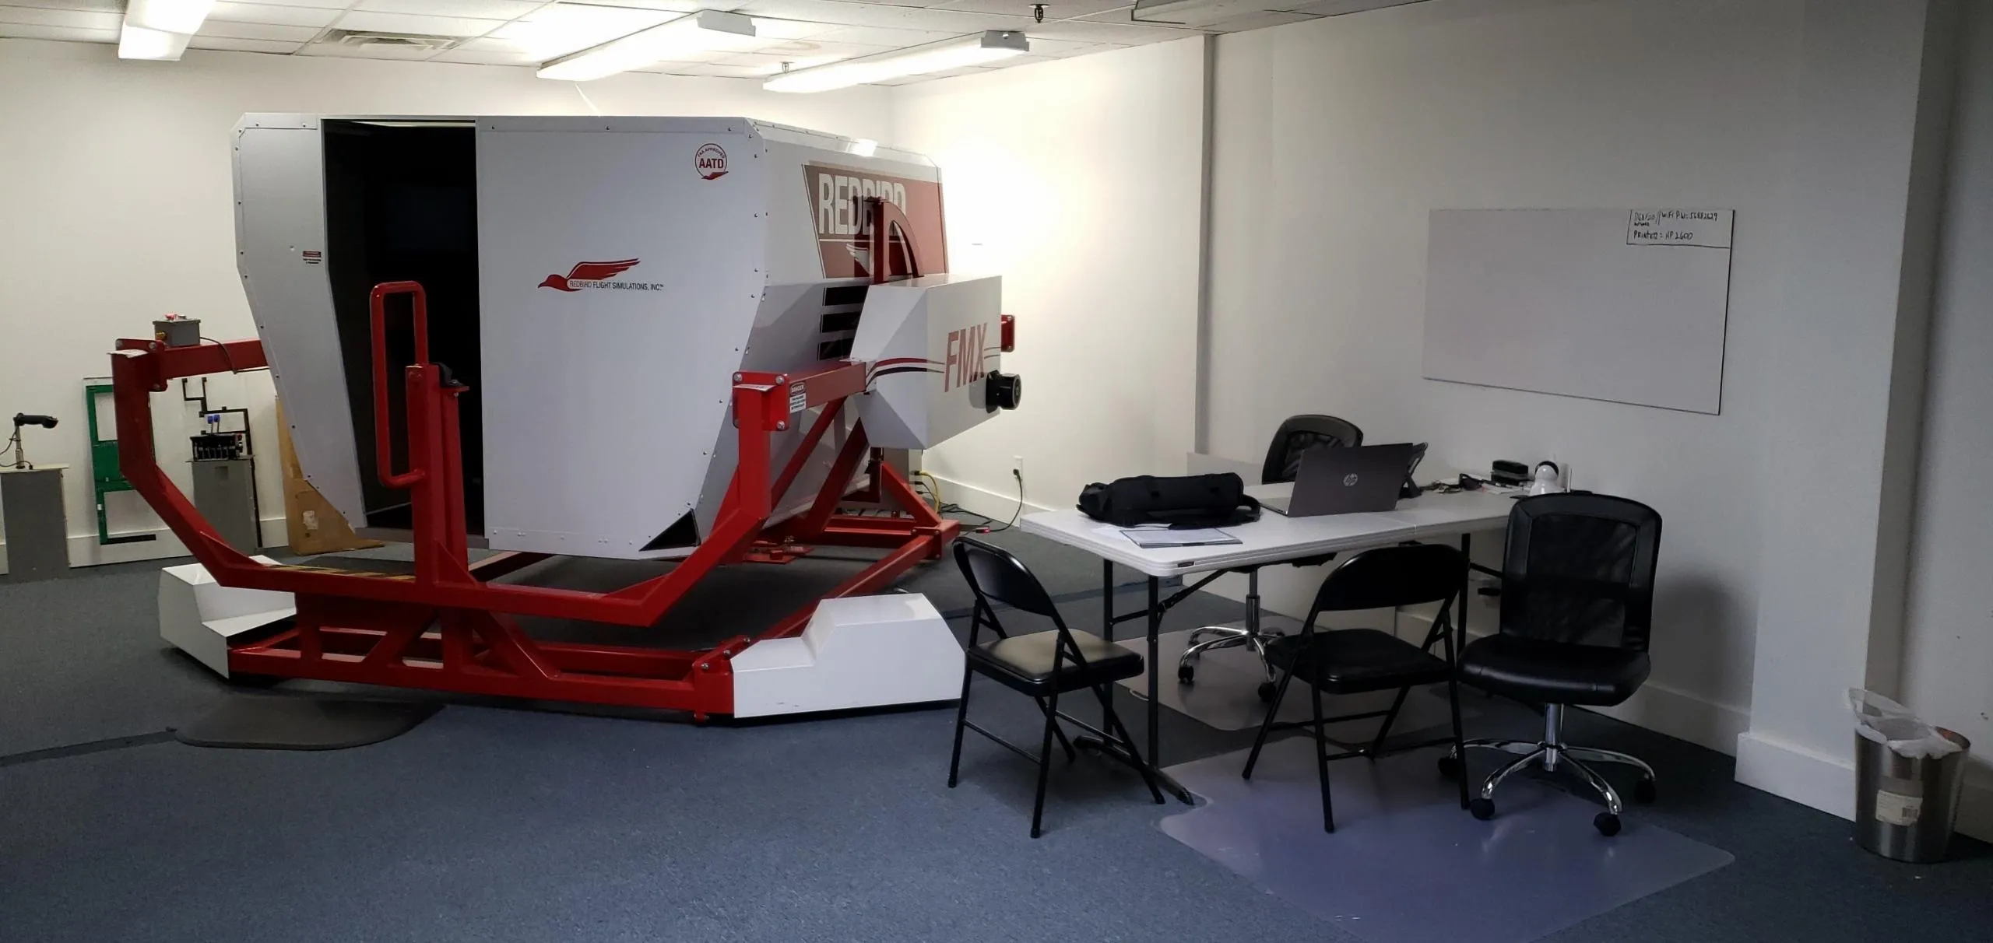

…to here

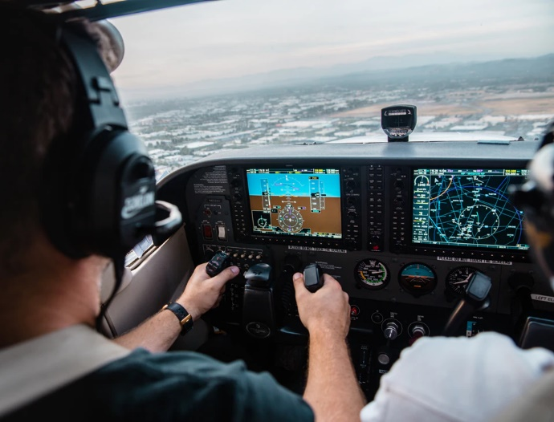

**\*\*Sessions are limited to 3 people.**

**For more information and/or to hold your spot, please contact us at:**

**Info@pilotproficiencyinternational.com**