
COMPUTER WORKSTATION SET UP
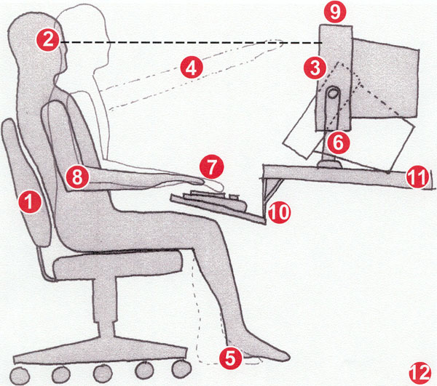
- Use a good chair with a dynamic chair back and sit back in this
- Top of screen (not monitor) at eye level
- No glare on screen, use an optical glass anti-glare filter where needed
- Sit at arms length from monitor
- Feet on floor or stable footrest
- Use a document holder, preferably in-line with the computer screen
- Wrists flat and straight in relation to forearms to use keyboard/mouse/input device
- Arms and elbows relaxed close to body
- Center monitor and keyboard in front of you
- Use a negative tilt keyboard tray with an upper mouse platform or downward tiltable platform adjacent to keyboard
- Use a stable work surface and stable (no bounce) keyboard tray
- Take frequent short breaks (microbreaks)
Tips & Tricks for Healthier Computing

Key Considerations/Guidelines:  - When standing, assume the “at ease” posture, not “at attention.”  - Allow your body to move as it needs. Take “ERGO” breaks every hour for 2 – 3 minutes.  - Choose a shoe that offers support — when standing, avoid shoes  without heels as well as high-heeled shoes.  - When someone comes to your desk to talk about a project,  STAND while you talk to them.  - Pace yourself as you learn which tasks you prefer to do standing  versus sitting; let your intuition and your ability to stay focused guide your efforts.  - If you have to concentrate on a project intensely don’t feel bad  about sitting: sometimes the body needs to direct most of its  energy into a cognitive effort.  - When the phone rings, stand up to talk. | - Set some goals to incorporate movement into your day; track and challenge yourself to meet those goals.  - Monitor your fatigue level throughout the day; when you start to experience it, change your position. If seated, stand. If standing, sit.  - Be aware that you may experience some discomfort at first as your body adjusts to standing more throughout your day. You may be using muscles that haven’t worked much lately.  - An anti-fatigue floor mat offers comfort and safety when standing on hard surfaces.  - Whether sitting or standing, a foot rest can reduce fatigue and increase stability.  - Congratulate yourself periodically for taking a stand for your health;

