
Thank you for choosing Rise N Shine Child Care LLC for your childcare needs. I operate upscale licensed family home childcare that is different than a Day Care Center due to the number of children enrolled and many of programs offered such as Y.A.M.E.L. Youth exercise, heathy Teeth and more.
By limiting enrollment, we are able to provide a nurturing atmosphere that your child deserves, which makes our home childcare a perfect place to learn and grow.
Rise N Shine Child Care LLC is not a preschool, but we do offer a theme based preschool programs. Children participate in a full range of activities such as free play, outside play, circle time, dramatic play, creative arts, crafts, music and much more.
As a family childcare provider, my goal is to provide a safe, healthy childcare and happy learning environment for each child that will stimulate their physical, intellectual, social and emotional growth at their own pace.
We offer loving care that focuses on each child as a unique and wonderful individual and in doing so, builds self-esteem and respect for others.
As your partner in caring for your child, our interaction with you, the parent,
is as important as our interaction with your child. I encourage parent involvement in the childcare setting.
I look forward to welcoming your family into our childcare.

Sincerely,
Sherise Alston
Owner Rise N Shine Child Care LLC
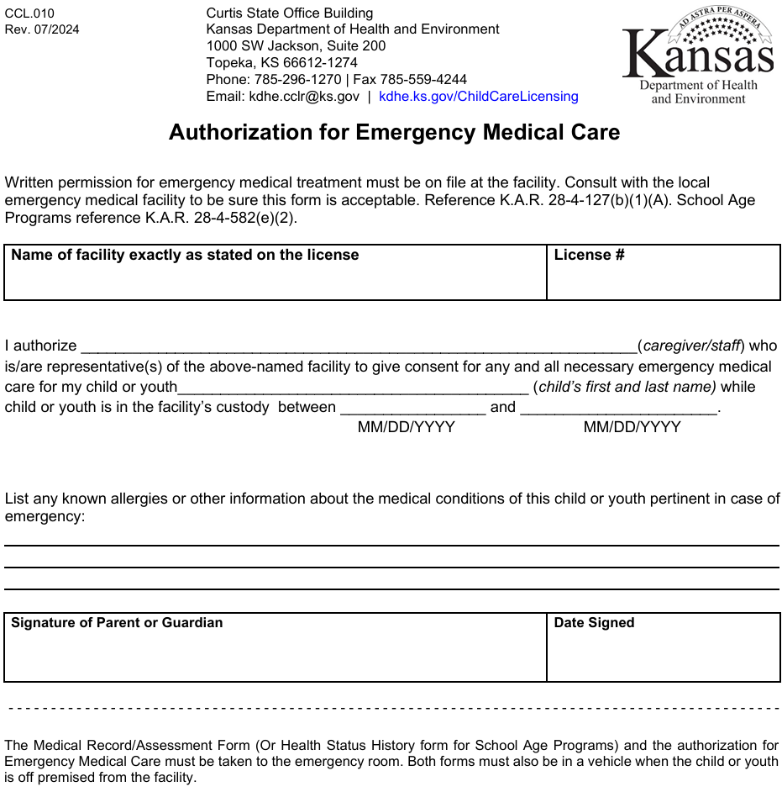

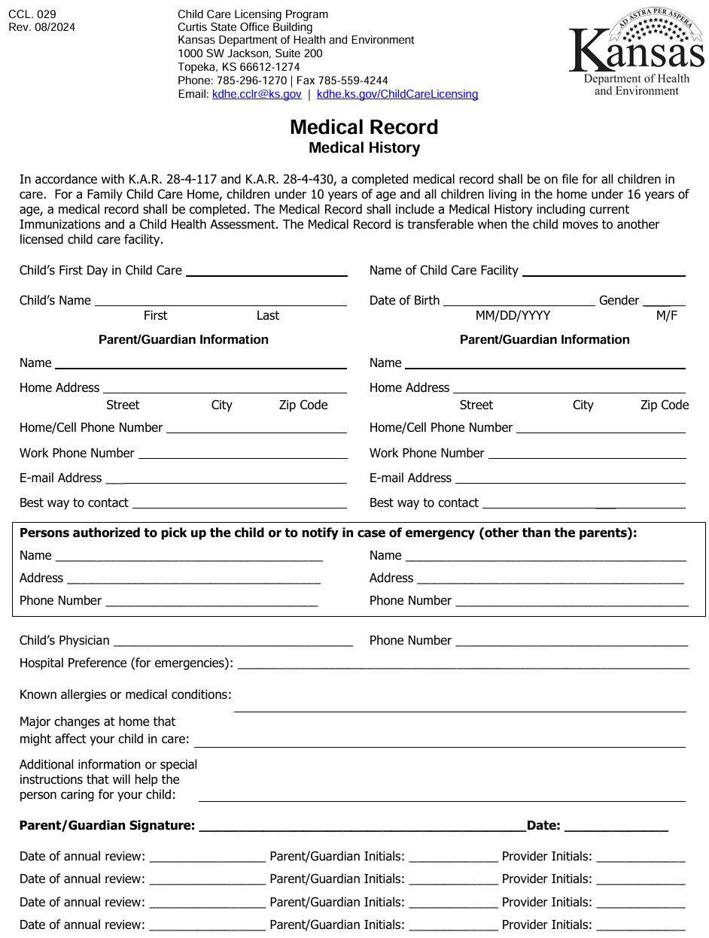

Full Name of Child:
Policies & Contract
DOB:

MM/DD/YY
Date of Enrollment:

Phone | Text | Email | Social Platform
Best form of contract:
Parent of contact Full Name

Childs Home Adress:
Contact Mobile Number ( )

@yahoo | @gmail | @icloud
E-Mail Address:
Place of Employment:

Employment Address:

Work Phone ( )

Second Parent of Contact Full Name:
Adress if Different:
Email Address:
@yahoo | @gmail | @icloud

Contact Number: ( )
Best Form of Contact:
Phone | Text | Email | Social Platform
Place of Employment:

Employee Address:
Work Phone: ( )

AUTHORIZED EMERGANCY CONTACTS/ AUTHORIZED PICK-UP
First to Contact Name:
Name of Emergency Contact:
Phone: ( )
Adress:
Relationship to child:

Name of Emergency Contact:
Phone: ( )
Adress:
Relationship to child:
BUSINESS HOURS AND FEES
All childcare related issues and business will be taken care of during business hours only.
Rise N Shine childcare hours are from 7:00 a.m. to 5:00 p.m. Monday through Sunday. The childcare is closed at 5:00 p.m. At 5:01 p.m. late charges will be added at the rate of $5.00 per minute you are late. All in and out times are taken from the clock at the childcare where parents are required to sign daily. Late fees are due the following day before your child can attend.
Weather rule: RNSCC will be closed with Topeka USD 501 and/or State office closings when declined weather is determined .The childcare will be closed on the listed days along with the Kansas state offices and on all religious/major holidays and Emergency:2P.M. on Federal Holidays (Martin Luther King Jr. Day, Presidents Day, Juneteenth and Veterans Day Christmas Eve) USD 501 Snow Day, national disaster/state emergency, New Year's Day, Easter Day. Day after Easter, Memorials Day, Independence Day, July 5, Labor Day, Thanksgiving Day, Black Friday, Christmas day, December 26. There will be 11 days of vacation per year. CDC required leave for disease and virus-related illnesses. Notification will be given through BAND account of any other closed days, such as personal days totaling three (3) days in year. Bereavement for immediate family totaling five (5) days. It is the parent's responsibility to find alternate care if needed during those times. Payment is due during closed days. Please call and let us know by 8:00 a.m. if your child will be late or absent for the day. This helps us prepare meals, activities etc. Failure to contact will result in a child being marked as absent.
Daily Minimum $35.00 for 18 months older $40.00 infant to 17 months
Weekly Minimum $150.00 per week 18 months & older $175.00 per week infant to 17 months
Part-Time Minimum $100.00 per week for 18 months older & $130.00 infants to 17 months
Weekend Minimum $ 180 per child infant-18 months and older
- Rates are subjected to amendment based on childcare needs, hours and/or meal plan
This fee includes: All services provided by Rise N Shine Child Care LLC Daily childcare, breakfast, lunch, snacks, Y.A.M.E.L, newsletter even when a child is not in attendance. You agree to pay this fee in full on each Monday. There is a late fee of $30.00 per day added for each day that payment is late (up to two days). Late fees are due the following day before your child can attend. Payment is due by 5:00 p.m. each Monday. At 5:01 p.m. payment is late, and the late fee will be added. It will be added at 5:01 p.m. each day thereafter. Children may not attend childcare unless full payment and late fees have been paid up to date.
FAMILY CHILD CARE BENEFITS
After six months of full-time enrollment family may receive three days for sick or vacation absence. Three days for Bereavement absence for immediate family only. Family requests forms must be completed two weeks before vacation. The requests accepted will reflect following weeks invoice. Request will not be accepted if payment is not current, incomplete enrollment and incomplete request form. Forms are provided upon request. Request forms cannot be used when child is sent home due to illness, behavior, family emergency or picked up early upon family schedule.
DRESS CODE
Shirt, pants and shoes are required before attending child care. Clothes should be easy to get on and off. Diapers and underwear must be covered with shorts or pants. You child should wear fitting and comfortable shoe that are enclosed and easy to take off and on. Avoid footwear such as backless sandals and flip-flops. Crocs are allowed. We encourage play attire daily. Two pair of seasonal clothing on hand for changing.
TOYS
We encourage no toys be brought in from home although the children are free to bring toys to child care at own risk. However, our rule is, “take turns or keep it in a safe place”. The child must be prepared to share the items they bring and let the other children play with them. If the toy is delicate or of great sentimental value, please do not bring it to child care. We will not be held responsible for toys that get broken when brought to child care. The children are supervised consistently, but accidents happen and toys break. Children bring toys at their own risk. Please no tables or cell phones.
ORGANIZED ENVIRONMENT/STRUCTURE
To maintain an organized and structured environment parents agree to provide us with items on supply list. We recommend being dressed in shoes and clothing that supports children at play daily. We promote use of good manners and respect through social, emotional, cognitive and physical skills. Using word; yes ma'am, no sir, yes please, no thank you. Words like; Stupid, hate, what the and shut-up are considered bad words and will be redirected. Communication is very important and encouraged, between family and provider all communication is done through BAND. We have no tolerance when a child uses harmful/misguided physical contact, inappropriate language and uncontrollable behavior to children and/ or provider. At meal times children will be asked to “put your hands together and pray or place hands on the lap while others pray”. Our prayer: God is gracious, God is good let us thank Him for the food we receive in Jesus name we pray Amen.
SUPERVISION
Video cameras are recording on site, they are not used as supervision for the children but as security for the home. Children will always be under direct supervision. Storage room, kitchen and stair ways are locked or gated for children to be supervised in daycare, bathroom, playground and colors’ room. Children will be checked on every 15 minutes while sleeping. While outdoors there will always be adult supervision for all ages. At least one hour and 15 minutes daily with weather rules. If one child must use the restroom, wash hands or needs a drink we must all go inside to keep safe. Children under the age of 5 will be personally supervised while in the bathroom. Children older than the age of 5 will be reminded and asked about toilet needs.
DAILY SCHEDULE/ NAP TIME
Safe Sleep guidelines are followed for all ages. Nap time is after lunch. All families are encouraged to respect this "rest our bodies time" Rest areas are located in “colors room" and "Daycare" areas. Over covered ground with nap mat or on a cot. The children need this rest time and we need the quiet time to be able to clean up and prepare for the afternoon activities, catch up on paperwork etc. Please be reminded that we do not get "breaks" and "lunch breaks". Parents are discouraged from visiting during nap time unless the child is being picked up for the day, nursed or needs assistance. It is very disruptive to the other resting children. They do not understand why one child can get up and play and yet others have to have quiet time.
FOOD SERVICE/FOOD ALLERGIE
This child care participates in the USDA food program. Meals meet the requirements set by the USDA. Children in need of a special diet must provide a signed doctor’s note stating nutritional needs. Unfortunately, homemade goodies cannot be brought from home. This is a state regulation. If you wish to send treats with your child to share for special occasions such as family events, holidays or child’s birthdays etc., the items must be commercially prepared and individually wrapped. Families acknowledge that treats may contain dye. PLEASE!!... NO GUM IS ALLOWED in CHILD CARE!! No food or drink upon arrival, you must have unopened food/drinks for everyone. Children do not understand why one child can get food and drink and others can not. Sharing food may also cause allergic reactions and sickness. FOOD ALLERGIE/MEDICAL TREATMENT Each child with a food allergy and/or medical condition should have a written care plan that will be discoursed routinely between staff, child and parent upon first day of arrival. Rise N Shine staff should notify the parents/guardians immediately of any suspected reactions even if a reaction did not occur.
HEALTH OF THE PROVIDER/ CHILDREN HEALTH
Each person working in the facility must be in good health with no communicable diseases. The provider must complete a health history questionnaire for the state and obtain appropriate results from a TB test. CHILDREN'S HEALTH All children must have complete health evaluation form and up to date immunizations before enrollment in the Childcare facility. Records must remain up to date while enrolled. A fee of $10 per day will be applied for any out-of-date enrollment forms. If a child is diagnosed with severe allergies to food, medication and/or requires special needs an amendment of contract will be in place and signed by parents and provider. INFECTION CONTROL Provider and all children will practice good hand washing habits and hygiene. Hand washing is required upon arrival/departure, after toileting. before and after handling food. Paper towels and liquid soap will be accessible in the bathroom. Bedding is washed every five uses.
SICK CHILDREN
Sick children may not attend day care. This is a state regulation. Sick children make the other children sick too. “Sick”, according to the regulations is any child that may be running a temperature of 100°F, has a rash, frequent cough, green mucus, unexplained symptoms, or who appears to be less that healthy. It is up to the child care provider to decide if a child is too sick to be in child care. If a child becomes ill in child care, the parents will be notified and expected to pick up the child within 45 minutes of call No Exceptions. Ill children will be isolated from the rest of the children to reduce spread of illness to others. Ill children are not to return to child care until child is 28-48 hours free of symptoms, no medication or doctors’ request.
CHILD DISCIPLINE
Praise and reward children during positive behavior. Modify the environment to attempt to prevent problems before they occur. Listen to the children. Provide alternatives for inappropriate and negative behavior to the children. Provide the children with natural and logical consequences of their behaviors. Treat the children as people and respect their needs, desires, and feelings. Explain situations to the children on their levels. Use short supervised periods of "time out”. Try to stay consistent in our behavior management program. We are happy to discuss this with you and to reinforce some methods you may use at home such as a reward system etc. No physical punishment or exercise is accepted. If child’s behavior is uncontrolled parents will be called and expected to pick up child with in 45 minutes of phone call.
EMERGENCY AND DISASTER Planning This child care has an emergency plan on file. Please see board for routine. Disaster plan drills will be held once a month for our safety.
Accident and Injury
The undersigned parent or legal guardian assumes all risk of injury or harm to the child while the child is in child care or on approved field trips. The parent or legal guardian agrees to fully release, indemnify, defend, and forever discharge Rise N Shine child care LLC, its owners, staff, employees, and agents of and from all liability, claims, demands, damages, costs, expenses, actions, and causes of action in respect of death, injury, loss, or damage to the child, or by the child, howsoever caused, arising out of or to arise by reason of or during the child’s participation in the child care
Tobacco Free Zone
This policy covers the use of cigarettes and any other tobacco products including smokeless tobacco products and electronic smoking devices, and applies to all employees, parents, volunteers, contractors, and vendors of Rise N Shine Child Care. U.S. Food and Drug Administration, the use of these products are not allowed during business hours nor on Rise N Shine Child Care LLC grounds at any time.
DAMAGES
Small repairs and accidents go with the territory when running a child care facility. However, parents/guardians will be held financially responsible for damages that cannot be classed as accident or fair wear and tear over $100.00 (Such as a deliberate breaking of toys, poking holes in furniture, broken electrical devices etc.). Parents will be notified of recurring damages.
Photography Release
I hereby grant Rise N Shine Child Care LLC permission to use photograph, video, or other digital media in any and all of its publications, including web-based publications, Social media without payment or other consideration.
NOTICE OF TERMINATION Two full weeks advance notice in writing is required to terminate child care with Rise N Shine Child Care LLC. Payment is required during these two weeks. Rise N Shine Child Care LLC reserves the right to terminate this contract for any reason. Two weeks' notice will be given under usual circumstances. However, we reserve the right to immediate termination of services under certain circumstances. (i.e. children who are a threat to others, non-payment, miscommunication etc. As required by the state, the following regulations are in force at this child care facility.
I HAVE READ AND ACCEPT THE POLICIES AND PROCEDURES OF Rise N Shine Child Care LLC. THEY ARE PART OF MY CONTRACT. I UNDERSTAND THAT THIS CONTRACT MAY BE REVIEWED AND REVISED AS NECESSARY AND THAT I WILL BE PROVIDED WITH WRITTEN NOTICE OF ANY SUCH REVISIONS/CHANGES AT LEAST 30 DAYS PRIOR TO ANY CHANGES/REVISIONS TO THIS AGREEMENT.
(Parent / Guardian) ________________ Date

1919 Se Indiana Ave Topeka KS 66607 (785-383-6311)
Agreement between Family Child Care Provider and Parent(s)
This is an agreement between _____________________, ________________________ parent(s) and Rise N Shine Child Care LLC family childcare provider, regarding the care of the following child(ren):
1.Name__________________________________.
Birthdate__________________________________.
2. Name__________________________________
Birthdate__________________________________.
3.Name__________________________________.
Birthdate__________________________________.
BUSINESS HOURS AND FEES
All childcare related issues and business will be taken care of during business hours only.
Rise N Shine childcare is open from 7:00 a.m. to 5:00 p.m. Monday through Sunday. The childcare is closed at 5:00 p.m. At 5:01 p.m. late charges will be added at the rate of $5.00 per minute you are late. All times in and out are taken from the clock at the childcare. Late fees are due the following day before your child can attend. In the event of an emergency, you agree to notify Rise N Shine provider as soon as possible letting us know an estimated arrival time. You will sign a form prior to your child’s first day of care indicating any individuals who are authorized to pick up your child(ren). You will agree to notify us prior to the day of any individual (other than yourself) picking up. Please call and let us know by 8:00 a.m. if your child will be late or absent for the day. This helps us prepare meals, activities etc. Failure to contact will result in a child being marked as absent.
Weather rule: RNSCC will be closed with Topeka USD 501 and/or State office closings when declined weather is determined .The childcare will be closed on the listed days along with the Kansas state offices and on all religious/major holidays and Emergency:2P.M. on Federal Holidays (Martin Luther King Jr. Day, Presidents Day, Juneteenth and Veterans Day Christmas Eve) USD 501 Snow Day, national disaster/state emergency, New Year's Day, Easter Day. Day after Easter, Memorials Day, Independence Day, July 5, Labor Day, Thanksgiving Day, Black Friday, Christmas day, December 26. There will be 11 days of vacation per year. CDC required leave for disease and virus-related illnesses. Notification will be given through BAND account of any other closed days, such as personal days totaling three (3) days in year. Bereavement for immediate family totaling five (5) days. It is the parent's responsibility to find alternate care if needed during those times. Payment is due during closed days.
RATES
Daily $30.00 for 18 months older $36.00 infant to 18 months
Weekly $145.00 per week 18 months & older $175.00 per week infant to 18 months
Part-Time $100.00 per week for 18 months old & $130.00 infants to 18 months
Weekend Minimum $ 180 per child infant-18 months and older
- Rates are subjected to amendment based on childcare needs, hours and/or meal plan
This fee includes Daily childcare, breakfast, lunch and snack even when a child is not in attendance. You agree to pay this fee in full on each Monday. There is a late fee of $30.00 per day added for each day that payment is late (up to 2 days). Late fees are due the following day before your child can attend. Payment is due by 5:00 p.m. each Monday. At 5:01 p.m. payment is late, and the late fee will be added. It will be added at 5:01 p.m. each day thereafter. Children may not attend childcare unless full payment and late fees have been paid up to date. THERE ARE ABSOLUTELY NO EXCEPTIONS TO THIS RULE.
Termination/Withdrawal
Two full weeks’ advance notice is required to remove your child from the day care facility. Payment is required for these two weeks even if the child does not attend.
YOU AGREE AND ACCEPT THE POLICIES AND CONTRACT PROVIDED. YOUE AGREE TO RECIVING A COPY OF THIS DOCOMENT OF RISE N SHINE CHILD CARE LLC CONTRACT AND POLICIES.
*Parent/ Guardian *Date

Rise N Shine Child Care Provider Date

All About Your Child


Childs Full name Nickname

I have Brother(s) and Sister(s). Their names are
Has your child attended child care before? Yes No
If yes, name of provider or center
Reason for leaving?
EATING HABITS
Does your child have a special diet? are there any foods that should not be served to your child?
Your child's favorite food?
Least favorite food?

Does your child eat independently? Yes No Use Utensils? Yes No
Does your child require: Bottle Sippy Cup High Chair Booster seat
SLEEPING HABITS
Does your child have a regular bed time schedule? Yes No Time:
What time does your child usually wake in the morning?
Does your child take naps? Yes No How Long?
Does your child have any issues getting to sleep or staying sleep? Please explain sleep routine

Do you give your child medication for sleep? Yes No
Are there any hearing or vison concerns? Yes No
Does your child have any allergies? Yes No Seasonal
Please list allergies and medications given per allergy:

Does your child suffer from any of the following on a regular basis?
Nosebleeds Headaches Sore Throat Stomachaches Runny Nose Ear infections
BEHAVIOR
How do you reward your child?

How do you discipline your child?

Anything about your child you think I should know? Do you have any concerns about your child’s health, behavior or development?

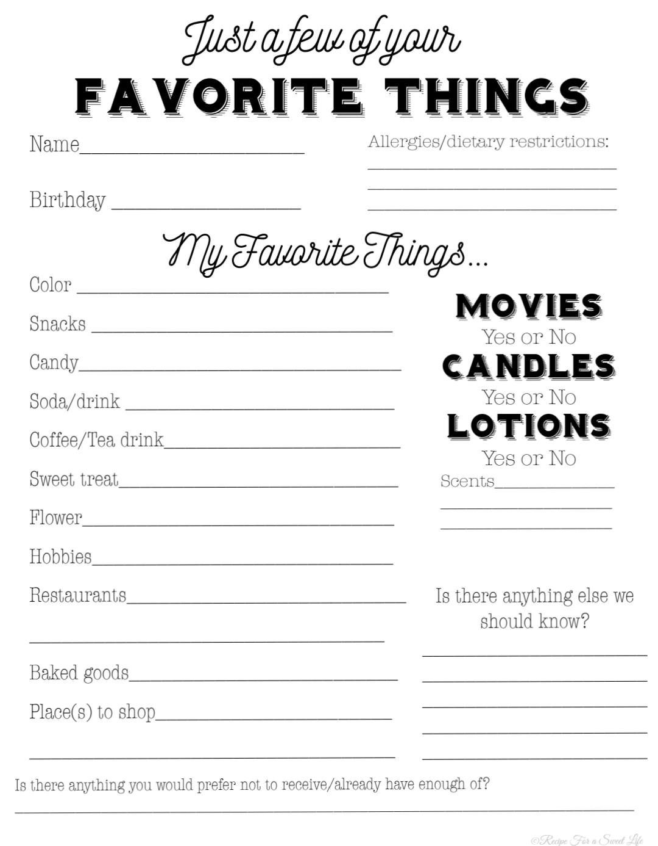
All About Parent/Gardian

SUPPLY LIST

Bedding
- One Blanket
*items will be kept at daycare while machine washed weekly and when soiled
Clothing (seasonal)
- Two Shirts
- Two Pants
- Two pairs of socks
- Two pair underwear
- Diapers
- Ointment(optional)
*Wet wipes are provided by childcare
Summer/Winter
- Swimsuit
- Sunblock (must sign medical form)
- Bug repellent (must sign a medical form)
- Towel
- Jacket
- Coat
- Gloves
- Hat

ITS POTTY TIME 
Your child is showing sign of potty training! Dressing own self, less wet diapers during the day, sitting on toilet, wanting to wear underpants and much more! Are you ready? At Rise N Shine we take pride in helping your child develop skills through self-learning and development stages. Let's work together to achieve another milestone!
First, we must practice healthy habits. Be sure we are washing our hand with soap and water after toileting
Second, we need a schedule. Please take the time to complete our potty schedule so that we can be on one accord.
Next, we will need at least 3 pairs of clothing daily. Underpants, socks and shoes.
Over time Rise N Shine has been successful with potty training our friends with the help of our parents. Our secrets are patience, timing, consistency and no more diapers/ Pull-ups. Diapers and Pull ups are only necessary in the beginning stages while your child is sleeping. If you would like your child to be aware of wetness underpants are best. To protect your child's clothing, we suggest using plastic training pants and/ or thicker underpants. Being aware of your child's food and beverage intake will help track timing. We suggest in the beginning stages to take your child to the restroom ever 30-40minutes! After your child has used the toilet, do not allow them to sit on the toilet for longer than 3-4 minutes if child is not having a bowel movement. With toilet training comes behavior changes we encourage you to be patient and consistent to help keep your child stay on track. We also encourage proper language for body parts and materials while speaking to your child.
Home Toilet schedule BM= Bowel movement W=Wet T=Tried P= Potty D=Dry

AM 7: 8: 9:
10: 11: NOON 12:
1pm: 2: 3:
4: 5: 6:
7: 8:


Late Pick-Up Reminder
Date: ________________
Hello Rise N Shine Parents and Guardians,
Please note that child care closes at 5:00 p.m. Parents are expected to pick up children before closing time. Please respect your child care providers time by arriving on time for pick-up. A late fee of $5.00 per minute after 5:00 p.m. is due the following day at arrival. You have received this letter due to your child being picked up late more than two times. When frequent late departure occurs a one-day suspension is given. This is a written notice. If there is an emergency, please call Sherise as soon as possible to make arrangements for your child to be picked up in a timely manner. Again, we ask that you please be respectful of your child care providers time by arriving before 5:00 p.m.
Sincerely,
Sherise Alston
785-383-6311
1919 Indiana Ave. Topeka KS

×
