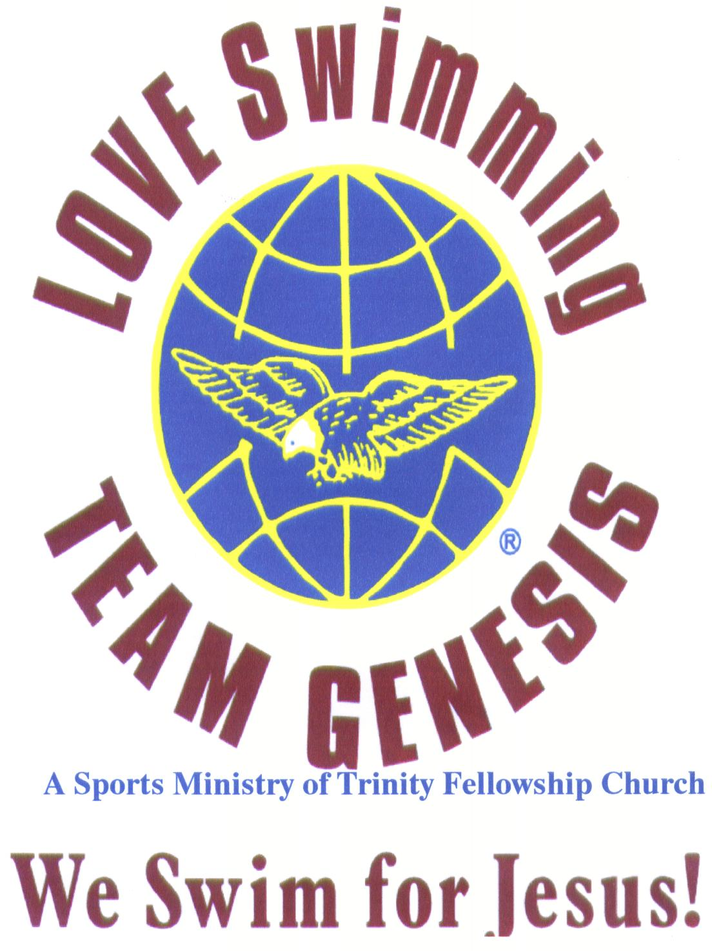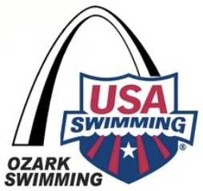
LOVE Swimming 2025-2026 Swim Season
Open, Time Trials & Sprint Series Swim Meets
- Updated 02-06-2026
Swim Meet Dates, Times & Location are subject to change, please check with your Coach*
Locations:
- Farmington Civic Center Pool, 2 Black Knight Drive, Farmington, Missouri 63640, & Mehlville Senior High School Pool, 3200 Lemay Ferry Road, St. Louis, Missouri 63128.
Pool:
- “SCY” 25 yards 6 lanes with Starting Blocks

Entry Fee due by “Day of the Swim Meet” & Entry Fee is:
- $15.00 per swimmer, due payable prior to each Swim Meet. A $10.00 transferrable Referral Bonus Coupon will be awarded to a person when the referred person purchases & participates in their 1st Personal Best Time Open, Time Trials & Sprint Series Swim Meet.
Entry Limits:
- Swimmers 10 & under may enter up to 4 events in the following distances (25,50,100,200) plus 1 Relay for the Time Trials & Sprint Series Swim Meet.
- Swimmers 11 & over may enter up to 5 events in the following distances (25, 50, 100, 200, 400, 500, and 1650) plus 1 Relay for the Time Trials & Sprint Series Swim Meet.
- Swimmers may enter only 1 event for the Open Personal Best Time Swim Meet in the following distances; 25, 50, 100, 200,400, 500 & 1650 during Time Trial Swim Meets and
- Swimmers may enter only 1 event for the Open Personal Best Time Sprint Swim Meets in the following distances 50’s, 100’s and 200’s.during Open Personal Best Time Sprint Swim Meets.
- The following events can be swam during Open & Personal Best Time Trial & Sprint Series Swim Meets; Free, Back, Breast, Fly and Individual Medley.
- Eligibility: Open to all swimmers age’s 3 years and older who sign a waiver prior to competing.

Qualifying Times:
- No Time Standards to participate in our Open & Personal Best Time Swim Meets.
Awards:
- Individual Ribbons 1st through 8th Place – Relay Ribbons 1st, 2nd , 3rd and 4th Place & will be given monthly & annually (see your Coach for exceptions) for the Open & Personal Best Time Trials and Sprint Series Swim Meets.

Age Groups:
- LTS (ages 4 and under), 5-6, 7-8, 9-10, 11-12, 13-14, 15-16, 17-18, Senior (i.e. 19-25, etc.)
Results:
- Will be posted on the wall if possible, emailed and/or mailed upon request, or given out at the following Open & Personal Best Time Trials & Sprint Series Swim Meets.
Warm-up:
- All swimmers are required to enter into the pool feet first from the starting block end. Dive designated lanes only.
Payment:
- Please make checks payable to LOVE Swimming or pay on-line at www.loveswimming.org and Payment can be mailed to LOVE Swimming, P.O. Box 345, Bonne Terre, MO. 63628

Swim Meet Time:
- Swim Meet Warm-ups are at 5:30 p.m., Swim Meet Starts 6:00 p.m. and ends by 7:00 p.m. unless otherwise required by the Facility. Please always verify Swim Meet Start time with your Coach.

Timers:
- Volunteer timers, starters, bull-pen, runners, heat awards, and officials appreciated We ask parents/others to volunteer to help with the meet, which can last up to 1 hour. This is a FUN MEET and DQ’s will not be issued, however, the Coach will discuss infractions with the swimmer.

Swimmers:
- Know your heat and lane assignments.
- Be prepared to swim to help meet start on time, and run timely.
- Fins, paddles, noodles and kickboards can be used by all training groups in all events to give swimmers the opportunity and feel of fast Swimming.
- Please be sure to have your training equipment and gear with you including a water bottle and a snack – you may get hungry.
LOVE Personal Best Open, Time Trials & Sprint Series
2025-2026 Annual Swim Meet Schedule

Open & Personal Best Time Trials and Sprint Series Swim Meets are a fun way to introduce swimmers of all levels to swimming competitions in a relaxed low-pressure environment. The emphasis is on self-improvement, with awards being presented for personal best time(s) & place.

Hosted by
Team Genesis Swim Club & LOVE Swimming Personal Best Race Club
- Location & Date to be determined (TDB)
Date | Time | Location | Cost | Meet Type
Friday,  8/28/2025 | 6:00 p.m. – 7:00 p.m. | Mehlville Senior High School Pool | $15.00 | Open & Personal Best Time Trials (1)
Thursday,  9/18/2025 | 7:30p.m.–8:30p.m. | Farmington Civic Center | $15.00 | Open & Personal Best Time Trials (2)
Thursday,  10/16/2025 | 6:00p.m.– 7:00p.m | Mehlville Senior High School Pool | $15.00 | Open & Personal Best Time Trials (3)
Thursday,  11/13/2025 | 6:00p.m.– 7:00p.m | Mehlville Senior High School Pool | $15.00 | Open & Personal Best Time Trials (4)
Thursday,  12/11/2025 (Canc) | 6:00p.m.– 7:00p.m | Mehlville Senior High School Pool | $15.00 | Open & Personal Best Time Trials (5)
Thursday,  1/6/2026 (Canc) | 6:00p.m.– 7:00p.m | Mehlville Senior High School Pool | $15.00 | Open & Personal Best Time Trials (6)
Friday,  2/13/2026 | 6:00p.m.– 7:00p.m | Mehlville Senior High School Pool | $15.00 | Open & Personal Best Time Trials (7)
Friday,  3/13/2026 | 6:00p.m.– 7:00p.m | Mehlville Senior High School Pool | $15.00 | Open & Personal Best Sprint Series (8)
Friday,  4/10/2026 | 6:00p.m.– 7:00p.m | Mehlville Senior High School Pool | $15.00 | Open & Personal Best Sprint Series (9)
Friday,  5/15/2026 | 6:00p.m.– 7:00p.m | Mehlville Senior High School Pool | $15.00 | Open & Personal Best Sprint Series (10)
Friday,  6/26/2026 | 6:00p.m.– 7:00p.m | Mehlville Senior High School Pool | $15.00 | Open & Personal Best Sprint Series (11)
Friday,  7/17/2026 | 6:00p.m.– 7:00p.m | Mehlville Senior High School Pool | $15.00 | Open & Personal Best Sprint Series (12)
Friday,  8/14/2026 | 6:00p.m.– 7:00p.m | Mehlville Senior High School Pool | $15.00 | Open & Personal Best Sprint Series (13)
LOVE’s Personal Best Open & Time Trial Swim Meet Events
10 & Under
25, 50, 100 & 200s (Distances)
Freestyle and Backstroke (unless otherwise authorized by the swimmers Coach)
11 & Over
50, 100, 200, 400, 500, & 1650 (Distances)
Of any stroke – Freestyle, Backstroke, Butterfly, Individual Medley
lays (All Ages – Male & Female)
100 Freestyle, 100 Individual Medleys or 100 Noodle Race

Personal Best Open & Time Trial Series Events

#1 Girl’s & Boys Noodle Relay Races 25’s/50’s
#2 Girls/Boys Kickboard
Races 25’s /50’s
#3 Girls/Boys HL-BL-SL-
LL Races 25’s/50’s
#4 Girls/Boys Free Drill
Races 25’s/50’s
#5 Girls/Boys Back Drill
Races 25’s/50’s
#6 Girls/Boys KB Washout
Races (anyone) 25’s/50’s
#7 Girls 25 Free
#8 Boys 25 Free
#9 Girls 50 Free
#10 Boys 50 Free
#11 Girls 100 Free
#12 Boys 100 Free
#13 Girls 200 Free
#14 Boys 200 Free
#15 Girls 500 Free
#16 Boys 500 Free
#17 Girls 1000 Free
#18 Boys 1000 Free
#19 Girls 1650 Free
#20 Boys 1650 Free
#21 Girls 25 Back
#22 Boys 25 Back
#23 Girls 50 Back
#24 Boys 50 Back
#25 Girls 100 Back
#26 Boys 100 Back
#27 Girls 200 Back
#28 Boys 200 Back
#29 Girls 25Breast
#30 Boys 25Breast
#31 Girls 50 Breast
#32 Boys 50 Breast
#33 Girls 100 Breast
#34 Boys 100 Breast
#35 Girls 200 Breast
#36 Boys 200 Breast
#37 Girls 25 Fly
#38 Boys 25 Fly
#39 Girls 50 Fly
#40 Boys 50 Fly
#41 Girls 100 Fly
#42 Boys 100 Fly
#43 Girls 200 Fly
#44 Boys 200 Fly
#45 Girls 100 IM
#46 Boys 100 IM
#47 Girls 200 IM
#48 Boys 200 IM
#49 Girls 400 IM
#50 Boys 400 IM
Any events not listed can also be swum if the meet timeline will allow.
___________________________________________________________________________________________________________________________________

Open & Personal Best Sprint Series Events
Girls | Event | Boys
1 | 25 Butterfly | 2
3 | 50 Butterfly | 4
5 | 100 Butterfly | 6
7 | 25 Backstroke | 8
9 | 50 Backstroke | 10
11 | 100 Backstroke | 12
9 | 25 Breastroke | 10
11 | 50 Breastroke | 12
13 | 100 Breastroke | 14
15 | 25 Freestyle | 16
17 | 50 Freestyle | 18
19 | 100 Freestyle | 20
21 | 100 IM | 22
23 | 200 IM | 24
25 | 100 Free Relay | 26
LOVE Personal Best
Awards for Open, Time Trials or Sprint Series Swim Meets

Attached is a schedule of events for Time Trials and for Sprint Series. Each 10 & under swimmer may choose up 4 events plus a 100 yard relay (Freestyle, Individual Medley or Noodle) and each 11& over swimmer may choose up to 5 events plus a 100 yard relay (Freestyle, Individual Medley or Noodle. All accepted Entries including late and deck entries accrue points and awards except Exhibition swims accrue no points and no awards. We ask parents/others to volunteer to help with the meet, which can last up to 1+ hour. This is a FUN MEET and DQ’s will not be issued, however, the Coach will discuss infractions with the swimmer.

Know your heat and lane assignments. Be prepared to swim to help meet start on time, and run timely. Fins, paddles and kickboards can be used by all training groups to give swimmers the opportunity and feel of fast swimming. Please be sure to have your training equipment and gear with you including a water bottle and a snack – you may get hungry.

Awards: 1st through 8th Place Awards will be given to the following Age Groups – LTS, 6&U, 8&U, 9-10, 11-12, 13-14, 15-16, 17-18,19-24, 25-29, 30-34,35-39,40-44,45-49,50-54,55-59,60-64… and Personal Best Time Awards will be given to swimmers who achieve Personal Best Times either at this meet or the next Personal Best Times Meet. Swimmer’s may swim the same event twice in one meet to attempt a personal best time in one meet. If a swimmer swims the same event twice that counts as 2 events towards their 3 Individual events plus a Relay total per meet. All meet awards will be placed in swimmers file or mailed following the meet along with the meet reports. Relay Place Awards will go only to the Top 4 in the 100 Freestyle, 100 Individual Medley, Kickboard Race or Noodle Race Relays.

Times achieved do not count as USA or AAU Times unless Certified USA Swimming Officials are present and participating in the Swim Meet. In addition to ribbon & heat awards; award points (1 point each for 3rd place, 2 points for each 2nd place and 3 points for each 1st place including relays) are presented for 1st, 2nd, and 3rd placings in Individual & Relay Events (no points for Heat place) and 1 point each for all Personal Best Times (this does not include Personal Best Relays).

New “Bonus Points” for the 2025-2026 Annual Open & Personal Best Time Swim Meets:

- Swimmers will be awarded a Bonus Point for every Open Personal Best Time Swim Meet and/or Personal Best Time Swim Meet Attended, and
- Swimmers will be awarded a Bonus Points for every event they swam during the Annual Open & Personal Best Time Swim Meet Season.

2” Medals are achieved when a swimmer has accumulated enough award points as follows:

- Bronze Medal for 15 award points
- Silver Medal for 25 award points
- Gold Medal for 50 award points
- 12” Championship Trophy for 100 award points
- LOVE’s Personal Best Race Club Official USA Swimming Back Pack or USA Swimming Gift of equal value for 150 award points
If a swimmer accumulates 100 award points, he or she is presented with a trophy. Presentations of Trophy(s) and medals when possible will be made before the commencement of races at our 1st Personal Best Time Trials and Sprint Series Swim Meets for the new Annual Swim Season.
Meet Entry Fee is $15.00 per swimmer per Swim Meet.
LOVE Personal Best – Sign-up Form
Open, Time Trials & Sprint Series Swim Meets

Complete and Return this Swim Meet Entry Information below along with your Entry Fee Payment/Receipt, and the attached waiver, release of liability and hold harmless agreement. Meet entry fee is $15 per swimmer to be paid prior to start of swim meet.

(One form per swimmer).

Anyone can participate in our Personal Best Time Trials Swim Meets even those

Registered with another swim team or no swim team.

Swim Meet Date(s):__________ Swim Meet Location:_________________

Payment Amount: ___________________ (Circle one: Check, Cash, On-line)

Last Name: _________________First Name: ___________________ Middle: __________

Preferred Name: ______________Birthdate: __________Age:____ Gender (M ___ F___)

Fathers Last Name: ___________________Fathers First: _________________

Mother’s Last Name: __________________ Mother’s First: _______________

Mailing Address: __________________________________________________

City: _______________________________ State: _____________ Zip: ______

Home Phone: ______________ Cell: _____________ Work: ______________

Email: __________________________________________________________

Team/Other: ______________________________Coach___________________

Event Name 1: _________________ Event Name 2:_____________________

Event Name 3:____________________ Event 4: ________________________

Event Name 5:____________________Relay Name: _____________________

Relays have to be set-up at the meet, the day of the meet.
I will volunteer Yes/No: (Circle Yes or No)
Circle the one(s) below you are volunteering to do
Starter - Timer - Runner - Bull Pen - Meet Ribbons – Heat Awards

LOVE Personal Best Open, Time Trials or Sprint Series Swim Meets
Team Genesis/LOVE Swimming
Hosted Swim Meets & Program Participation requirements:
- All Swimmers are to sign and return this form by the deadline date if applicable along with the $15.00 fee specified in the meet, time trials, invitation or program.
- All swimmers participating in Trinity Fellowship Sports Ministry hosted Swim Meets and Programs are required to sign the waiver, release or liability and hold harmless agreement below.
Waiver, Release of Liability and Hold Harmless Agreement Minor Participants
In return for my child’s (minor) participation in swim meets/programs hosted by LOVE Swimming, I
- Acknowledge that I understand the nature of the swim meets or programs, and believe that minor is qualified and in proper physical condition to participate. I further agree that if at any time, I or minor believes conditions to be unsafe with respect to Minor’s physical condition, the equipment, or facilities, it shall be Minor’s responsibility to, and Minor will, immediately discontinue participation in the swim meet or program.
- Further acknowledge that the swim meet or program involves the risk of serious bodily injury (including the possibility of permanent disability, paralysis or death), which may be caused by (a) Minor’s own action or inactions, (b) the actions or inactions of others participating in the swim meet or program, (c) the condition of the equipment and/or facilities at which the swim meet or program is located, or (d) the actions or inactions of the entities and persons identified below; and I fully accept and assume all such risk and all responsibility for losses, costs, and damages Minor may incur as a result of Minor’s participation in the swim meet or program.
- Acknowledge that this is a Trinity Fellowship Sports Ministry sponsored swim meet or program and as such, all applicable regulations, policies, procedures and consequences as defined in the Ministry’s athlete handbook will apply during the Minor’s participation in this swim meet or program.
- Accordingly, I hereby release Trinity Fellowship Church, together with its directors, officers, employees, volunteers, and agents from all liability, claims, demands, losses, or damages arising out of Minor’s participation in the swim meet or program; and I further agree that if, despite this release and waiver of liability agreement I, the Minor, or anyone on behalf of Minor or myself, makes a claim released in this agreement. I will indemnify and hold harmless each entity and person released herein from any and all litigation expenses, attorney fees, loss, liability, damage, or cost that may incur as the result of such claim.
- Agree than in an emergency, any Trinity Fellowship Sports Ministry representative may transport or authorize the transportation of my child to a hospital/medical facility and I authorize any physician or other medical personnel to carry out any diagnostic procedures or emergency care deemed necessary. I understand that the cost of medical attention and ambulance are my responsibility.
- Acknowledge that information about my child provided in this registration/swim meet sign-up may be used by a Trinity Fellowship Church Sports Ministry representative or any individual or organization identified by Trinity Fellowship Church Sports Ministry as needed in order to effectively execute this swim meet or program.
- Acknowledge that from time to time, a Trinity Fellowship Church Sport Ministry representative may photograph or videotape my child while he/she is involved in a swim meet or program activity. These photographs or videotape will solely be used by Trinity Fellowship Church Sports Ministry for the promotion and marketing of its Sports Ministry Programs and activities and will not be sold. I understand that it is my responsibility to notify Trinity Fellowship Church Sports Ministry in writing if I do not wish to have my child photographed or videotaped.

I have read this agreement as well as the regulations, policies, procedures and consequences as defined in the Trinity Fellowship Sports Ministry athlete handbook, fully understand its terms, and have voluntarily entered into this agreement of my own free will based only upon the terms and conditions included herein.

Date: __________ Swimmers/Parent Signature if swimmer is under 18 years ____________________________________________

Swimmers Name– Swim Group/Birthdate/Current Age _________________________________________________________________
Make all checks payable to Trinity Fellowship or Sign-up On-line at www.loveswimming.org or pay Cash or Check the day of the Meet, etc.
Send registrations and payment to: Trinity Fellowship, P.O. Box 345, Bonne Terre, MO. 63628 or Fax this form along with the Meet or Program Sign-up Form and Payment information to 573-358-7727. To request Swim Meet Invitation or Program Registration forms and information email us at programs@loveswimming

August 2025 through August 2026

LOVE’s Monthly
Open Personal Best & Personal Best Time Trials & Sprint Series Meets

Referral Bonus Coupon Program Form
(Please complete & submit your form at the Swim Meet to receive your $6.00 Referral Bonus Coupon)

For information, please call or fax Coach Alice at 573-358-7727 or email: programs@loveswimming.org

How did you hear of us?
Swim Team Family/Staff (circle one) ____
Organization _____
Newspaper ____
Internet ____
Flyer _____
Other (describe) _______________________________________________________________

- If you are a 1st time Personal Best Swimmer, please provide a name, email and/or address of the person who referred you so that we may send them a $10.00 Referral Bonus Coupon when you purchase your 1st Monthly Personal Best Open, Time Trials & Sprint Series Swim Meets,

- Our Monthly Personal Best Time Open, Time Trials & Sprint Series Swim Meets Referral Bonus Coupon apply only to a 1st time purchase.

- Everyone will receive our Referral Bonus Coupon when a swimmer(s) they refer purchases their 1st time Monthly Personal Best Open, Time Trials & Sprint Series Swim Meet.

- A Referral Bonus Coupons is transferrable & expires 1 year from the 1st date swimmer referred purchases our Monthly Personal Best Open, Time Trials & Sprint Series Swim Meet.
Referral Bonus $10.00 Coupon

Your Name: First: _____________Middle: ________Last:______________
Date of your 1st OPBT/PBT Swim Meet:____________________________
Name of Person who referred you:

First: ________________Middle: _______Last:______________________
Address:_______________________________________________________
City: _________________________________________Zip:_____________
Home Phone:______________________ Cell Phone:__________________
Email Address:__________________________________________________

A Personal Best Referral Bonus Coupon can only be used by the holder of the coupon to purchase their first “One Personal Best Time Swim Meet”.

