Sr no | Nakshtra Name | Name of Tree in Indian Language | Name of tree in English | Botanical Name | Tree | Flower/Fruit/Seeds
1 | Ashwini/ Aswathy/ Ashvayuja | Kanjiram/ Yetti/ Etti/ Kuchala | Strychnine | Strychnos nux-vomica | 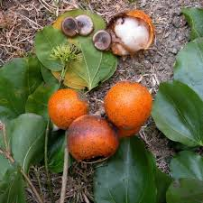 | 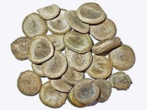
2 | Bharani/ Apabharani | Nelli/ Perunelli/ Aavali/ Amla/ Amalaki | Indian Gooseberry/ Amla | Phyllanthus emblica/ Emblica officinalis | 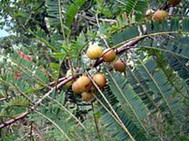 | 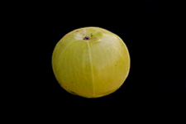
3 | Krittika/ Karthika | Athi/ Ambar/ Udumbara/ Gular | Cluster Fig/ Country Fig/ Fig | Ficus glomerata/ Ficus racemosa | 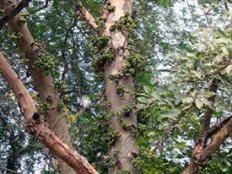 | 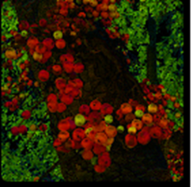
4 | Rohini | Naval/ Jambhali/ Perunjaval | Jamun/ Black Plum | Eugenia Jaambolana/ Syzygium cuminii | 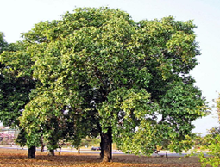 | 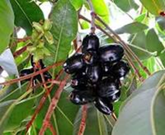
5 | Mrigashirsha/ Makayiram | Karingali/ Karungali/ Kher | Cutch Tree/ Milmesha/ Ebony | Acacia catechu/ Diospyros ebunum | 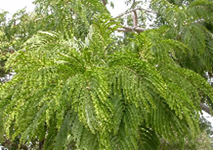 | 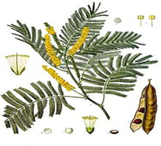
6 | Aardra/ Thiruvathira | Kari /Kumbil/ Karai/ Thippilli/ Agar/ Krushnagus/ Agalichandanum/ Akil/ Sen Santhanam/ Aguru | Cashmere Tree/ Long Pepper/ Red Sandal | Diospyros melanoxylon/ Ptero carpus santalinus/ Aquillaria agallocha | 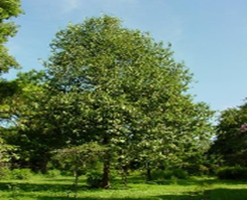 | 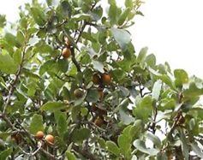
7 | Punarvasu/ Punartham/ Punarpusam | Mula/ Moongil/ Velu | Bamboo | Bambusa vulgais/ Bamboosa arundinorea | 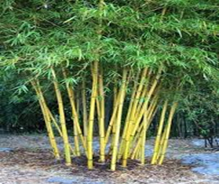 | 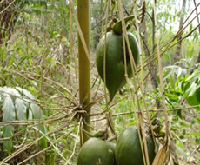
8 | Pushya/ Pooyam/ Pusam/ Tishya | Arayal/ Arasamaram/ Pimpal/ Pipal/ Aal | Sacred Fig/ Peepal/ Ficus | Ficus religiosa | 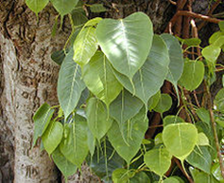 | 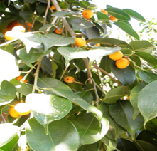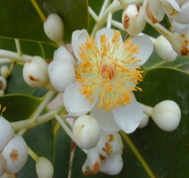
9 | Aashlesha/ Aayilyam | Punna /Punnai/ Nagapoo/ Naagchafa/ Nagkeshar/ Nahar | Messua Tree/ Alexandrian Laurel/ Beauty Leaf Poon | Calophyllum indophyllum/ Mesua ferrea | 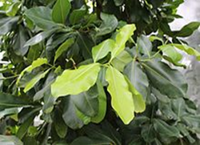
10 | Magha/ Makam/ Magam | Peral/ Alamaram/ Vatt/ Bargad | Banyan Tree/ Indian Fig | Ficus benghalensis | 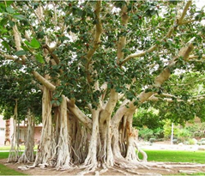 | 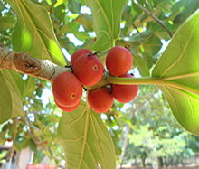
11 | Purva Phalguni/ Pooram/ Poorva | Plasu/ Chamata/ Palas/ Khakda/ Modugu/ Murikku/ Parasu/ Polash/ Desuka Jhad/ Dhak/ Chalcha | Flame of the Forest/ Parrot Tree | Butea monosperma | 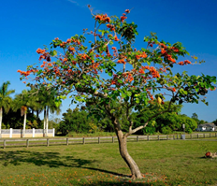 | 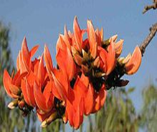
12 | Phalguni/ Uthram/ Uttara/ Uthiram/ Uttara Phalgunī | Ithi/ Itti/ Arali/ Payari | Indian Laurel/ Rose Laurel/ Indian Cleaner | Ficus tinctoria/ Nerium indicum/ Ficus arnottiana | 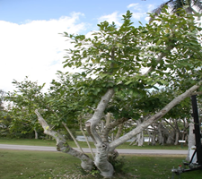 | 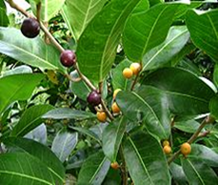
13 | Hasta/ Atham/ Astham | Ambazham/ Marima/ Nalini/ Kaatuma/ Velam/ Chameli/ Mulla/ Mullai | Hog Plum/ Neem/ Royal Jasmine / Azadirachta indica/ Jasminum grandiflorum | Spondias pinnata / Azadirachta indica/ Jasminum grandiflorum | 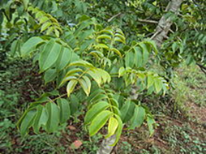 | 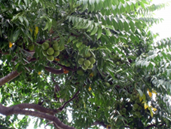
14 | Chitra/ Chithira/ Chithirai | Koovalam/ Vilvam/ Bel/ Bilvam/ Bilwa/ | Beal Tree/ Bengal Quince/ Stone Apple/ Wood Apple | Aegle marmelos | 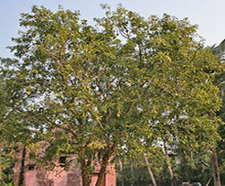 | 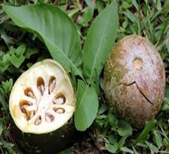
15 | Swathi/ Chothy/ Suvathi | Maruthu/ Neermaruthu/ Marutham/ Jarul/ Arjun | Arjuna Tree / Queen's Flower | Terminalia arjuna/ Lagerstroemia speciosa | 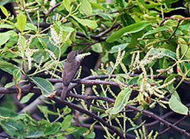 | 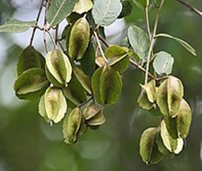
16 | Vishaka/ Visakham | Dadhipala/ Vayamkatha/ Vilamaram/ Kaith/ Naagkeshar/ Nahar | Governor's Plum/ Wood Apple/ Ceylon Ironwood/ Indian rose chestnut | Feronia elephantum/ Feronia limonia/ Mesua ferrea/ Limonia acidissima | 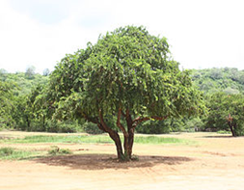 | 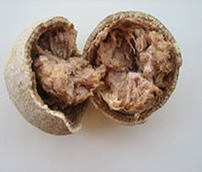
17 | Anuradha/ Anizham/ Anusham | Elanji/ Magizh/ Magizham/ Maulshree/ Naagkeshar | Bullet Wood Tree | Mimusops elengi/ Mesua ferrea | 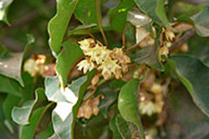 | 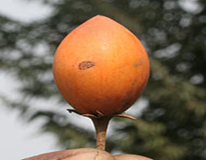
18 | Jyeshta/ Ketta/ Thrikketta/ Kettai | Vetti/ Pachotti/ Kuttipala/ Prayan/ Sambar | Bodh Tree/ Stunted Jack | Aporusa lindleyana/ Calammus rotang/ Connatus wightii | 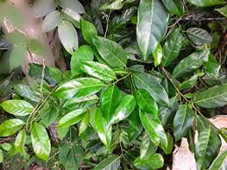 | 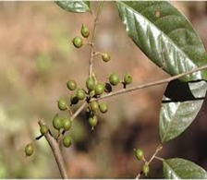
19 | Mula/ Moolam/ Vichrita | Kunthirikkam/ Veluthakunthirikom/ Acha/ Anjan/ Mamaram/ Raal/ Sal/ Shala/ Ashvakarna/ | White Dammar/ Hardwickia/ Sal Tree | Boswellia serrata/ Mangiferus indicus/ Shorea robusta/ Hardwickia binate | 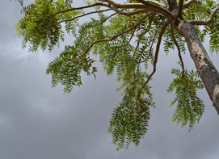 | 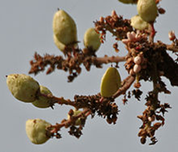
20 | Purva Ashada/ Pooradam | Aattupala/ Aatrupalai/ Samudrakai/ Vanchikodi/ Vet | Fish Poison Tree/ Tinospora | Salix tetraspeama/ Tinos pora cardifodia/ Calamus pseudo-tenuis | 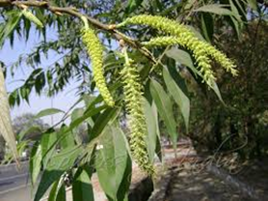 | 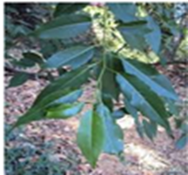
21 | Uttar Ashada/ Uthradam | Plavu/ Pila/ Pala/ Sakkai Pala/ Phanas | Jack Fruit Tree/ Bread Fruit | Artocarpus heterophyllus/ Autocarpus cummunis | 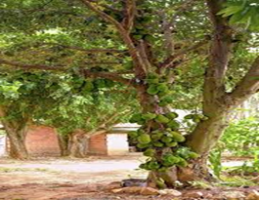 | 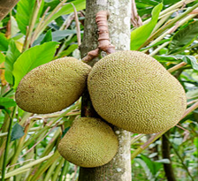
22 | Sravana/ Thiruvonam/ Shrona | Erukku/ Vellerukku/ Rui | Gigantic Swallow/ Swallow Wort | Calotropis procera/ Calotropis gigantea | 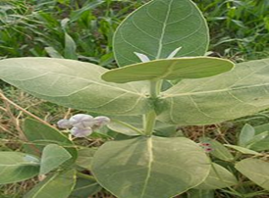 | 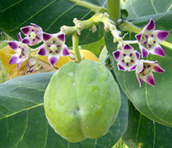
23 | Shravishtha/ Avittam/ Dhanishta | Muringa/ Paarampu/ Muringai/ Vanni/ Vilaytikikar/ Shashi | Indian Gum Tree/ Indian Mesquit/ Kejari | Moringa oleifera/ Prosopis cinenaria/ Prosepsis speciosa/ Prosopis julifl ora | 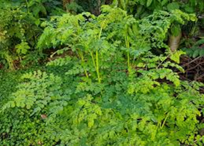 | 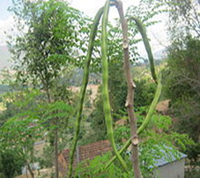
24 | Satabisha/ Shatataraka/ Chathayam/ Sathayam | Kadambu/ Kadambam/ Katampu/ Valanch | Kadam Tree/ Indian Oak | Anthocephalus cadambu/ Mitragyna parvifl ora/ Neolamarckia cadamba | 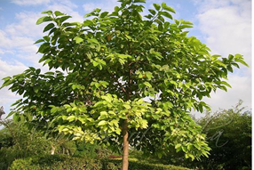 | 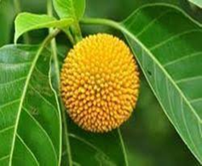
25 | Pooruruttathi/ Purva Badrapada/ Purva Proshtapada | Thembavu | साज | Terminalia Elliptica | 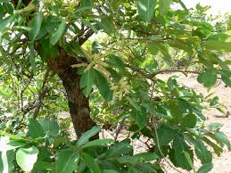 | 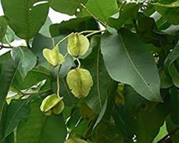
26 | Uttra Badrapada/ Uthruttathi/ Uttara Proshtapada | Kudappana | Bajarbattu बजरबट्टू | Corypha umbraculifera | 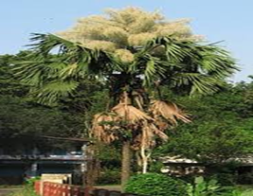 | 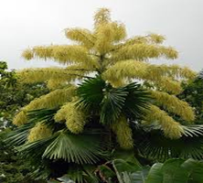
27 | Revathi | Eluppa/ Iluppai/ Moha | Butter Tree | Madhuca longifolia/  Maduca indica | 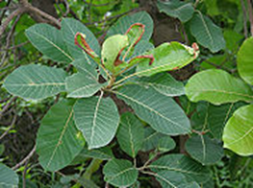 | 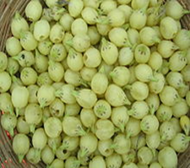

Prepared by: Siddhi S Kadam Approved by: Shailesh S Kadam

