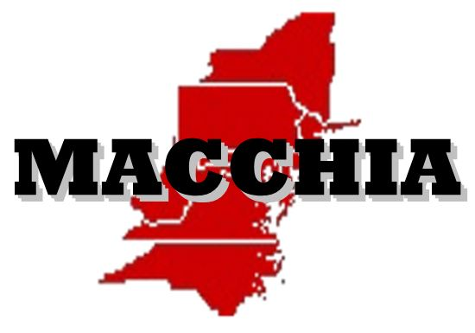


Mid-Atlantic Cold Case Homicide Investigators Association Spring 2020 Cold Case Round Table

The Mid-Atlantic Cold Case Homicide Investigators Association will hold its Spring 2020 Round Table on Thursday April 30th ,2020 at the Fairfax County Public Safety Headquarters (PSHQ) Multi-Purpose Room 2107 (second Floor) 12099 Government Center Parkway, Fairfax, Virginia 22035.
The Roundtable session will be held 0830 to1630 hours. Lunch will be provided by the Mid Atlantic Cold Case Homicide Investigators Association.

Case presentations will include open cold case homicides and lesson learned cases. The round table session will be restricted to “Law Enforcement Only” and after each case presentation a discussion period about the case will be conducted.

Several hotels are located within minutes from the roundtable location for those planning to remain overnight. They include Hilton Garden Inn, Extended Stay America, Fairfax Marriott at Fair Oaks and others with nightly rates from is $78.00 to $130.00.

For further information or if you are interested in presenting an open case please contact Detective Chris Flanagan Fairfax County Police Department at 703-246-7860 or email at Christopher.flanagan@fairfaxcounty.gov or Mike Sullivan NCIS (retired)
at 443-440-0777 or email at sullymg@aol.com

We look forward to meeting and discussing cases in the hopes of advancing them to closure!!

