

CUH Gluteal Tendinopathy Booklet

Introduction:
This booklet has been created for patients who are experiencing lateral hip pain which has been diagnosed as coming from the gluteal tendons. The leaflet covers what gluteal tendinopathy is, why it happens, what the symptoms are, pain onset, how it is diagnosed and treated. Then it covers how a patient can help themselves, including positions that will reduce aggravation of the tendons, and static and dynamic stage 1 exercises that will help to reduce pain and aid with strengthening.
Traditionally pain over the lateral hip (pain on the side of the hip and thigh) has always been referred to as trochanteric bursitis (bursitis is inflammation of a fluid filled sack which protects the tendon from bone). We now know that issues with the bursa are rare in isolation, and it is an inconsistent feature of lateral hip pain (isolated bursitis is rare- shown in only 2% of patients). Research has shown that issues with the tendons co-exist with issues with the bursa and it usually co-presents with tendon pathology (88-98% of patients have tendon pathology). However, the most recent evidence shows that the primary cause of lateral hip pain is due to pain from the tendons of gluteus medius or minimus that attach the muscle to the bone. These tendons are from the gluteal muscles (buttock muscles) that arise from the pelvis and attach to the greater trochanter- bony point at the side of the hip. Therefore, it is now known as greater trochanteric pain syndrome (GTPS) and gluteal tendinopathy.
Gluteal Tendinopathy is the most common tendinopathy affecting the lower limbs. It is more common in females than in males (4x as many women get GTPS than men) and can affect up to 25% of adults. The condition is most common in peri and post-menopausal females, present in 23.5% of women and 8.5% of men between the ages of 50 and 79. Pain in the lateral hip has been reported in up to 77% of patients with hip osteoarthritis. This condition can also occur in the young athletic population and is particularly an issue with runners or those involved with step training.
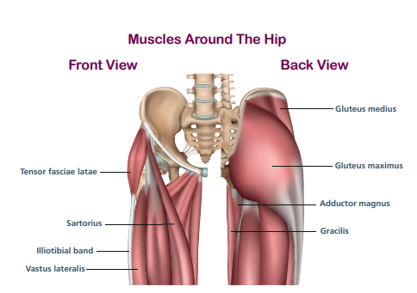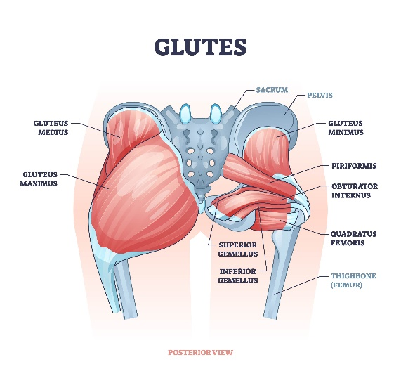
Greater Trochanter
Why does it happen?
The exact causes for Gluteal Tendinopathy are still being explored, but it is often associated with weakening of the gluteal muscles and movements that increase the stress on the gluteal tendons. Compression of the gluteal tendons over the greater trochanter is thought to be a key factor in the development of gluteal tendinopathy and can be linked to certain postural habits and movement patterns, such as hip hanging or excessive movement of the hip inwards on loading.
There are however a multitude of other contributing factors for developing Gluteal Tendinopathy including:
Any of these factors can make you more susceptible to developing gluteal tendinopathy and often it is a combination of factors.
In younger populations, it often occurs in runners or those people participating in activities involving step-up or lunging tasks. Gluteus medius and minimus (two of the hip muscles) tendinopathy may co-exist with hip joint pathology and degenerative tears of these tendons have been seen in 20% of patients with osteoarthritis. It also occurs in 20-35% of patients with lower back pain.
There is also suggestion in the research of a link between bony structure of both the femoral neck and the acetabulum (socket), the forces imposed on the soft tissues and the development of pathology, but further research is required.
What are the symptoms?
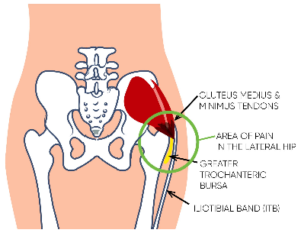
The most recognised feature of gluteal tendinopathy is pain and tenderness on the outside of your hip directly over the greater trochanter (bone at the side of the hip). Pain can also extend down the lateral thigh to the knee and may radiate anteriorly or posteriorly to the greater trochanter. Pain is often felt as sharp pain over the greater trochanter on compression or may be aching or burning in nature. Sharp pain may also be associated with snapping or clicking and this can occur when the iliotibial band (band of connective tissue at the side of your leg) crosses over the greater trochanter. Patients can also report feelings of ‘giving way’ during weight-bearing tasks.
- Pain when lying on side (either side)
- Pain on single leg loading (such as standing on one leg to get dressed)
- Pain on sitting for a prolonged period in low chairs or car.
- Pain on rising from a chair for first few steps
- Pain on walking up hills or stairs
- Pain on running
- Pain when touching on the lateral hip bone
Pain onset:
Gluteal tendinopathy often becomes symptomatic when a tendon that is weak, is exposed to a sudden increase in loading, for example hill walking or walking a much longer distance than normal, or climbing lots of stairs. Tendons can react when a change of load has occurred such as too much or too little loading- so after a period of rest for example.
It can also occur after a direct impact to the greater trochanter, such as a slip or fall which resulted in landing onto the greater trochanter and therefore a sudden increase in load and compression on those tendons. However, it is multifactorial and often it is difficult to identify a specific incident, and it can therefore be due to a gradual deterioration in tendon health overtime, alongside load changes and compression elements. Subsequently, the overload on the tendon becomes too much and tendon pain occurs.

How is it diagnosed?
In most cases your doctor or physiotherapist will suspect Gluteal Tendinopathy from the symptoms you describe and also from a cluster of tests they will complete when the physically examine your hip. These can include (but are not limited to): palpation of the side of your hip, single leg balance test, resisted side lying abduction test, a hip rotation test as well as others. Sometimes, further diagnostic tests such as an ultrasound or MRI scan are used but are not required for confirmation of diagnosis.
How is it treated?
A detailed assessment of your hip will be completed by your Physiotherapist or medical professional, they will also assess your postural and movement habits as well as discuss your day to day activity. The most up to date evidence supports that the best treatment for Gluteal Tendinopathy is Physiotherapy.
Treatment should focus on:
1. Reduction of compression of the tendons over the greater trochanter.
2. An exercise programme, which should focus on the correct control, recruitment and capacity of the muscles around the hips and pelvis.
Gluteal tendinopathy is multi-factorial and therefore your Physio will discuss with you all factors that could be contributing to your pain- this may include weight management, diet, hormones, activities etc. You will also be advised on adjustments to work/hobbies/leisure activities that may be required to settle your pain.
What can I do to help myself?
The quickest way to make a difference is to reduce the compressive load on the tendon by preventing any postures that aggravate the tendon and load the lateral hip- so any position where the hip is moved out the side relative to the knee- so standing with one hip ‘hung to the side’ such as holding a child on your hip, or stopping bringing the knee across the body (sitting cross legged) and stop doing buttock stretches.
The first step to treating Gluteal Tendinopathy is to decrease the amount of compression on the tendon over both the day and during the night. Postural activity modifications are vital:
Sitting
• Minimise the time spent crossing your ankles or legs
• When you sit aim to sit with the hips higher than the knees, and try not to sit on low chairs. Using a wedge cushion may help to keep the hips higher than the knees.
Sitting positions examples of correct and incorrect
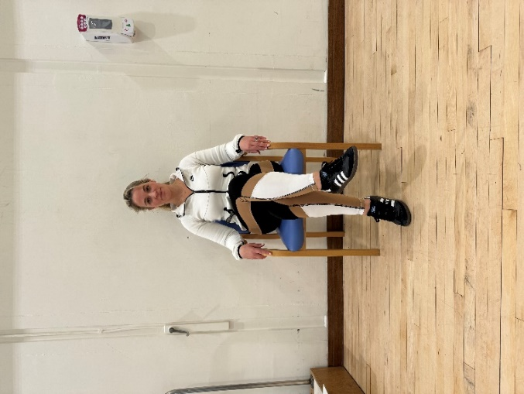
X- Incorrect
Woman demonstrating incorrect sitting posture with crossing legs.
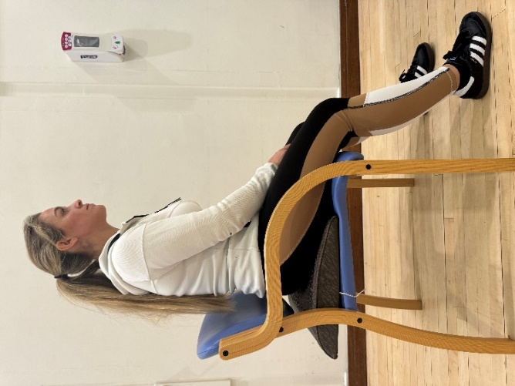
- Correct
Woman demonstrating sitting on a wedge cushion to aid hip pain and with knees lower than hips.

Sleeping:
- If you sleep on your side- try to avoid sleeping on the sore hip and place a pillow between your knees- this will keep your hips in neutral alignment
- Another sleeping position that can be helpful is semi prone (halfway between lying on your tummy and your side- to avoid direct compression on the affected hip) again pillows need to be used to support the top leg and in front of the trunk to avoid rolling fully onto your tummy and the underside hip can be straightened
- If both hips are painful, an option is sleeping on your back with pillows under your knees
- An eggshell mattress topper can be helpful as it reduces the amount of compression through the hips.
Sleeping positions examples of correct and incorrect
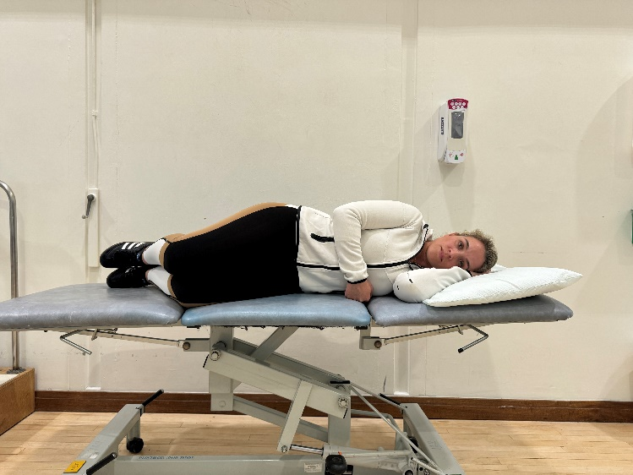
X- Incorrect
Woman demonstrating incorrect sleeping position
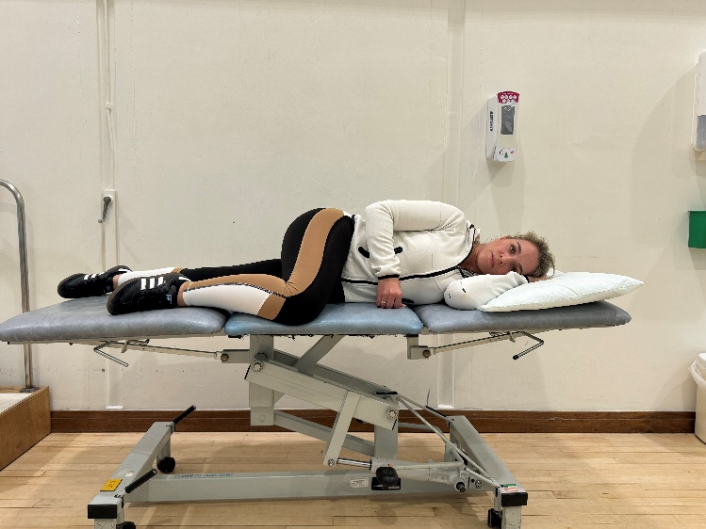
X- Incorrect
Woman demonstrating incorrect sleeping position

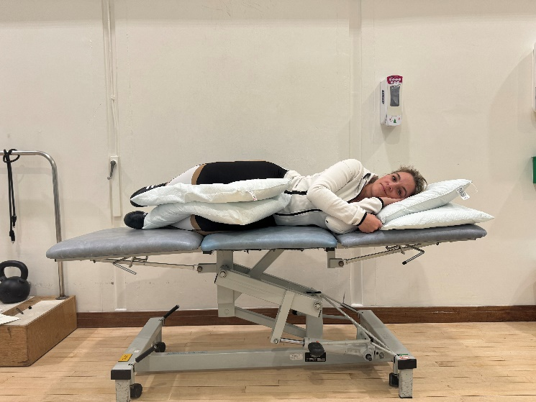
- Correct
Woman demonstrating correct sleeping posture with use of pillows to aid alignment.
Functional movements:
Your Physiotherapist will assess you and advise on specific movement and postural adaptations to you, but here are some you can try:
- Avoid hill walking and stairs where possible
- Try not to walk too far in a day and minimise walking distance where able
- In standing try to keep weight distribution equal through both feet and do not hang on one hip.
- On stair climbing use a rail on the opposite side to the painful hip and try to put your leg a little wider and reduce the rolling inwards of the knee.
- Avoid end range, prolonged stretching of the hip.
Standing positions examples of correct and incorrect
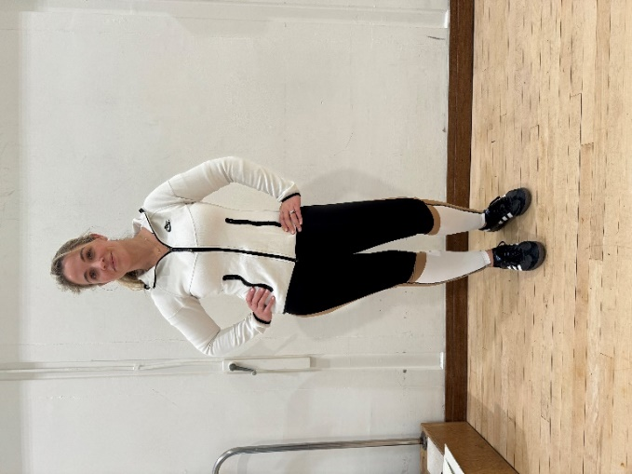
X- Incorrect
Woman demonstrating incorrect standing posture
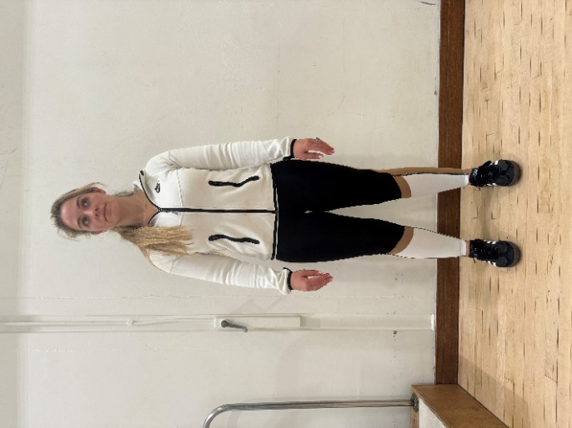
- Correct
Woman demonstrating correct standing posture
Stair climbing position examples of correct and incorrect
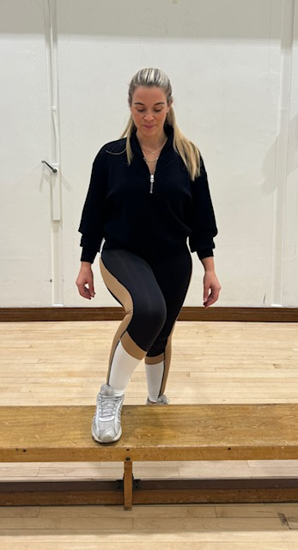
X- Incorrect
Woman demonstrating incorrect stair climbing position of leg.
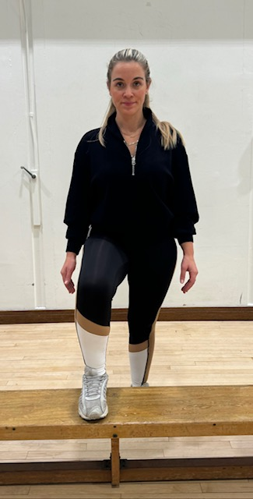
- Correct
Woman demonstrating correct leg position for climbing stairs.
Lifestyle changes:
- Maintaining a healthy weight is important to reduce likelihood of further flare ups.
- Healthy diet as per NHS eat well plate is recommended
- Smoking cessation- smoking has been shown to adversely affect the health of tendons.
- Low cholesterol and low saturated fat diet- high cholesterol also affects tendon health and is important to manage to aid with tendon pain.
- Discuss pain relief with pharmacist or GP as required
- Relaxation and mindfulness

Should I consider a Cortico-steroid injection?
- Physiotherapy, compression and load management should be the first port-of call before considering a steroid injection.
- Steroid injections can aid with pain relief in the short term (3-6 months) in low-moderate grade tendinopathy. Caution should be considered as steroid can have potential negative effects on tendon health in certain tendons.
Exercises:
Changes in abductor muscle size and quality have been shown on MRI studies in those patients with lateral hip pain. Fatty atrophy of gluteus medius and minimus has been observed- this means that there is a combination of reduced muscle size and the replacement of muscle tissue with fat.
Studies looking at muscle strength in gluteal tendinopathy have demonstrated that if pathology is present in one hip, both hips gluteal strength is affected. On average the symptomatic side is 32% weaker and the non-symptomatic side is 23% weaker than patients without gluteal tendinopathy. Therefore, it is key to strengthen both hips in the presence of gluteal tendinopathy.
- Avoid any stretching as this will increase compressive forces applied over the greater trochanter and aggravate symptoms. Avoid gluteal stretches, strong lumbar rotation stretches or ITB stretches.

Example of stretching exercise that may aggravate hip

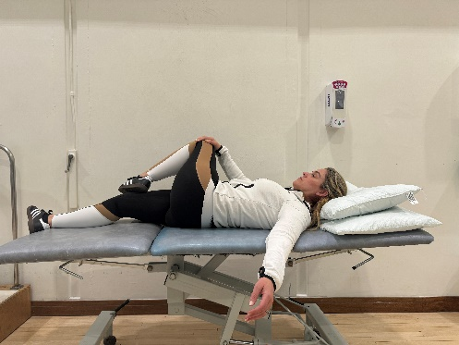
X- Incorrect

- Load management- minimise time spent in provocative postures such as sitting cross legged, hip hanging, reducing walking distance etc.
- Avoid hill and stair climbing.
- If doing floor based pilates, avoid clams and side lying leg lifts as these both increase compression and friction at the greater trochanter.
- Gait re-training- smaller stride length, leading with the knee and landing softly.
- Graded strengthening programme.
Stage 1 Exercises:
- The early exercises are designed to start strengthening your muscles without irritating the pain.
- The exercises labelled P can help ease pain. Do these every day if you have hip pain. Even if you are having a flare up.
- The exercises labelled s are strengthening exercises. Do a selection of these at least four times per week.
- Muscle ache during exercise is OK but it should settle quickly and feel no worse as a result later. If it does, reduce the number you are doing and discuss it with your physiotherapist.
Exercise 1: Static muscle activation:
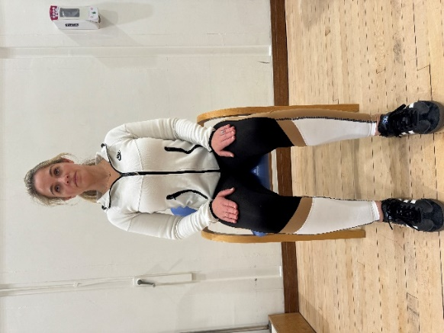
P: STARTING POSITION: Sitting. Knee's bent and hip width apart. Feet flat on floor
ACTION: Imagine that your feet are resting in a sandpit. Steadily push the soles of your feet out into the sand as though trying to leave a convincing impression in the sand.
HOLD TIME: 10-20 seconds. Relax slowly
NUMBER OF REPETITIONS: 4 reps 3 sets

Woman demonstrating static gluteal muscle activation in sitting feet apart.
Exercise 2: Static muscle activation:
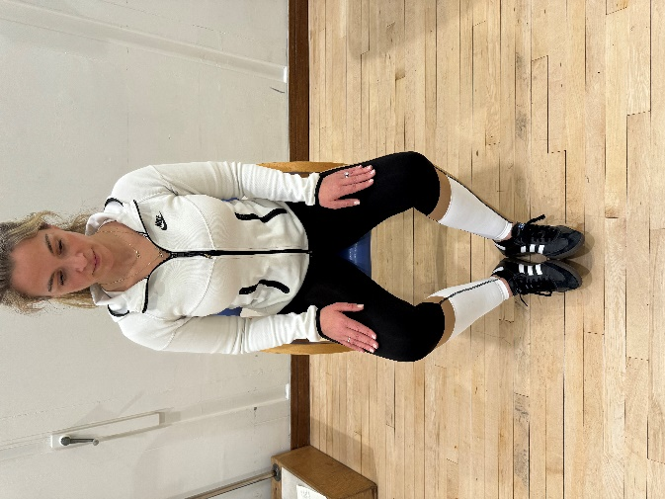
P: STARTING POSITION: Sitting. Knee's bent and hip width apart. Heels together. Put a cushion or something soft between your heels if needed for comfort
ACTION: Steadily squeeze your heels together
HOLD TIME: 10-20 seconds. Relax slowly
NUMBER OF REPETITIONS:
Woman demonstrating static gluteal muscle activation in sitting heels together.
Exercise 3: Static muscle activation in lying with belt:
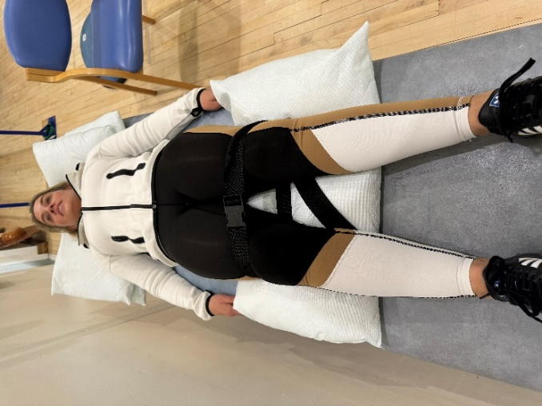
P: STARTING POSITION: Lying on your back pillow under your knee, hips hip width apart. Belt around the top of the knees (as shown)
ACTION: Steadily squeeze your knees out into the belt- feeling an activation in your bottom.
HOLD TIME: 30 seconds. Relax slowly
NUMBER OF REPETITIONS:

Woman demonstrating static muscle activation against belt in lying position with pillow under knees and belt around top of knees.
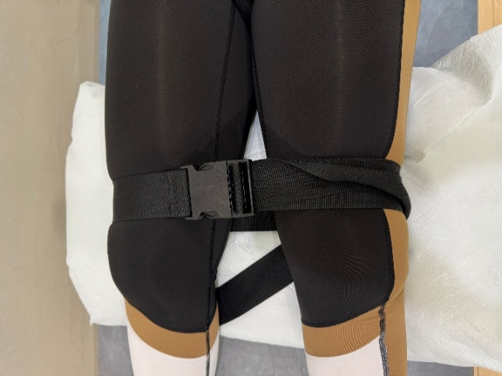
Close up picture of belt position-Woman demonstrating static muscle activation against belt in lying position with pillow under knees and belt around top of knees.

Exercise 4: Static muscle activation in sitting against belt
P: STARTING POSITION: Sitting. Knee's bent and hip width apart. Feet flat on floor. Place a strong leather belt, luggage strap or similar around your lower thighs
ACTION: Steadily push your knees out into the restraint- feeling an activation in your buttock- do this slowly like turning up the button on the radio.
HOLD TIME: 30 seconds. Relax slowly
NUMBER OF REPETITIONS: 4 reps 3 sets

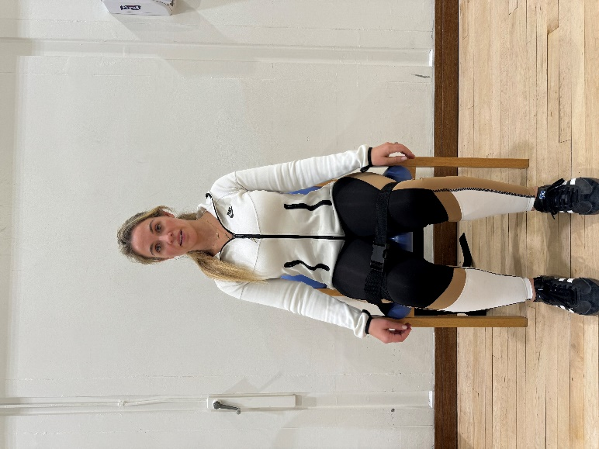
Woman demonstrating static muscle activation in sitting with belt around top of knees.

Strengthening exercises:
Exercise 5: Bridge with belt.
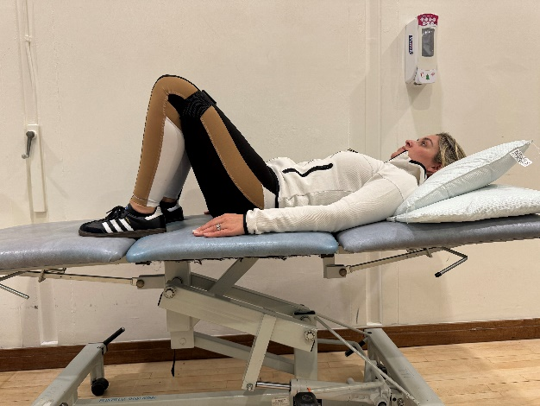
S: STARTING POSITION: Lying on back, knees hip width apart and bent to roughly 90°. Feet apart on floor/ bed. Belt around your knees gently squeeze out into the belt.
ACTION: Slowly roll your pelvis back and tuck your tail bone in, this flattens your lower back into the floor/ bed. Then slowly push through your heels and raise your bottom off the bed.
HOLD TIME: 5 seconds. Relax slowly
NUMBER OF REPETITIONS: 8 reps 3 sets
PROGRESSION: As above and then place your feet in a step stance position.

Woman demonstrating starting position in lying with belt around knees and bent legs.
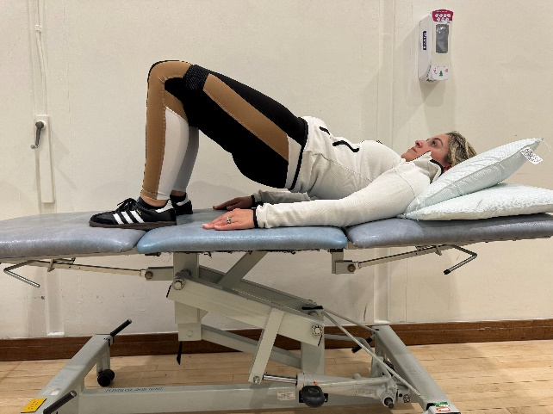
Woman demonstrating bridge exercise with belt around knees and knees bent lifting bottom off the bed whilst gently squeezing out into belt.
Exercise 6: 4 point kneeling core activation.

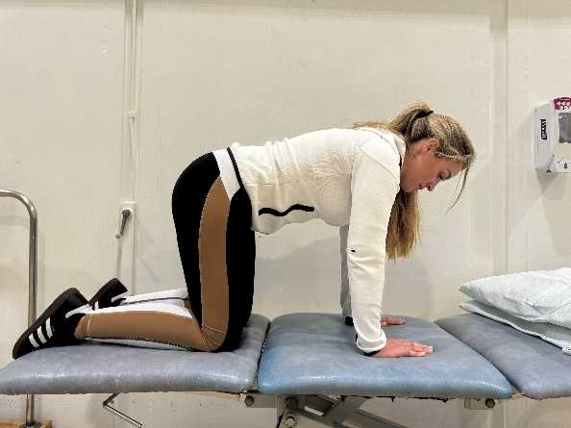
S: STARTING POSITION: Kneel on all fours with your knees and hands hip width apart. Stomach relaxed. Keep your spine straight throughout
ACTION: Draw your lower tummy (area below the belly button) in towards your spine. The effort needed to do this should not be more that 50% of the maximum effort you could try. Breathe normally
HOLD TIME: 10-20 seconds. Relax slowly
NUMBER OF REPETITIONS: 4 reps
PROGRESSION: As this gets easier, start to add a buttock clench at the same time

Woman demonstrating kneeling on all 4’s and then trying to draw belly button up to spine and engage lower abdominal muscles.
Exercise 7: Sit to stand with belt
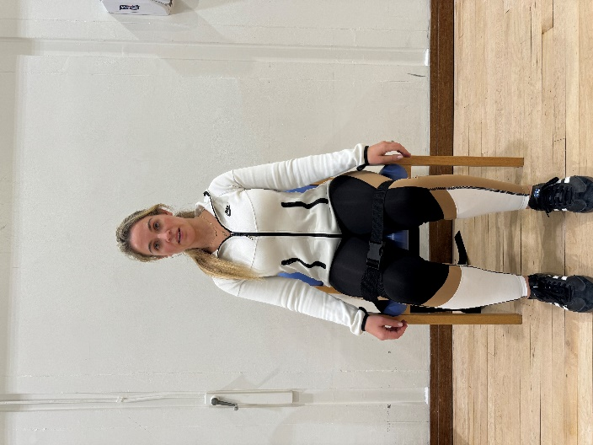
S: STARTING POSITION: Sitting. Knee's bent and hip width apart. Feet flat on floor. Arms folded across your chest. Belt around your knees squeezing out into the belt.
ACTION: Tighten your buttocks then slowly stand up maintaining the 'squeeze' of your buttocks. Then do the same to sit down slowly. Keep your feet and knees apart throughout.
NUMBER OF REPETITIONS: 8 reps 3 sets
PROGRESSION: Start with a high chair and as it gets easier, move to a lower chair.

Woman demonstrating sit to stand with belt around knees.
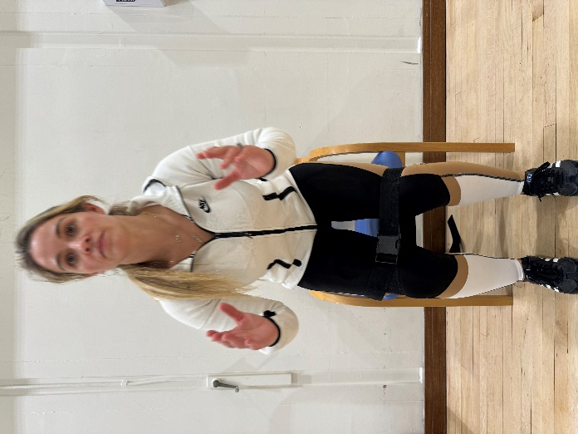
Woman demonstrating sit to stand with belt around knees.

Key Messages:
- Hurt doesn’t equal harm- pain is not a direct indication of damage.
- Pain is multifactorial and lots of things impact pain levels: such as poor sleep, stress, poor diet and high BMI, alcohol, smoking and low activity levels.
- Reconditioning your hip and building up tendon strength and capacity is key to all the tasks you need to do.
- Striking a balance between working hard enough to recondition the tendons but respecting their sensitivity is key- Listen to your pain.
- Think of pain like a traffic light system 0-4 is green pain, 4-6 is amber pain and 7-10 is red pain, be cautious exercising in amber and do not push into red pain.
Beware of latent tendon pain: Monitoring night time pain can be useful for how the hip is tolerating loading. If pain increases at night it can highlight that the activity completed that day or within the last 2 days may have been too much for the tendon and therefore should be reduced. You can push into a tolerable amount of pain that settles within an hour or so- this means the load is correct.
Prognosis:
Early diagnosis and management of load and compression with Physiotherapy can see symptoms change fairly quickly. The most optimal outcomes are achieved over a period of at least 12 weeks of exercise and two thirds of people will see their symptoms resolve within a year. Gluteal tendinopathy is a degenerative process with significant implications on quality of life and it is important to seek advice on management.

What have I learnt?

What will I try?

Notes page

Written by Holly Soper Young Adult Hip Advanced practice Physio and Wioleta Jonecko Senior YAH Physio.

