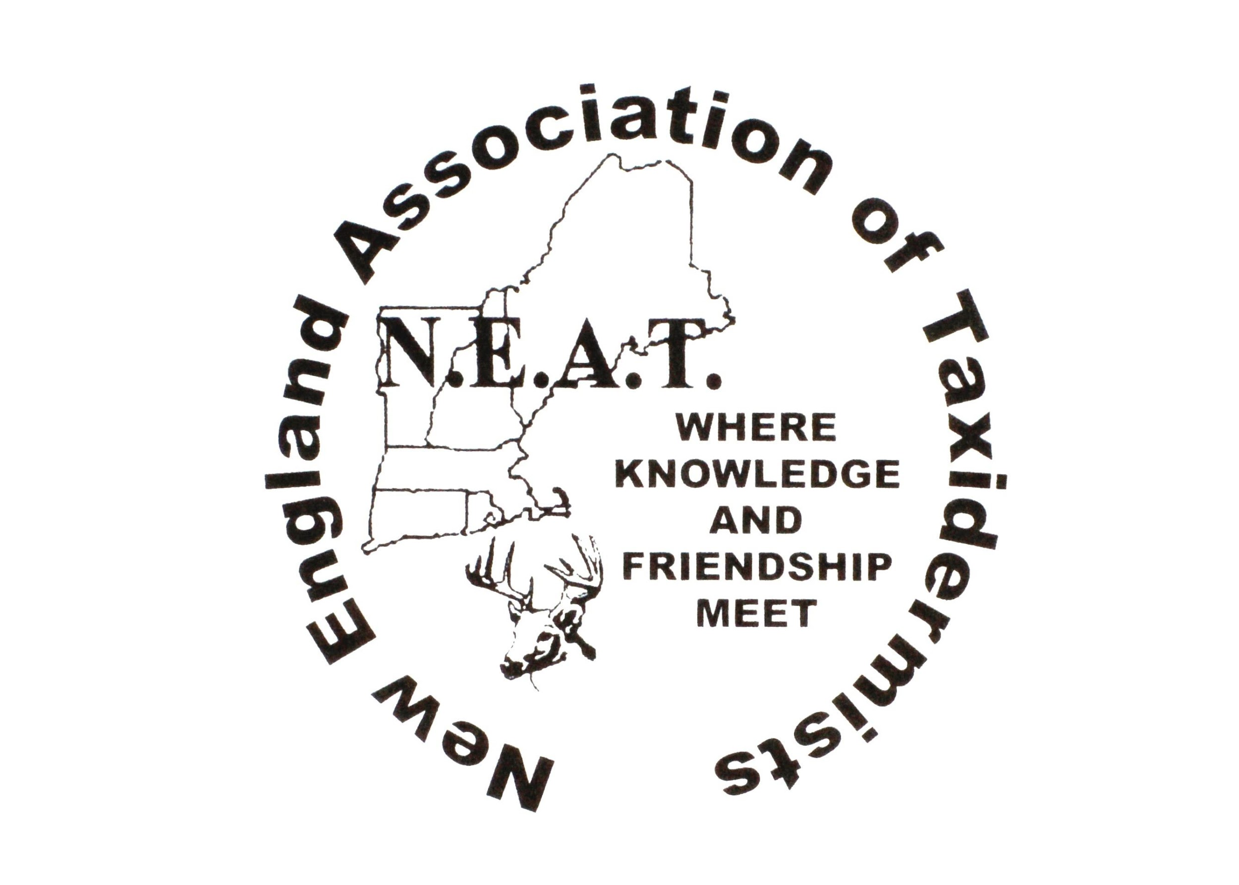
New England ASSOCIATION OF Taxidermists
www.newenglandtaxidermists.org

Where Knowledge and Friendship Meet March 2026
Officers:

President:
Steve Mudgett
(978)771-4185

Vice President:
Duane Couture
(802)309-2624
cwctaxidermy21@outlook.com

Treasurer:
Mary King
300 Maple Ridge Rd
Danby, VT 05739
(802)293-2031

Secretary:
Ann Couture
(802) 309-9465
2495 Boston Post Rd
Enosburg, Vt 05450
cwctaxidermy21@outlook.com

Board of Directors:

Gerald Menard, Jr Amy Blanchette
(603)475-8910 (207)577-9514

John Biedakiewicz Katherine Nee
(585)619-0989 (603)957-1284

Cole Young Peyton Sweet
(607)661-9259 Jr member

David King Ed Haberern
(802) 688-3668 (860)462-9869

New England Association of Taxidermists
Annual Convention and Competition
2026 Spring Newsletter

President’s Message
Hello all- this will be our last notice before our 2026 show. Spring is right around the corner, and the show is fast approaching. Hopefully everyone is already working on multiple pieces for the show. Please make every effort to get your registration in early along with your banquet meal number. This is very helpful to plan meals. We have some great judges coming and looking forward to a great show. We will have some changes to our show room area for better exposure and safety to all pieces entered.
Hope to see you all there May 29-31st
Sincerely,
Steve Mudgett, NEAT president

Vice President’s Message

Hi everyone,

Just a few quick words from your VP. First, I wanted to tell you all how much we appreciate your support of NEAT. Without your support we cant make this happen. We are working hard to set up another excellent show for you all this year with some great seminars and I hope to see you all there!

Thank you,
Duane Couture

TREASURER’S MESSAGE

Hi everyone,

It will be great to see everyone at the show, and I look forward to meeting new members. For many it was a traditional New England winter and I’m sure you are looking forward to spring. I know some may think I’m repetitious with the below, but it is so important that I can’t help bringing it to your attention.

Hotel booking deadline for the special rate of $146.00 is April 30th.

The hotel regular rate a/o Feb. 2026 is $195.00, and they sometimes raise their rates for spring/summer. Pre-registration for the show is a very important part of the planning process, especially for the Banquet.

BANQUET deadline is May 23rd.

Please note: for folks that sign up for the (children’s meal 5 and under) you must put a quantity in otherwise it doesn’t show up for a count on-line.

Last year we had people wanting to register for the Banquet at the door, unfortunately I had to say no.

ENTRIES – give us a preliminary quantity of entries so that we have sufficient room on the boards, you can add or subtract that quantity and pay at the door.

PLEASE EMAIL YOUR PRELIMINARY ENTRY FORMS TO:

MARY KING

dcking@vermontel.net

if you prefer to call: 802-688-3329

or mail them to:

300 Maple Ridge Rd

Danby, VT 05739

Mary King

Mark Your Calendars!

2026 Show Dates are May 29-31st

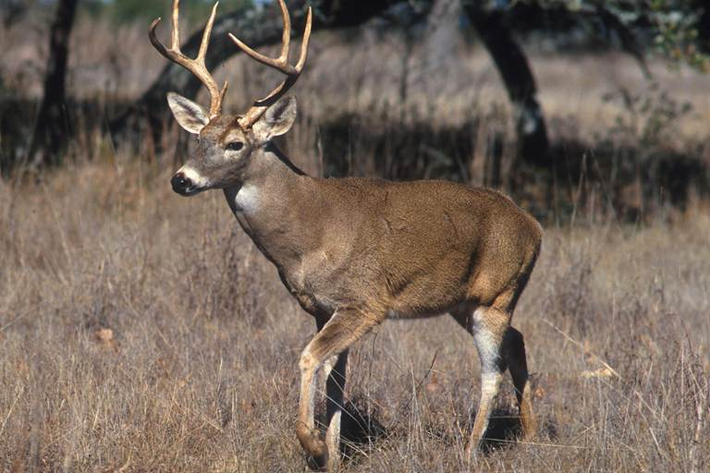

2026 President’s Cup: Fur Bearing
Mammal, Lifesize or Shoulder Mount

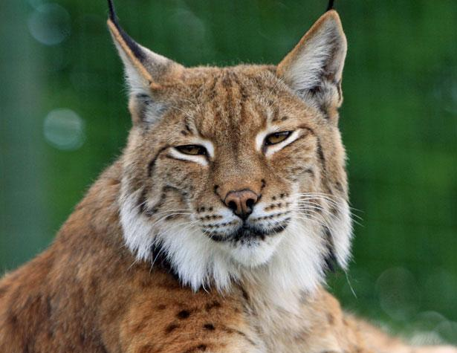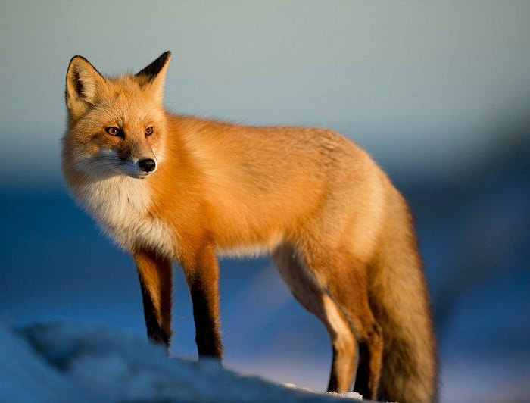
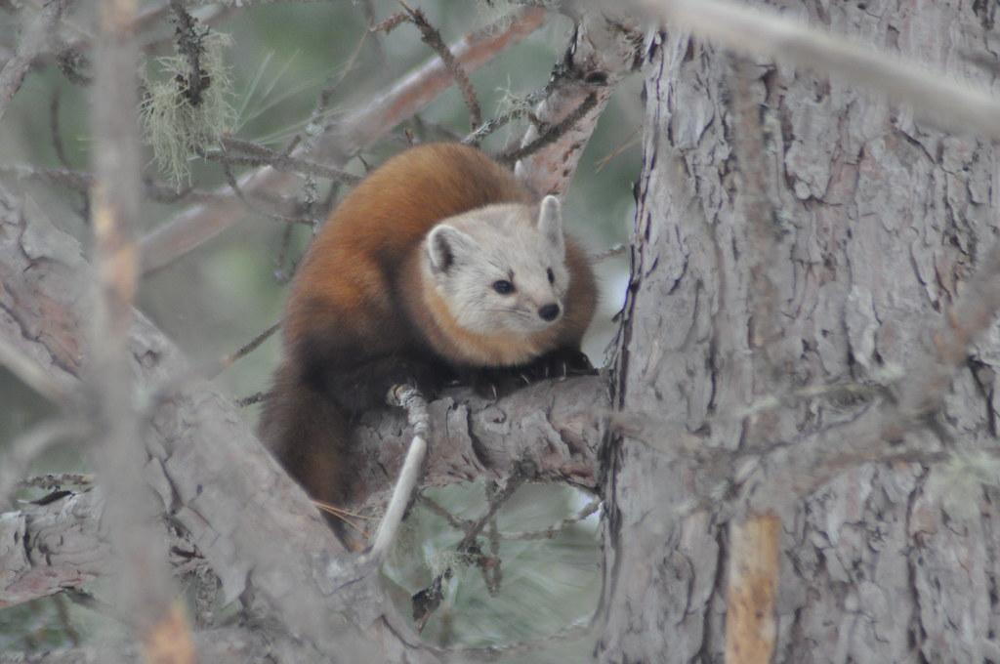
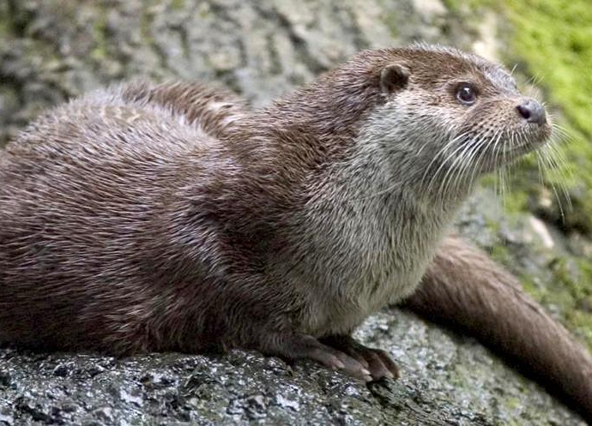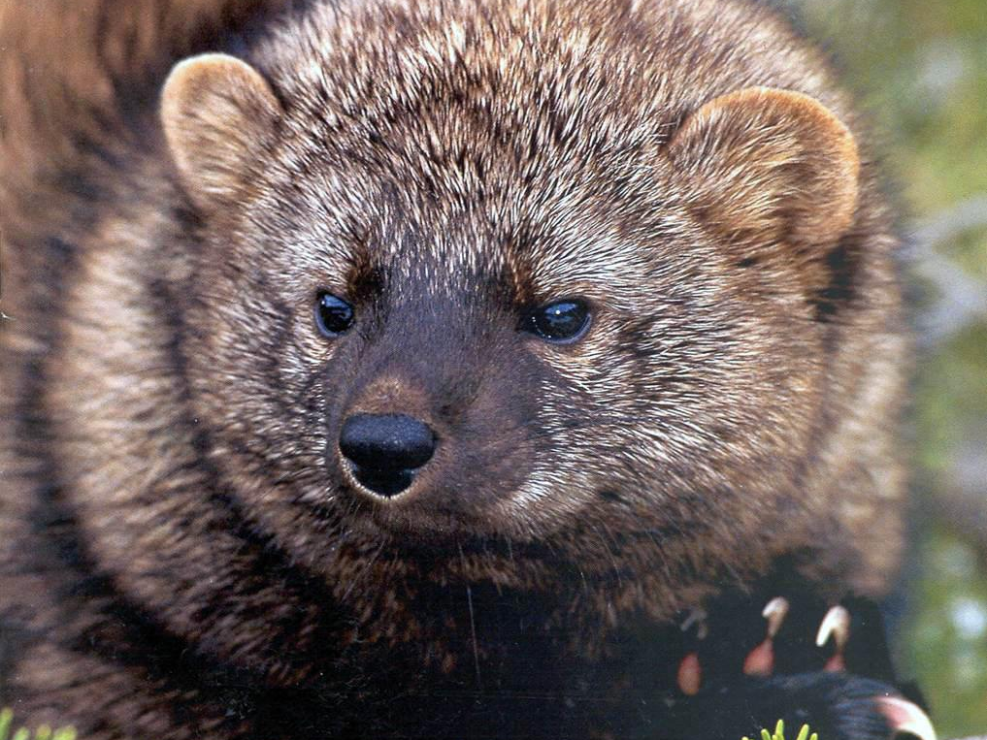
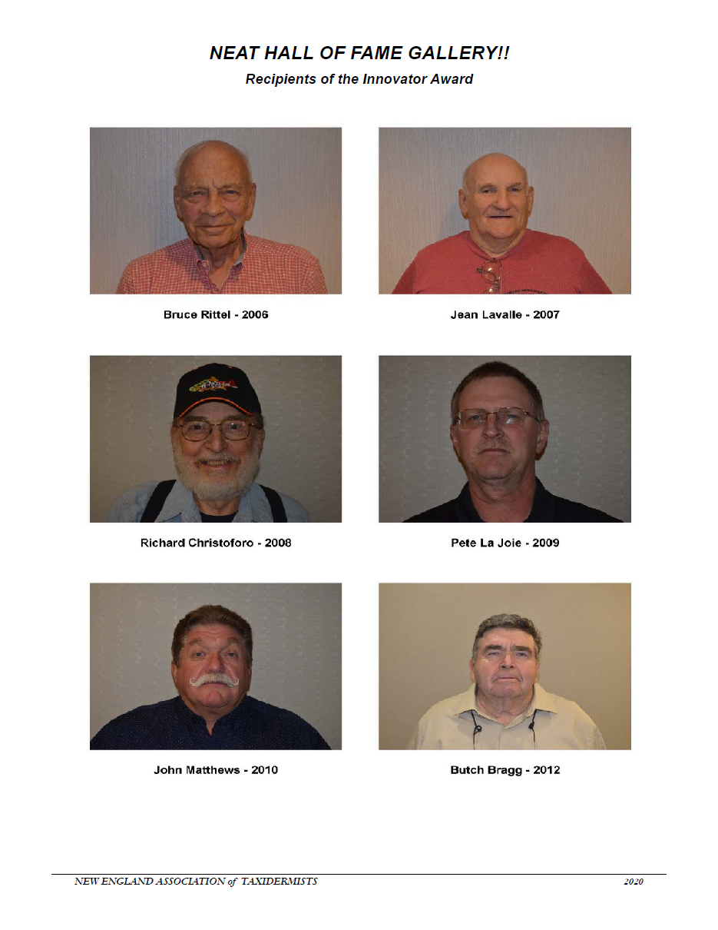
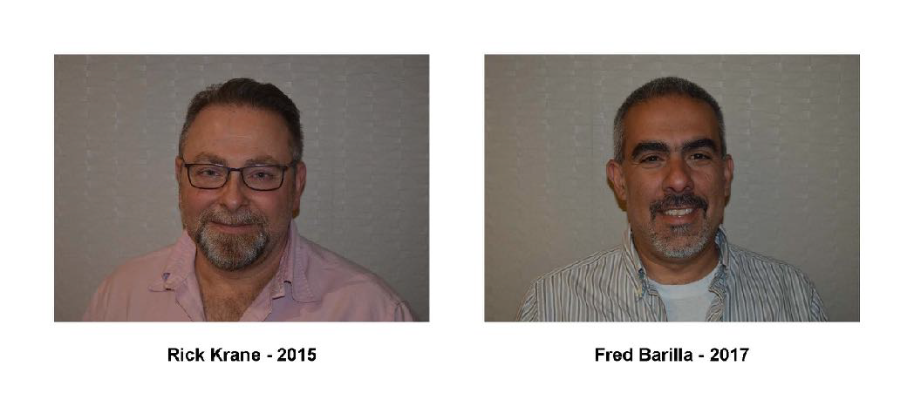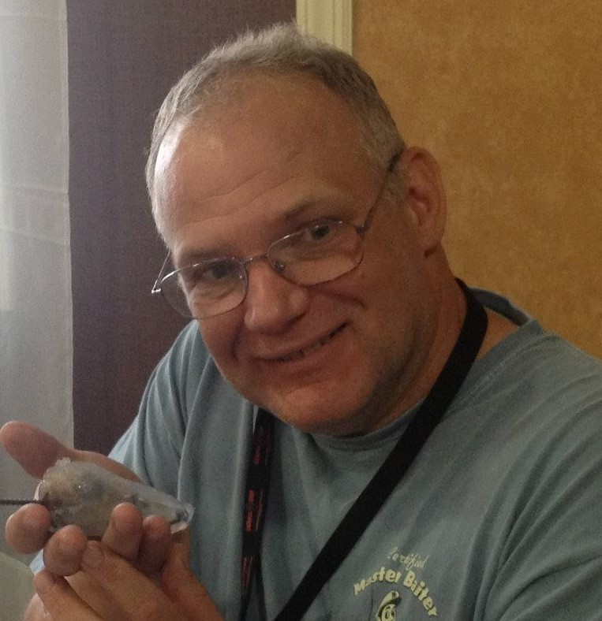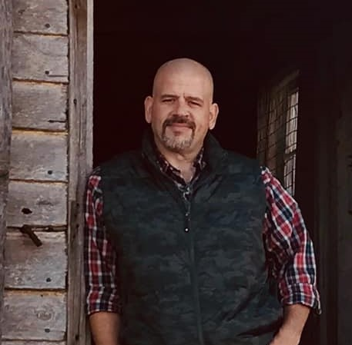

Steve Hackett - 2021 Matt Marulli - 2024

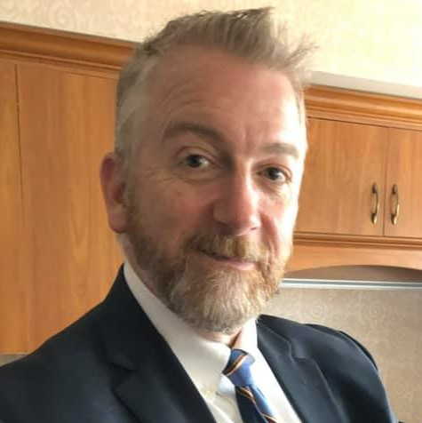
Dave Whitney - 2025

2026 Judges

Dalton Jeffers - Deer
Dalton grew up around taxidermy and the outdoors from a very early age with his father. At the age of 8 he went to his first National Taxidermy Show in Louisville, KY. He joined the board of Maryland Taxidermy Association at the age of 18. He trained under Tom Jeffers and Walter “Tinker” Johnson, along with a few lessons from Charlie Fegan of Fegan’s Taxidermy. Dalton is a National Champion Award Winner; he has won Regionals and awards in W. Virginia, Kentucky, Virginia, N. Carolina and Maryland. Dalton resides in Virginia.

George Dante - Fish and Birds
The founder of Wildlife Preservations, George has over thirty years of experience as a taxidermist, model maker, illustrator and fine artist. He has been fascinated by art and the natural world throughout his entire life. George began a successful part-time taxidermy business while in high school and continued his company while obtaining a BFA from The School of Visual Arts in NY. In 1996 George combined his two passions when he officially formed his growing high school business as Wildlife Preservations, LLC. George’s awards include a 1997 National Taxidermy Association (NTA) National Championship and an NTA Award of Excellence. He is an NTA Certified Judge. His sculptures, paintings and illustrations have been exhibited in numerous New York art galleries.

2026 Judges

Bob Coughlin - Mammals and Gameheads
Bob has been doing taxidermy for 45 years. He was a member of both the New York Taxidermy Association and the Empire Taxidermy Association and played a role in the unification of the two associations into the UTNY. He also created the logo for the United Taxidermists of New York. Bob is a six-time recipient of the Best All Around Taxidermists Award. He has won awards in New York, Connecticut, New Jersey, Canada, the Nationals and World Show. Bob and his wife Cindy reside in Binghamton, NY.

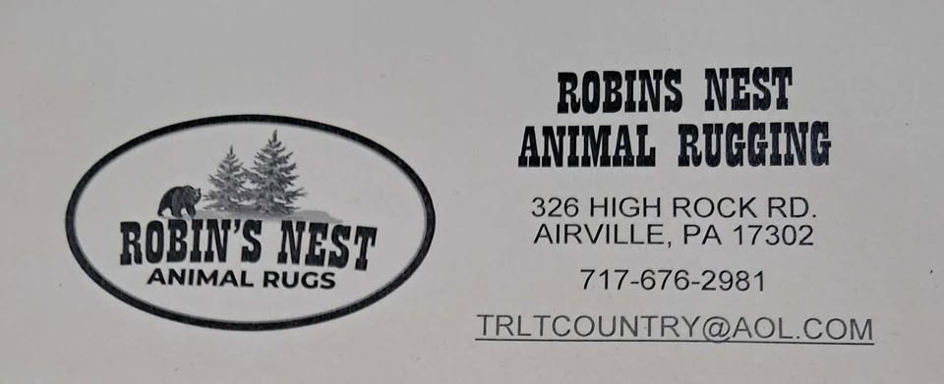

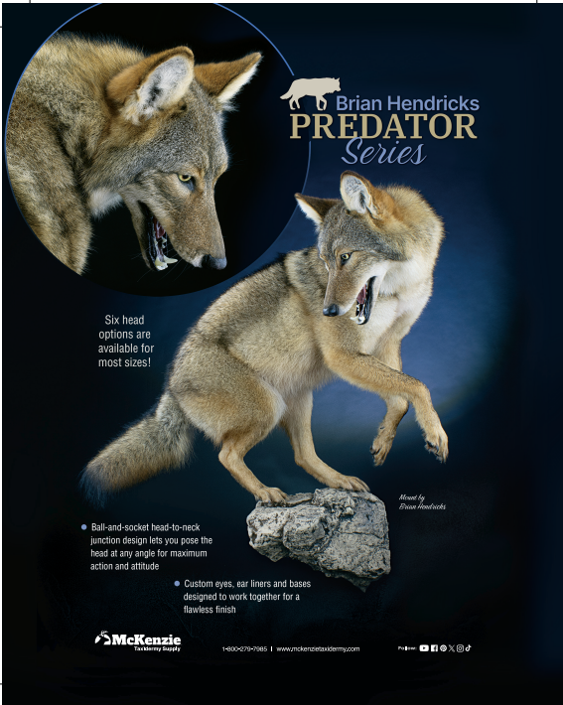

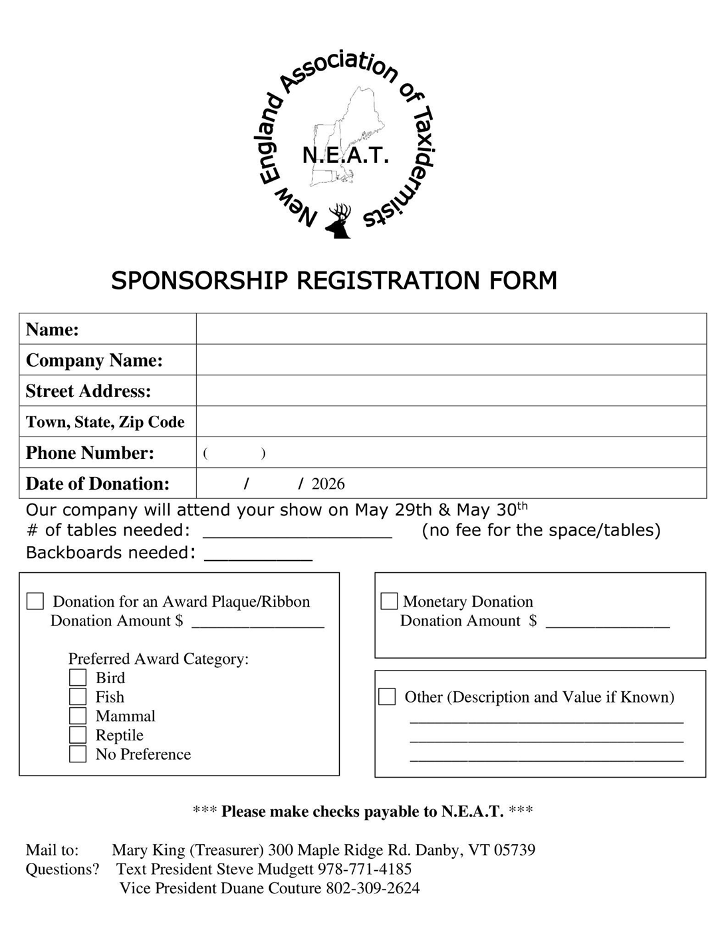 The Double Tree by Hilton in Windsor Locks, CT

16 Ella T. Grasso Turnpike
1-860-627-5171

Make your room reservation now!
https://www.hilton.com/en/attend-my-event/new-england-taxidermists-2026/
We have a block of rooms reserved for NEAT
**If you would rather call, when making reservations, please mention you are attending the NEAT taxidermy show and give the date and give the date **
The room rates are $146.00 per night, book by 4/30/26

"There is no fee to make a reservation, so make them early and don't miss out on a better rate."

From points South:
I-84 East, or I-95 North to I-91 North to exit 40, Route 20 (to Bradley International Airport). Follow Route 20 for 2 miles to the second exit, Route 75. Turn Right at the top of the exit. The Hotel is.1 mile ahead on the left.

From Points North:
I-91 South to exit 40, Route 20 (Bradley International Airport). Follow Route 20 for 2 miles to the second exit, Route 75. Turn right at the top of the exit. The Hotel is .1 mile ahead on the left..

From Points West:

The Massachusetts Turnpike (I-90) West to exit 51. Take a left onto I-291 to I-91 South. Follow I-91 South to exit 40, Route 20. (to Bradley International Airport) Follow Route 20 to the second exit, Route 75. Turn right at the top of the exit. The Hotel is .1 mile ahead on the left.

Many suppliers will be giving a discount for up to a week after the show

Pre-Registration Benefit

All pre-registered competitors will be entered into a drawing for a prize.

So please pre-register for a chance to win!

Please preregister by 5/22/2026!

Raffle Tickets For 2026 Show
New England Association of Taxidermists
$10.00 each Drawing 5/30/2026

1st Prize: $1,000.00

2nd Prize: $500.00

3rd Prize: $250.00

***Winner does not need to be present to Win

*****Another raffle to be sold at the show only:
$10.00 each Drawing 5/30/2026
Free membership & 3 Free Entries For 2027 Show

For those who wish to purchase raffle tickets in advance- these are money order/ check only purchases, you can send the money to Mary King, Treasurer, at 300 Maple Ridge Road Danby, VT 05739. Mary will then fill them out and send you proof of purchase (ticket with your name on it), via email. She will need: Legible name, phone number, and email address.

