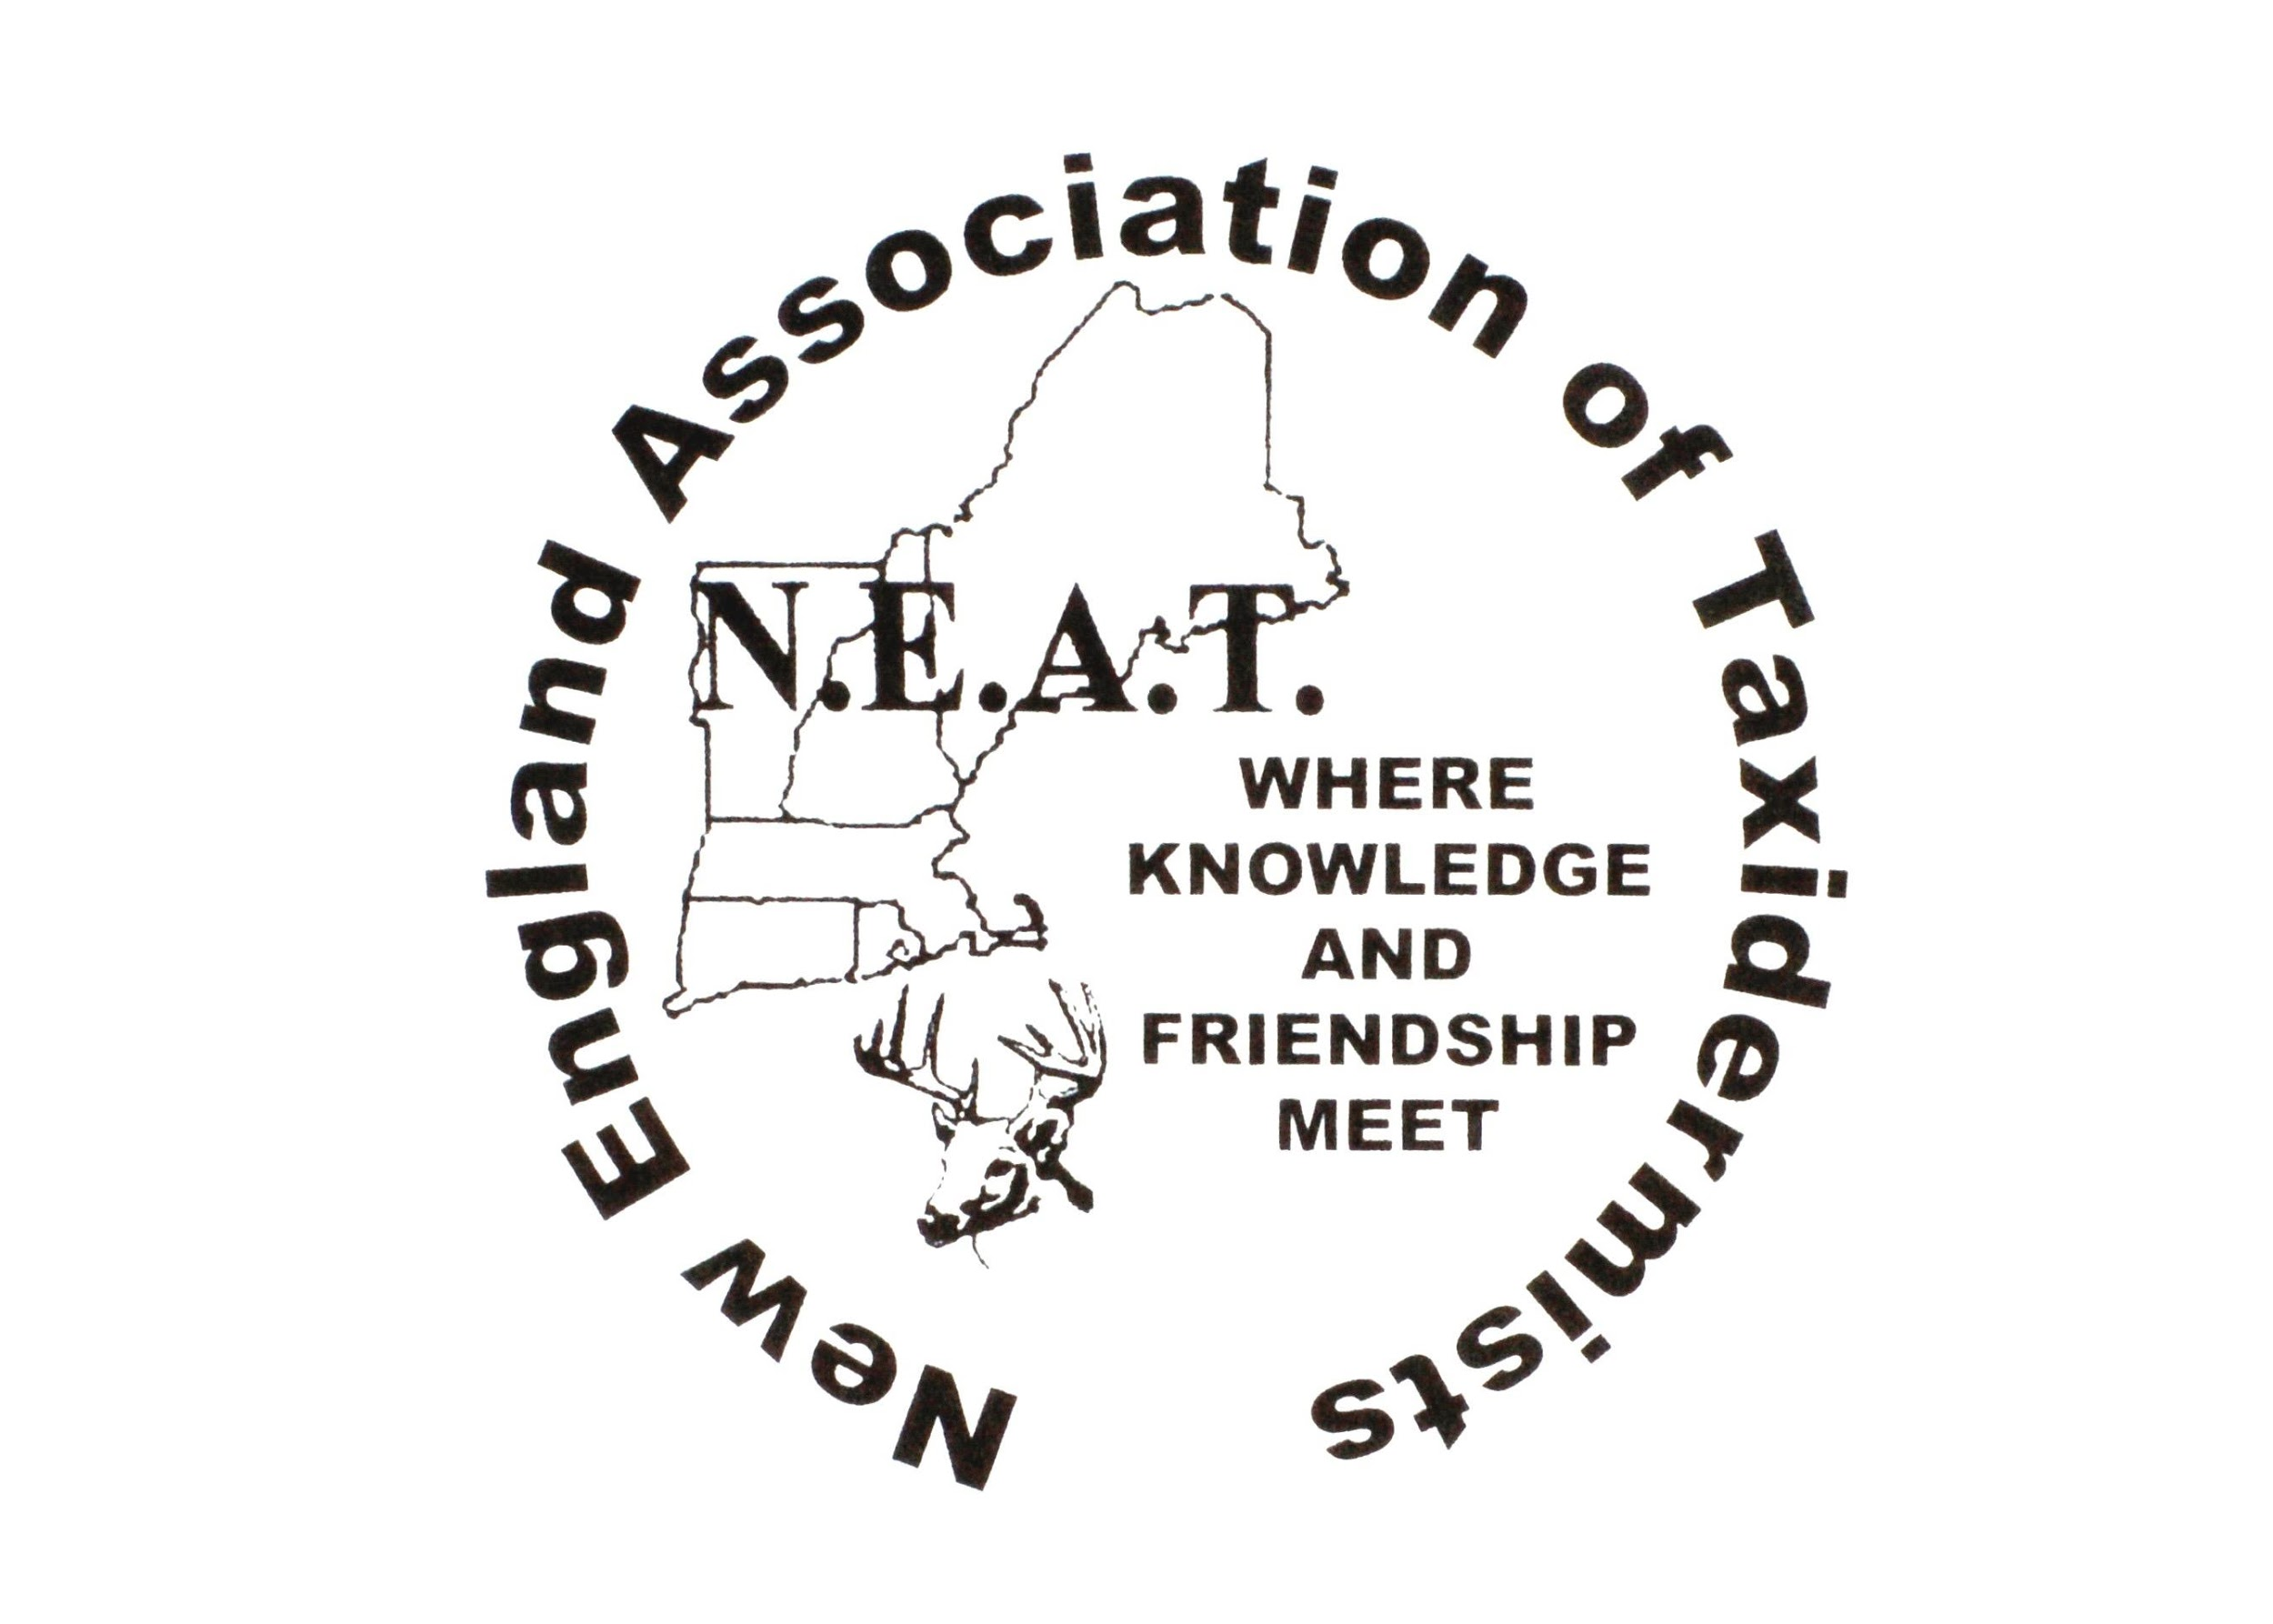
New England ASSOCIATION OF Taxidermists
www.newenglandtaxidermists.org

Post Show Where Knowledge and Friendship Meet October 2025
Officers:

President:
Steve Mudgett
(978)771-4185

Vice President:
Duane Couture
(802)309-2624
cwctaxidermy21@outlook.com

Treasurer:
Mary King
300 Maple Ridge Rd
Danby, VT 05739
(802)293-2031

Secretary:
Ann Couture
(802) 309-9465
2495 Boston Post Rd
Enosburg, Vt 05450
cwctaxidermy21@outlook.com

Board of Directors:

Gerald Menard, Jr Amy Blanchette
(603)475-8910 (207)577-9514

John Biedakiewicz Katherine Nee
(585)619-0989 (603)957-1284

Cole Young Peyton Sweet
(607)661-9259 Jr member

David King Ed Haberern
(802) 688-3668 (860)462-9869

New England Association of Taxidermists
Annual Convention and Competition
2025 Fall Newsletter

President’s Message

Good day, NEAT members. After coming off a great 2025 show, I am excited to announce we have finalized the plans for our upcoming 2026 show. Our board has been tremendous at putting things together. We have some exceptional judges committed to our show, thanks to the help of Wayne Rodd. With feedback from our members, we will be improving our show room with more updated displays, improving our placement of entries to help the ease of locating the different levels of talent for judges, and general viewing for awards. If you were able to attend the 2025 show, we thank you and hope to see you again. If you were unable to attend, we would love to see you for the 2026 show. As we say, this is where knowledge and friendship meet. We will continue having updates leading up to our show. We will also be announcing our plans for the 2026 workshop soon. Enjoy the fall season and upcoming holidays.
Sincerely,
Steve Mudgett, NEAT president

TREASURER’S MESSAGE

Thank you to all the existing and new members of NEAT that helped make our 2025 show a successful one. It was great seeing old friends and meeting many new ones.

I am excited to say this year’s raffle will be $1000.00 cash, $500.00 cash and $250.00 cash at $10.00 per ticket – for those that are selling the tickets they will not have to second guess who may be interested in purchasing, because everyone likes cash. The board members will be selling these tickets this fall to get a head start on its success. If you are interested in selling some tickets, I can send you some. My email will be on the front of the newsletter – only serious sellers please as this is going to be a great fund raiser.

We are also going to have a second raffle – at the show only at $10.00 per ticket – and it will pertain to the 2027 show – 1 free membership & 3 free entries.

Unfortunately, last year we had some members get raffle tickets to sell but they did not sell any and the tickets that were not sold did not get returned to me, so other members were not able to sell them and we lost some revenues due to this. Fund raisers are extremely important to our association and other associations. So please keep that in mind when you agree to sell tickets for NEAT or any other organizations.

Mary King, Treasurer

Secretary’s Message

Hi Everyone,

Wow, this year is flying by! I wanted to thank you all for your continued support for NEAT. It's always nice to see our members and meet the new members coming into the organization.

The 2025 show was one of the largest NEAT Shows in quite some time. It was wonderful to see all the awesome mounts. I know you all put hours and hours into making those pieces and we really appreciate you sharing with us at the show

We are planning for a great 2026 show and are looking forward to seeing you all next year. If you have questions or need any information regarding next year's show please don't hesitate to reach out to any one of the board members.

Thanks,

Ann Couture
NEAT Secretary

2026 President’s Cup: Fur Bearing
Mammal, lifesize or shoulder mount

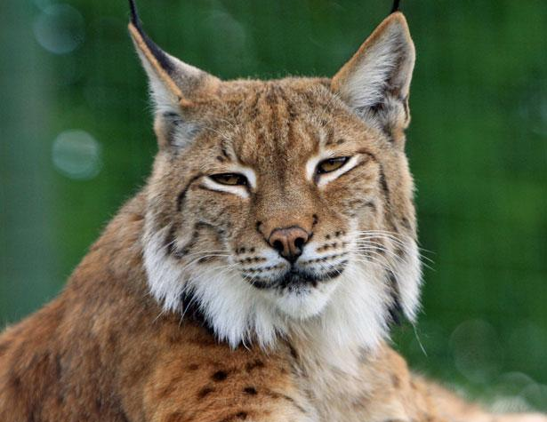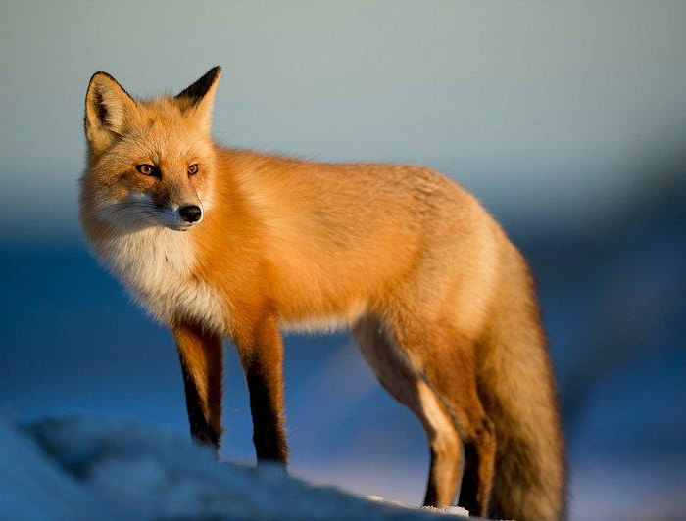
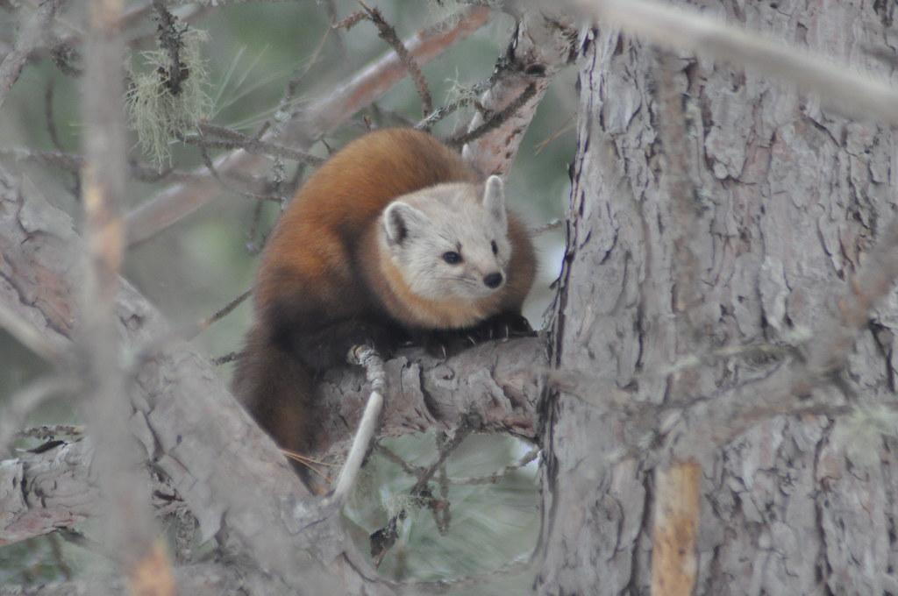
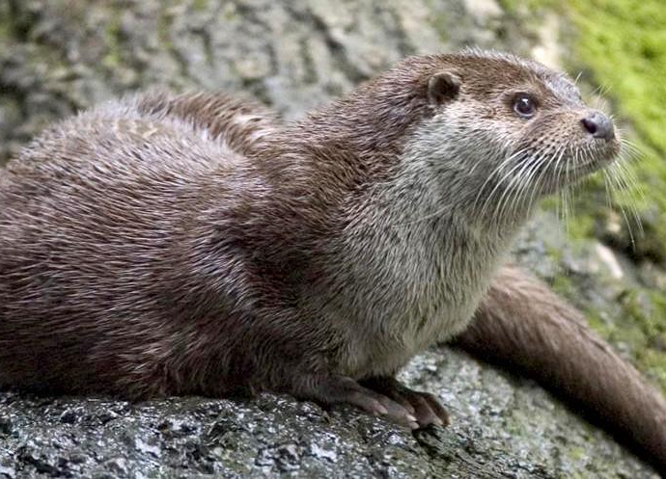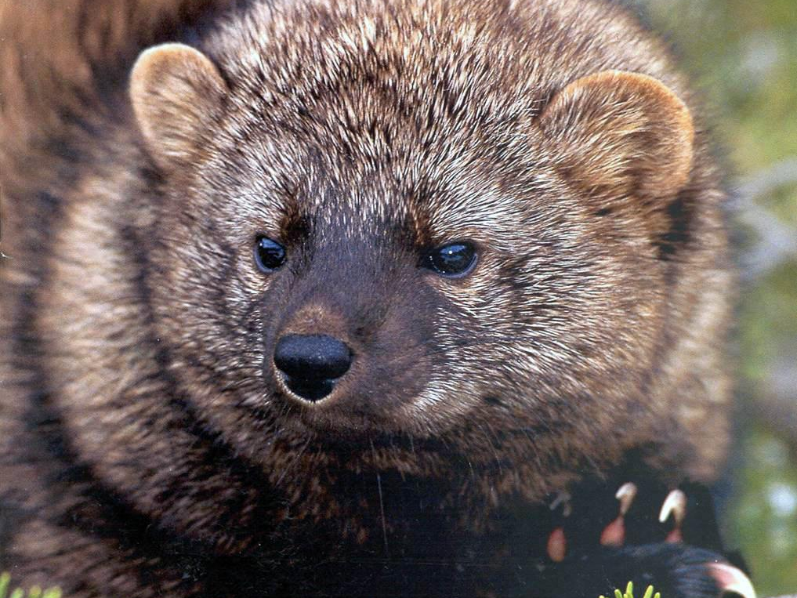
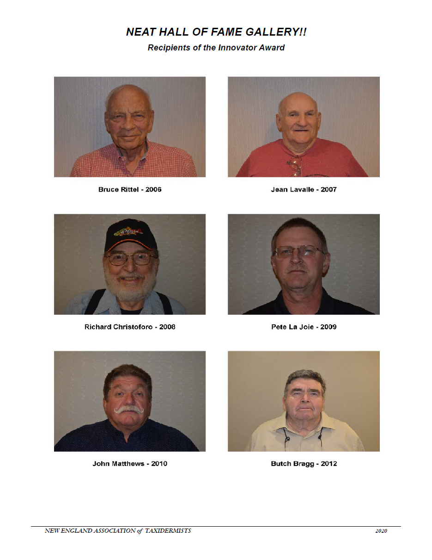
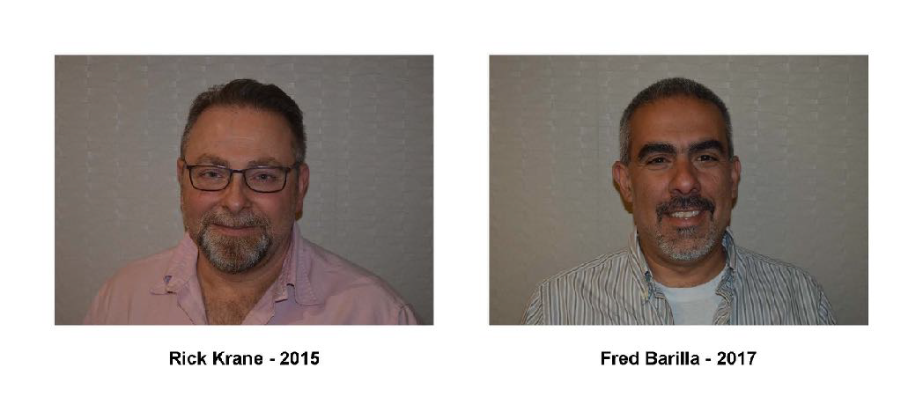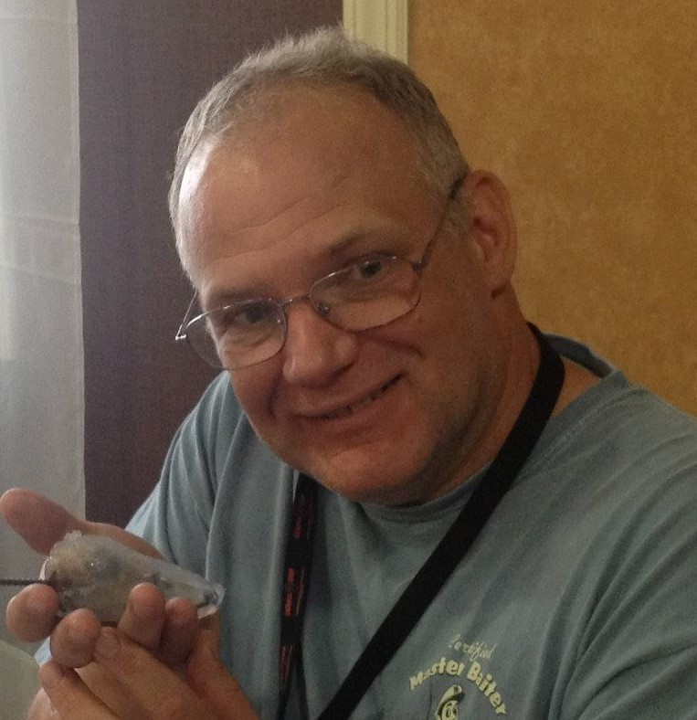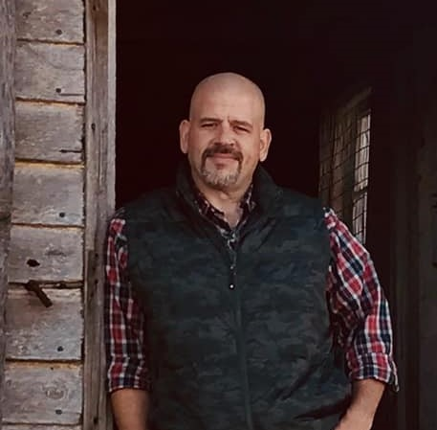

Steve Hackett - 2021 Matt Marulli - 2024

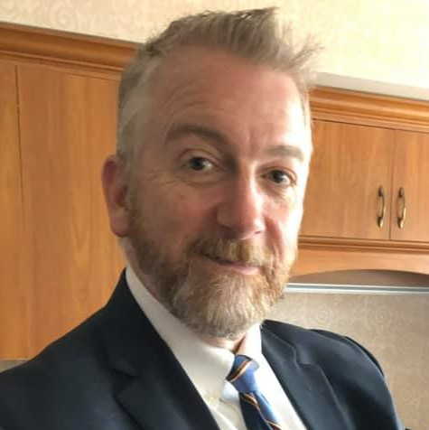

Dave Whitney - 2025

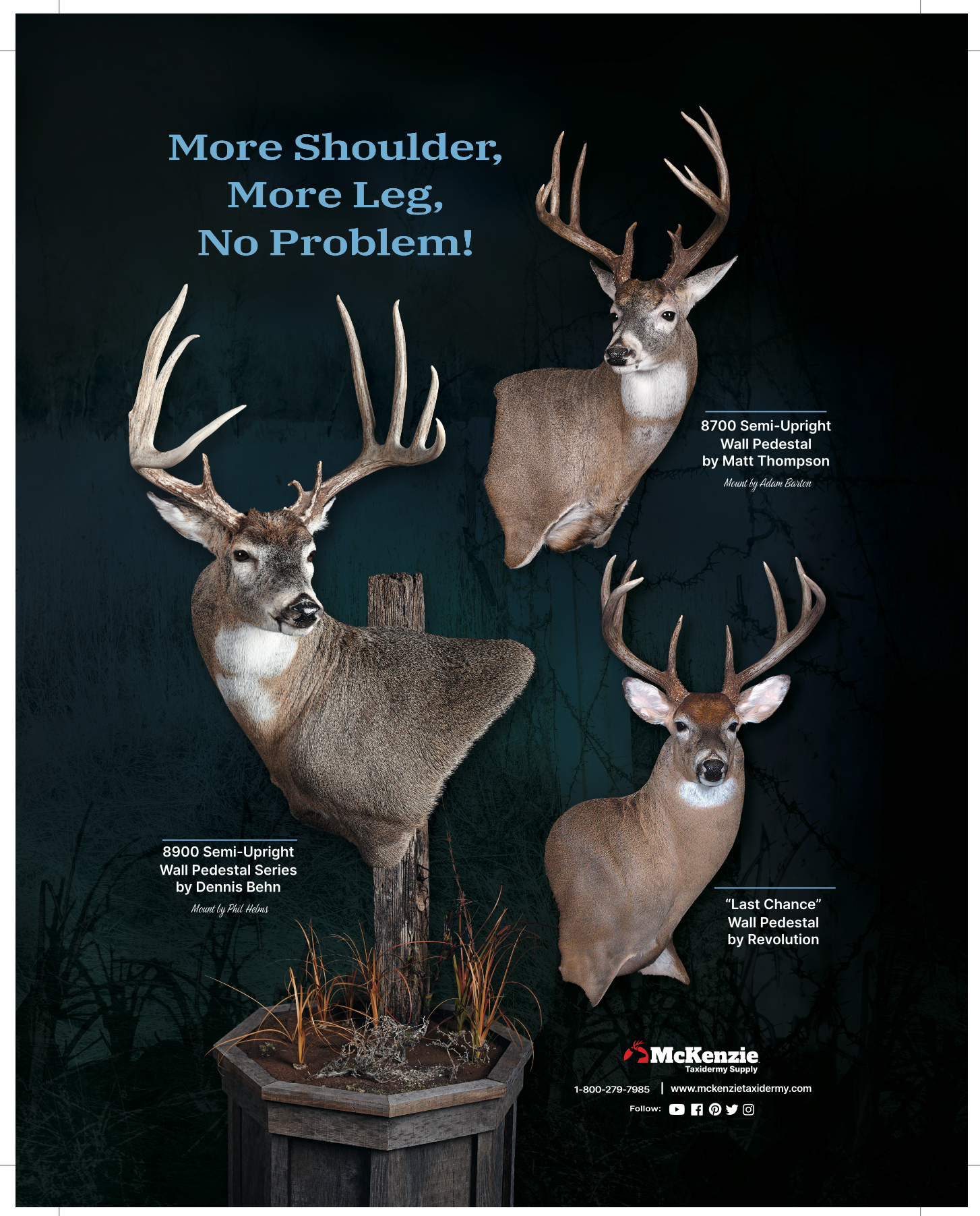
2026 Judges

Dalton Jeffers - Deer
Dalton grew up around taxidermy and the outdoors from a very early age with his father. At the age of 8 he went to his first National Taxidermy Show in Louisville, KY. He joined the board of Maryland Taxidermy Association at the age of 18. He trained under Tom Jeffers and Walter “Tinker” Johnson, along with a few lessons from Charlie Fegan of Fegan’s Taxidermy. Dalton is a National Champion Award Winner; he has won Regionals and awards in W. Virginia, Kentucky, Virginia, N. Carolina and Maryland. Dalton resides in Virginia.

George Dante - Fish and Birds
The founder of Wildlife Preservations, George has over thirty years of experience as a taxidermist, model maker, illustrator and fine artist. He has been fascinated by art and the natural world throughout his entire life. George began a successful part-time taxidermy business while in high school and continued his company while obtaining a BFA from The School of Visual Arts in NY. In 1996 George combined his two passions when he officially formed his growing high school business as Wildlife Preservations, LLC. George’s awards include a 1997 National Taxidermy Association (NTA) National Championship and an NTA Award of Excellence. He is an NTA Certified Judge. His sculptures, paintings and illustrations have been exhibited in numerous New York art galleries.

Bob Coughlin - Mammals and Gameheads
Bob has been doing taxidermy for 45 years. He was a member of both the New York Taxidermy Association and the Empire Taxidermy Association and played a role in the unification of the two associations into the UTNY. He also created the logo for the United Taxidermists of New York. Bob is a six-time recipient of the Best All Around Taxidermists Award. He has won awards in New York, Connecticut, New Jersey, Canada, the Nationals and World Show. Bob and his wife Cindy reside in Binghamton, NY.

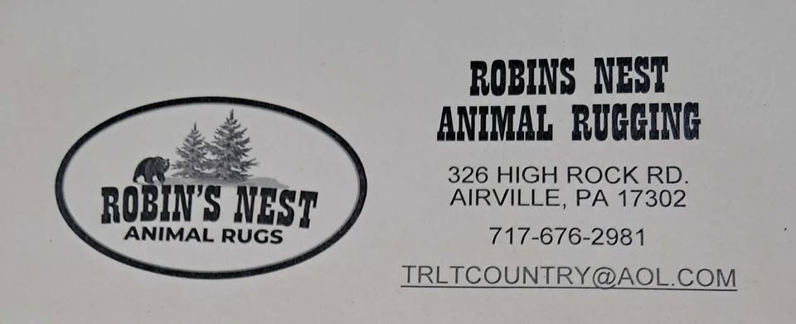

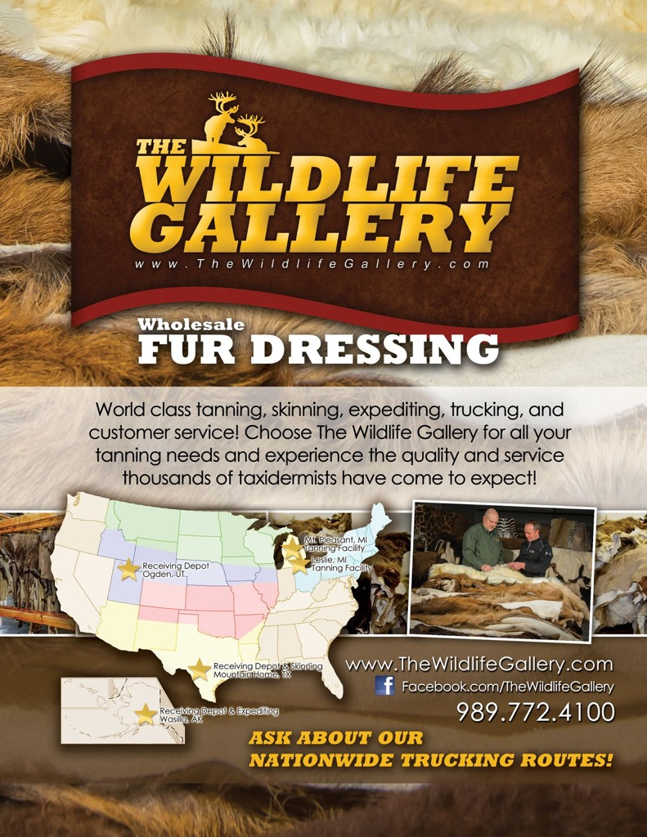
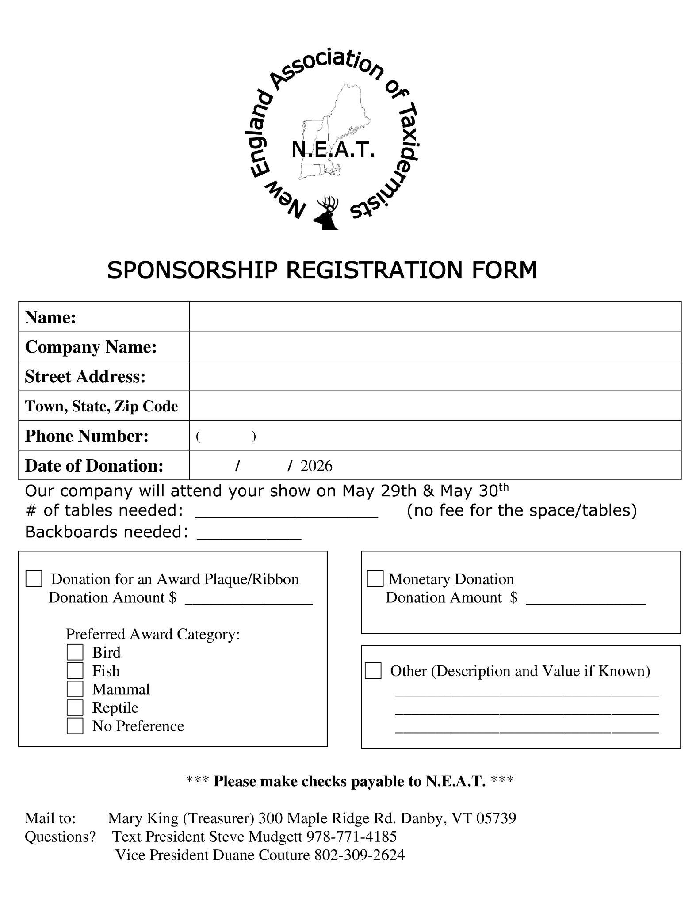

Mark Your Calendars!

2026 Show Dates are May 29-31st

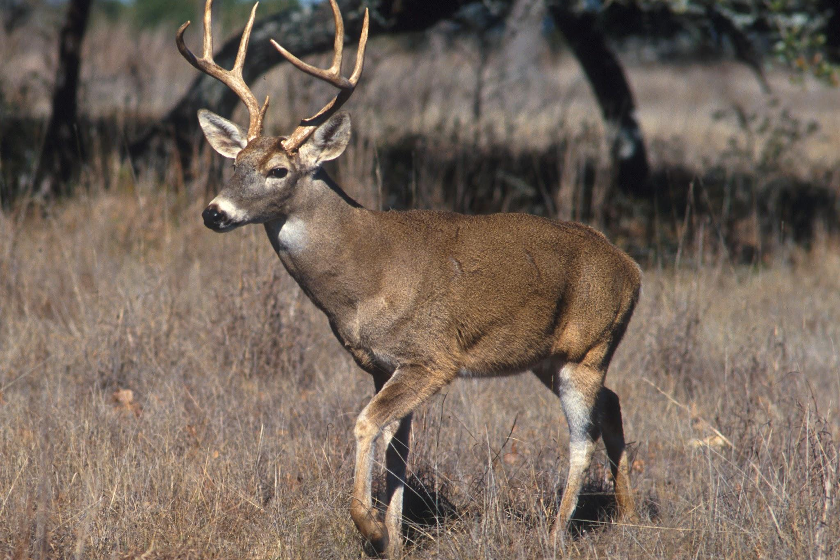

The Double Tree by Hilton in Windsor Locks, CT

16 Ella T. Grasso Turnpike
1-860-627-5171

Make your room reservation now!
We have a block of rooms reserved for NEAT
**When making reservations, please mention you are attending the NEAT taxidermy show**
The room rates are $146.00 per night, book by 4/30/26

All pre-registrations can check in from 8-10pm Thursday night.

"There is no fee to make a reservation, so make them early and don't miss out on a better rate."

From points South:

I-84 East, or I-95 North to I-91 North to exit 40, Route 20 (to Bradley International Airport). Follow Route 20 for 2 miles to the second exit, Route 75. Turn Right at the top of the exit. The Hotel is.1 mile ahead on the left.

From Points North:

I-91 South to exit 40, Route 20 (Bradley International Airport). Follow Route 20 for 2 miles to the second exit, Route 75. Turn right at the top of the exit. The Hotel is .1 mile ahead on the left..

From Points West:

The Massachusetts Turnpike (I-90) West to exit 51. Take a left onto I-291 to I-91 South. Follow I-91 South to exit 40, Route 20. (to Bradley International Airport) Follow Route 20 to the second exit, Route 75. Turn right at the top of the exit. The Hotel is .1 mile ahead on the left.

Many suppliers will be giving a discount for up to a week after the show

Pre-Registration Benefit

All pre-registered competitors will be entered into a drawing for a prize.

So please pre-register for a chance to win!
Please preregister by 5/22/2026!

2025 Award Winners

Best of Category
Youth
Large Mammal Peyton Sweet
Fish Brycen Coffin
Amateur

Whitetail Timothy Bolduc
Waterfowl Ryleigh Breton

Professional
Gamehead Lucas Storrs
Whitetail Cole Young
Small Mammal Cole Young

Masters
Waterfowl Katherine Nee
Whitetail Dustin Coons
Large Mammal Amy Blanchette

Division of Excellence
Waterfowl Scott Ferguson
Upland Bird Ed Kunelius
Fish Jared Mitchell
Whitetail Ed Kunelius
Small Mammal R Brian Noody

McKenzie Taxidermist’s Choice
Fish Scott Ferguson
Mammal Amy Blanchette
Deer Cole Young
Bird John Biedakiewicz

People’s Choice
3rd Logan Hinchey
2nd Katherine Nee
1st Thomas Rodreguez
Amateur Peyton Sweet

Jack Wilson Best Upland Bird
Logan Hinchey

Richard Christoforo Best Gamehead
Lucas Storrs

Jean Lavalley Best Conventional Mount
R Brian Noody

Bruce Rittel Best Home Tan
Cathy Gearwar

Pete Lajoie Best Amateur Whitetail
Timothy Bolduc

John Matthews Award
Katherine Nee

Butch Bragg Best By BOD
Katherine Nee

Fred Barilla Best Non-indigenous Species
Amy Blanchette

Rick Crane Award
Mark Van Leuven
Steve Hackette Best WF in Natural Setting
Scott Ferguson

Matt Marulli Best Pro Small Mammal
Cole Young

Old Timer’s Award
Ed Haberern

President’s Cup
Lucas Storrs

Whitetails Unlimited Best Pro Deer
Cole Young

Most Distinguished Taxidermist
Katherine Nee

Buckshot Tannery Best Large Mammal

Mounted In Alaska Award
Sam Cassida

NEAT Taxidermist’s Choice Gamehead
Wayne Rodd

Van Dykes Award
R Brian Noody

Innovator Award
Hall of Fame
Dave Whitney

UTA Award
Katherine Nee

Polytranspar
Jared Mitchell

Best of Show

Commercial
Cathy Gearwar

Amateur
Timothy Bolduc

Professional
Cole Young

Masters
Katherine Nee

Division of Excellence
R Brian Noody

Habitat
Lita Brown

Wildlife Art
Paul Szostek

Freeze Dry

Youth
Peyton Sweet

Pro-1 Award
Masters/DOE Cathy Gearwar
Professional Cole Young

Matuska Award
Gerald Menard, Jr.

Mike Adams Best Whitetail
Ed Kunelius

McKenzie Service Award
Ann Couture

WASCO Award
Logan Hinchey

Breakthrough Best of Show
Katherine Nee

New England Champion

Bird
Katherine Nee

Fish
Jared Mitchell

Deer
Ed Kunelius

Gamehead
Lucas Storrs

Mammal
R.Brian Noody

2026 Spring Workshop

We are working to bring you a friendly and informative workshop for March 2026. Please watch your email for the topic and details.
photo for example, only

