**Sports Testing Event/Athlete Assessment**

All athletes should have a scorecard with their name clearly printed. Each station manager should write the athletes name on the card the first time he goes to a station. The athletes phone number should be written at the bottom of the card. Athletes can access their account by downloading the Peak Performance Network Mobile Application or via the World Wide Web at [www.ppnsports.com](http://www.ppnsports.com)

The athlete is responsible for keeping up with their scorecard at the event and presenting the scorecard to each station manager as they execute the skills at each station. The station manager will write the appropriate score, time, etc. into the appropriate box and then give the scorecard back to the athlete. If we have a “scorekeeper” with a mobile device at that station, they will immediately record the result.

The athlete should go from station to station as the lines best suit always avoiding long lines making sure to complete all stations. Upon completion of the final station the athlete should give the scorecard to the Scorekeeper or event manager and receive the yellow carbon to take with them. Scorekeeper shall immediately load in the testing results into PPN or you can have athlete input their own info. Sport Tester is responsible to quality control check all input from athletes.

The testing results will immediately show in the athletes Peak Performance Network account once put into the system and will be available for review at any time thereafter on a permission-based viewing option. Scouts and recruiters will have access to view these scores if athlete permits.

The athlete can visit Test and Train Sports website <https://testandtrainsports.com/testing-benchmarks> to view the matrix for the appropriate sport to see how they match up. This will provide immediate direction to see how the athlete stacks up against the top 10% in each age group.

Athletes should be tested every quarter to track progression and make modifications to personalized development plan to remain efficient at training. Results will dictate the intensity of training and the long-term plan that should be put into place and modified upon initial benchmark testing.

**Sports Testing Scorecard**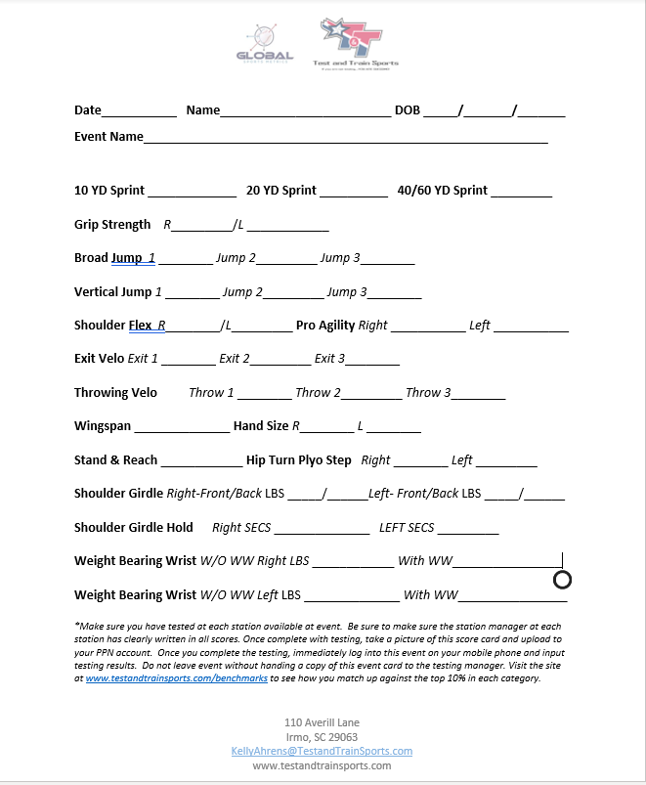

**Testing Stations**

**Sprint-** 60YD.  Station Timer should start the watch on the sprinter's first movement and stop the watch upon crossing the finish line. It is best to have area marked clearly with cones. (Measuring tape, cones, stopwatch)

**Grip Strength Right and Left**- Athlete holds Dynameter in hand with the screen facing athlete with the arm at a 90 Degree angle.  The athlete should squeeze the device as hard as possible and then let go. Pass from one hand to the other after completion. (Camry Dynamometer)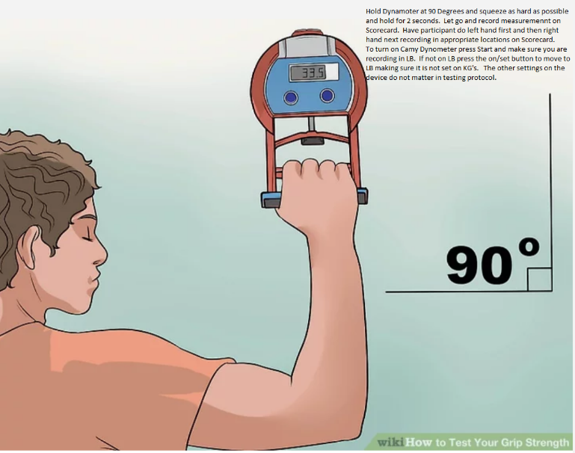

**Broad Jump**- Athlete should stand beside the green broad jump mat with toes behind the line.  The athlete will jump forward without step and land without falling back. The athlete should “Stick” their landing and the station manager should locate where the back of the foot is and call out and record the appropriate distance jumped. The athlete should jump three times in a row and all three jumps should be recorded.  (broad jump mat or a measuring tape)

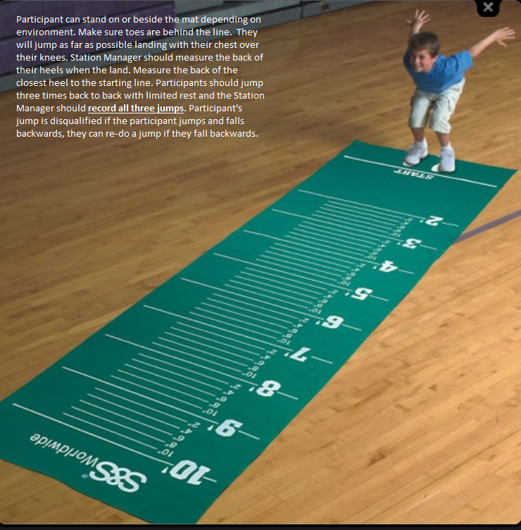

**Vertical Jump-** Athlete will jump upwards keeping legs dangling down (not pulling knees to chest) and land back in same area they jumped from.  The athlete should perform three jumps with a slight pause in between and all three jumps should be recorded. **Use Vert to get measurement** and be sure to clip at the center of the waist.

**Shoulder Flex**- Athlete should first extend the right hand over right shoulder and left hand under left shoulder reaching to connect fingers to extend as far as possible.  A negative reading will be provided if the fingers overlap, and a positive reading will be provided if the fingers do not meet.

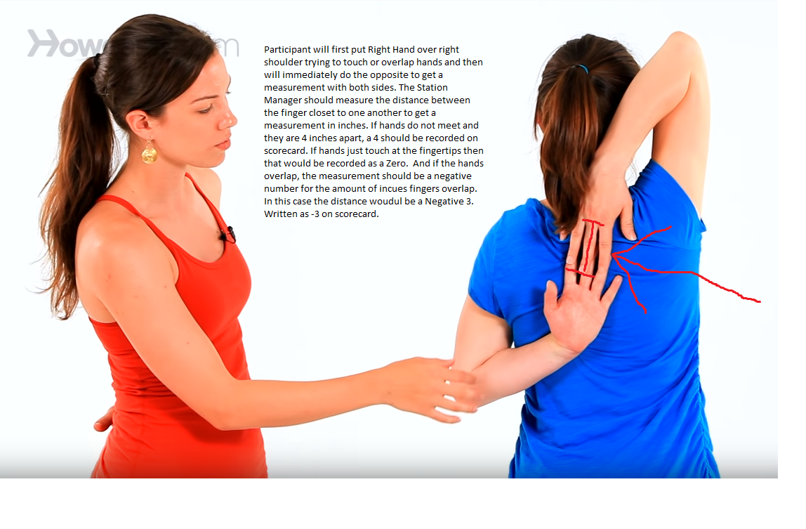

**5-10-5 (Pro Agility Shuttle)** – Athlete should start in the middle of the cones at the 15-foot mark where the cones extend a total of 30 feet.  There should be a cone placed at 0 Feet, 15 Feet, and 30 Feet.  The athlete starts in the center and must begin in upright position on the middle cone.  The tester starts the stopwatch upon the athlete's first movement to the right. The athlete must touch the ground at the first cone, change directions sprinting to the 0 Feet Cone and touching the ground by the cone with the left hand before changing direction and sprinting back past the middle cone where the timer will stop the watch upon crossing the middle cone.  The tester should start on athletes the first movement. The athlete shall run this station first started going to the right and then the second time started going to the left. Athlete shall run the test going back-to-back going right first and then left. (Cones, measuring tape, stopwatch) .

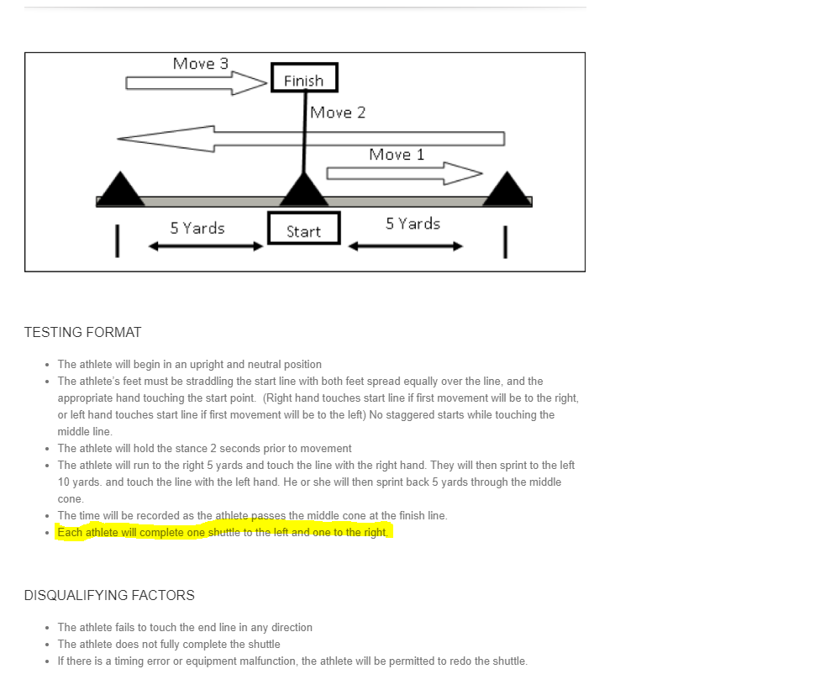

**Exit Velocity**- Ball shall be placed on a tee with the athlete taking three swings hitting the ball into the net.  The ball should be hit directly at the station manager who will be pointing a radar gun at the ball. The more direct hit the ball is to the radar the higher the reading will be. The athlete is looking to provide three consistent swings that measure bat control and skill targeted directly to the radar gun.

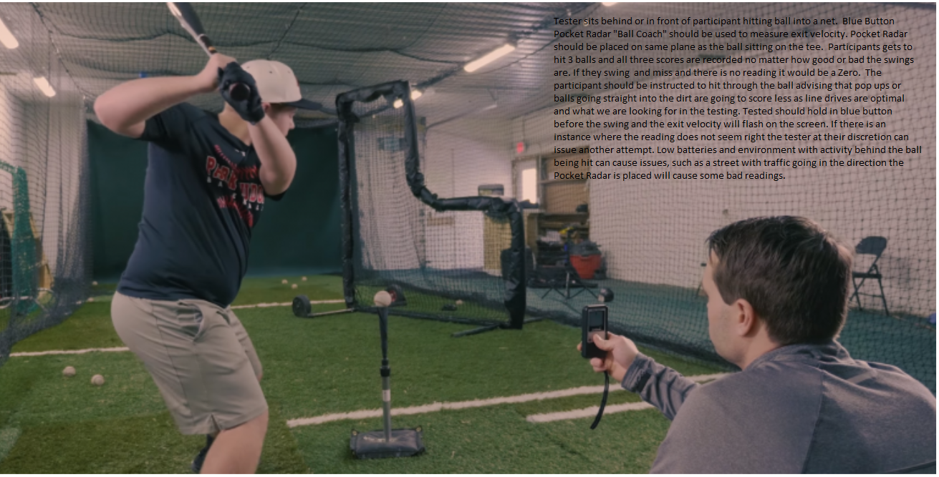

**Throwing Velocity Instructions- Athlete run and guns three throws into a net or target. Finish the throw at least 15 feet from the target. Record all three throws with Pocket Radar. Any questionable number have athlete make another attempt.**

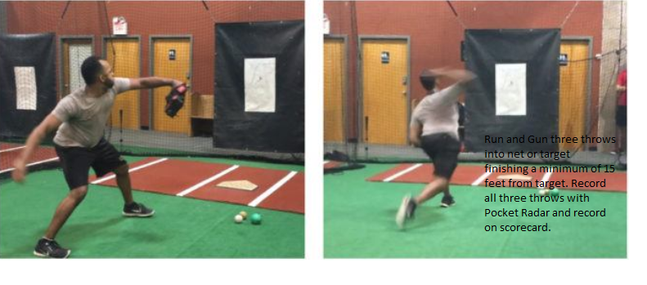

**Stand N Reach**- Athlete stands with feet together and knees locked. While keeping knees locked athlete should try to touch the ground with fingertips in front of shoes. If the athlete is 5 inches from touching the ground, then that would be = to 5. If the athlete’s hands are 7 inches long and they can put the palm of their hands on the ground it will be scored as -7. Negative numbers mean athlete is touching ground. Positive number reflects how far away from the ground they are touching. If they just touch the ground with their fingertips it should be registered as -.05 (Tape Measure)

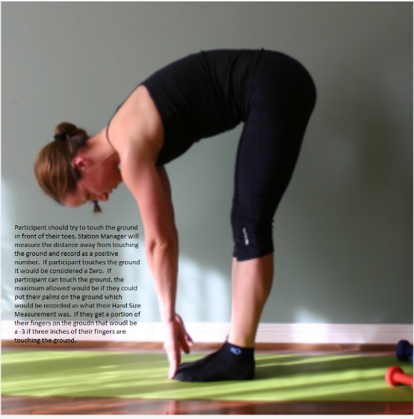

**Hip Turn Plyo Step- (HTTPS) -** HTTPS is a 10 YD Sprint facing away from the timer. Athlete must open right shoulder and sprint 10 yards and then do the same opening up left shoulder. Timer begins on athletes first movement. This is a reaction drill to see how well the athlete can run and go get a ball behind them or turn and go catch another athlete.