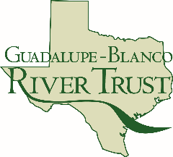
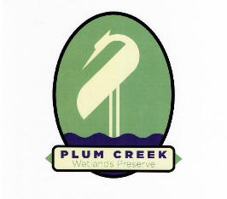
PCWP Planning Committee
August 17, 2021 – 10:00 am – 12:30 pm
GBRA River Annex - 905 Nolan Street, Seguin, TX
Zoom Option: https://us06web.zoom.us/j/8467056539
Meeting ID: 846 705 6539

MEETING 3 AGENDA

- Discussion: Revised Mission Statement and Core Values
  - Action: Confirm updated mission statement
- Discussion: Master Plan Examples
  - What did we like? What didn’t we like?
  - What is the Plan being used for?
  - What sections are needed?
- Discussion: Possible Stakeholders
  - Action: Identify and prioritize top __ stakeholder groups
  - Action: Identify top __ collaborative stakeholders
- Discussion: List of Activities
  - Action: group exercise – Activity prioritization
- Discussion: Meeting 4 date and time
- Homework
- Adjourn

