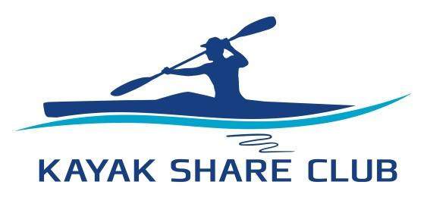

**Where can you paddle? – Guidelines**

Where you can paddle is determined by your paddling experience, your ability to self-rescue and do an assisted rescue, and the type of kayak you are using (ie. Sit-on-top or Sit-in). The guidelines are part of KSC’s duty of care to ensure your safety.

Always check weather conditions using MetEye or Willy Weather App before paddling off.

|  |  |  |  |
| --- | --- | --- | --- |
| **Paddling Skill Progression** | **Skills** | **Paddling Areas**  **Enclosed Waters**  **(Bays and Harbour areas)** | |
| ***From Hayes Street Beach*** | | | |
| NB Level 1 | Completed initial paddling safety training.  Able to perform an assisted rescue, as rescuer and rescue in the kayak type you are using.  (if you can’t perform a self-rescue you must always stay within 50m of shore unless accompanied by a paddler able to perform assisted rescue as rescuer) | **NB Area 1**  **Neutral Bay and adjoining Careening and Shell Coves, no further west than Wudyong Point (Royal Sydney Yacht Squadron)**  **< 10 knots**  (NB Area 2 if accompanied by a competent paddler) | |
| NB Level 2 | Have demonstrated an assisted rescue, both as a rescuer and rescuee, in the kayak type you are using.  **AND**  Completed 6 trips in NB Area 1.  (if you can’t perform a self-rescue you must always stay within 50m of shore unless accompanied by a paddler able to perform assisted rescue as rescuer) | **NB Area 2**  **Mosman and Chowder Bay**  **< 15 knots**  (NB Area 3 if accompanied by an advanced paddler) | |
| NB Level 3 | Have demonstrated a self-rescue in the kayak type you are using and completed 6 trips in NB Area 2  **AND**  Completed a half-day guided paddle involving transits of major shipping/ferry lanes. | **NB Area 3**  **Across the harbour to Watsons Bay and to areas west of the bridge.**  **< 20 knots** | |
| ***From Pearl Bay*** | | | |
| PB Level 1 | Completed initial paddling safety training.  Able to perform an assisted rescue, as rescuer and rescue, in the kayak type you are using.  (if you can’t perform a self-rescue you must always stay within 50m of shore unless accompanied by a paddler able to perform assisted rescue as rescuer) | **PB Area 1**  **South of D’Albora Marina and Northbridge Sailing Club**  **< 10 knots**  (Area 2 if accompanied by a competent paddler) | |
| PB Level 2 | Have demonstrated an assisted rescue, both as a rescuer and rescuee, in the kayak type you are using.  **AND**  Completed 6 trips in PB Area 1.  (if you can’t perform a self-rescue you must always stay within 50m of shore unless accompanied by a paddler able to perform assisted rescue as rescuer) | **PB Area 2**  **Anywhere within Middle Harbour west of Grotto Point and HMAS Penguin Marina**  **< 15 knots** | |
| PB Level 3 | Have demonstrated a self-rescue in the kayak type you are using and completed 6 or more trips in PB Area 2  **AND**  Completed a half-day guided paddle. | **PB Area 2**  **Anywhere within Middle Harbour west of Grotto Point and HMAS Penguin Marina**  **< 17 knots** | |
| ***Holders of Paddle Australia Qualifications*** | | | |
| Accredited Enclosed Se Guide and/or Enclosed Sea Instructor | Has extensive knowledge to make complex decisions in new situations in enclosed sea conditions.  (For those interested in gaining PA qualifications, keeping a logbook is a great start) | | Anywhere in Sydney Harbour except restricted areas eg. Circular Quay, Garden Island, HMAS Penguin and Chowder Bay Naval Facilities.  **< 17 knots**  **< 1.5 nautical miles from shore** |
| Accredited Sea Guide and/or Sea Instructor | Has extensive knowledge to make complex decisions in new situations in sea conditions, including coastal waters.  (For those interested in gaining PA qualifications, keeping a logbook is a great start) | | Coastal waters  **< 17 knots**  **< 5 nautical miles from shore** |

**Club Trips**

Our Club works to develop effective paddling skills, so you paddle further, and for longer. As a recreational club, KSC runs half day trips and overnight excursions. These are a great opportunity to upskill with trip planning, crossing the harbour and meeting other paddlers. We encourage and support members to become coaches, guides, trip leaders and instructors. Please let us know if you are interested in getting involved in the community. Adrian Clayton, our club’s certified instructor, can assist with accreditation.

**Enjoy your paddling. Stay safe.**

**Paddling Limits – Neutral Bay**

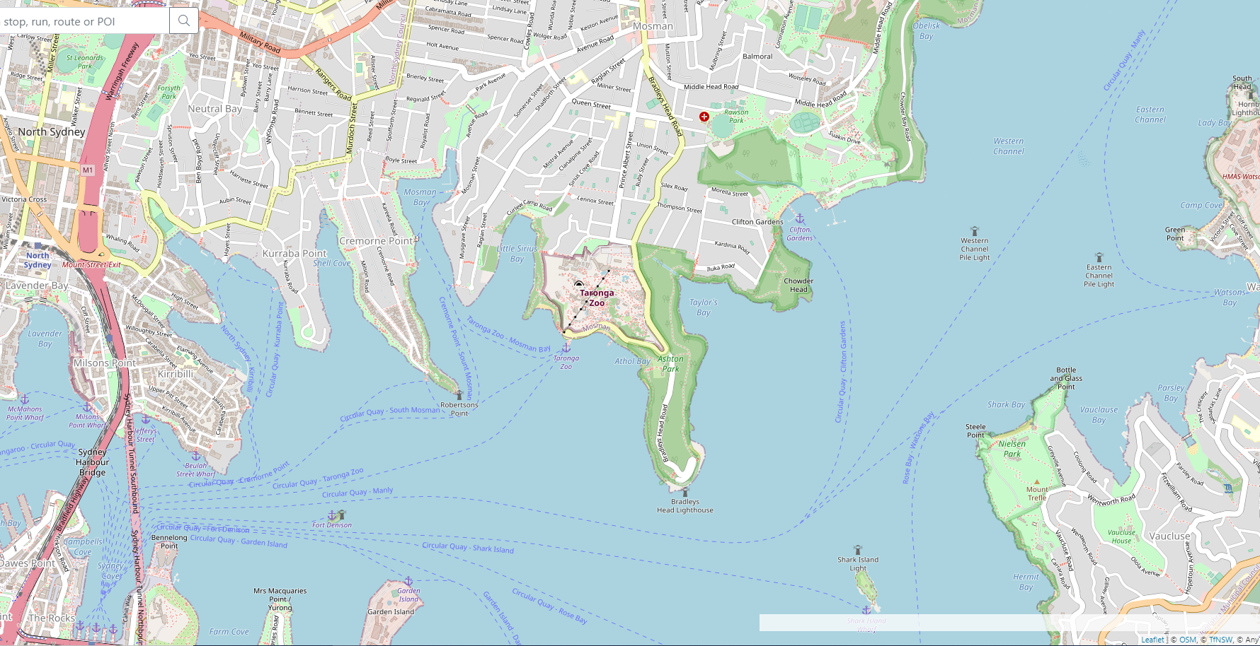

**Area 1**

**Area 2**

**Area 2**

**Area 3**

**Area 3**

**Area 3**

**Area 3**



**Port Jackson – East of Sydney Harvour Bridge**

Ferry Lane Crossing

**Paddling Limits – Pearl Bay**

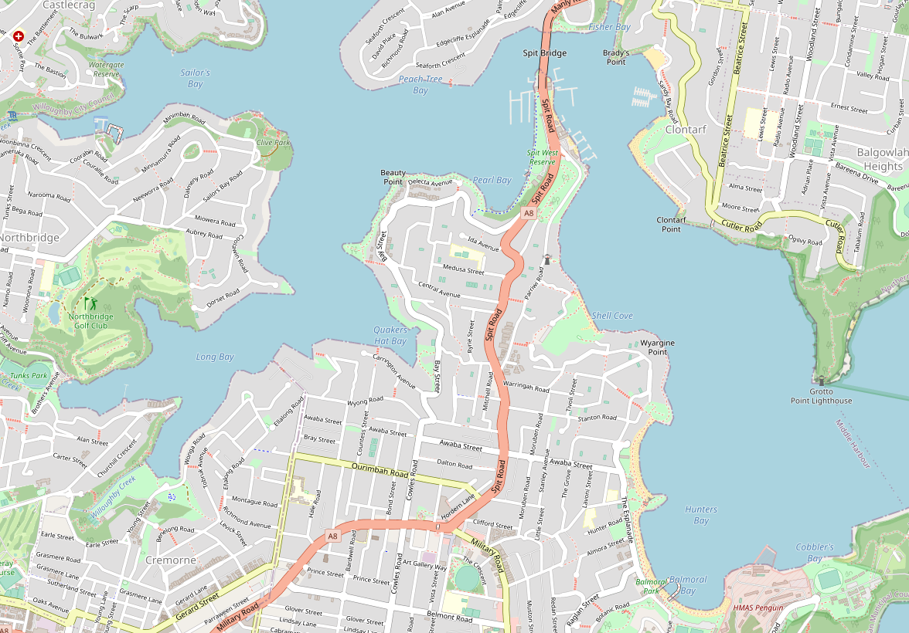

**AREA 1**

**AREA 2**

**AREA 1**

**AREA 2**

**AREA 2**

**AREA 2**

**Middle Harbour**