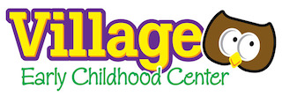
Medication Form
Village Early Childhood Center
155 Parkway
Harrington Park, New Jersey 07640
Tel. (201) 767-9909 Fax. (201) 767-9919
DiscoverNPS@gmail.com

Parents,

Village ECC requires that all students who need medication (OTC as well as prescription) during school hours must do the following:
- Present a written consent form signed by the parent
- Bring medication in the original prescription bottle, properly labeled by a registered pharmacist as prescribed by law.
- The child’s physician must also sign the request form.

Name of child:__________________________________________________________________

TO BE COMPLETED BY THE PHYSICIAN

Name of medication:_____________________________________________________________________

Specific time(s) and dose(s) to be given at School:_____________________________________

Length of time:_____________________________________________________________________________

Diagnosis:____________________________________________________________________________________

____________________________________ __________________________________
Printed Name of Physician Signature of Physician

TO BE COMPLETED BY PARENT/GUARDIAN

I, _____________________________, give permission for my child to receive the above medication as directed.

__________________________________ _______________________
Parent’s Signature Date

