July *Special Guest* 2019
Sunday | Monday | Tuesday | Wednesday | Thursday | Friday | Saturday
 | Welcome! 1 | 2 | 3 | 4 | 5 | 6
Party in the  USA | 1st Day of Summer Camp | Scavenger Hunt |  | CLOSED | CLOSED
7 | 8 | 9 | 10 | 11 | 12 | 13
Animal Planet  Adventure | Speed Soccer* | 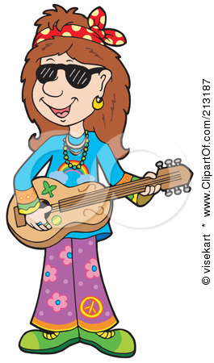  Music | Outragehiss Pets | Rainforest Bob  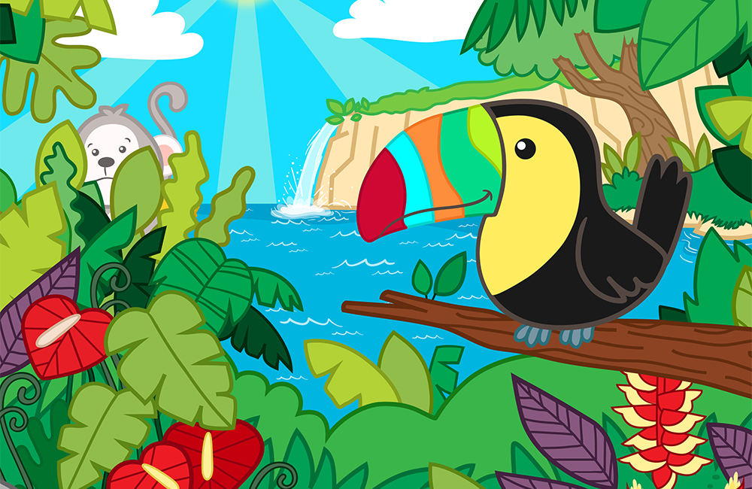 | Fun Bus *  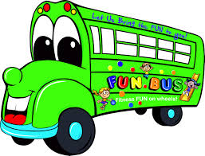
14 | 15 | 16 | 17 | 18 | 19 | 20
Clowning Around | Speed Soccer * | Yoga | Dolly the Clown | Traveling Tumblers | Fun Bus *
21 | 22 | 23 | 24 | 25 | 26 | 27
Creative Campers | Speed Soccer* | Music | Miss Kaity’s Kreations | Miss Kaity’s Kreations | Fun Bus *
28  Ocean Commotion  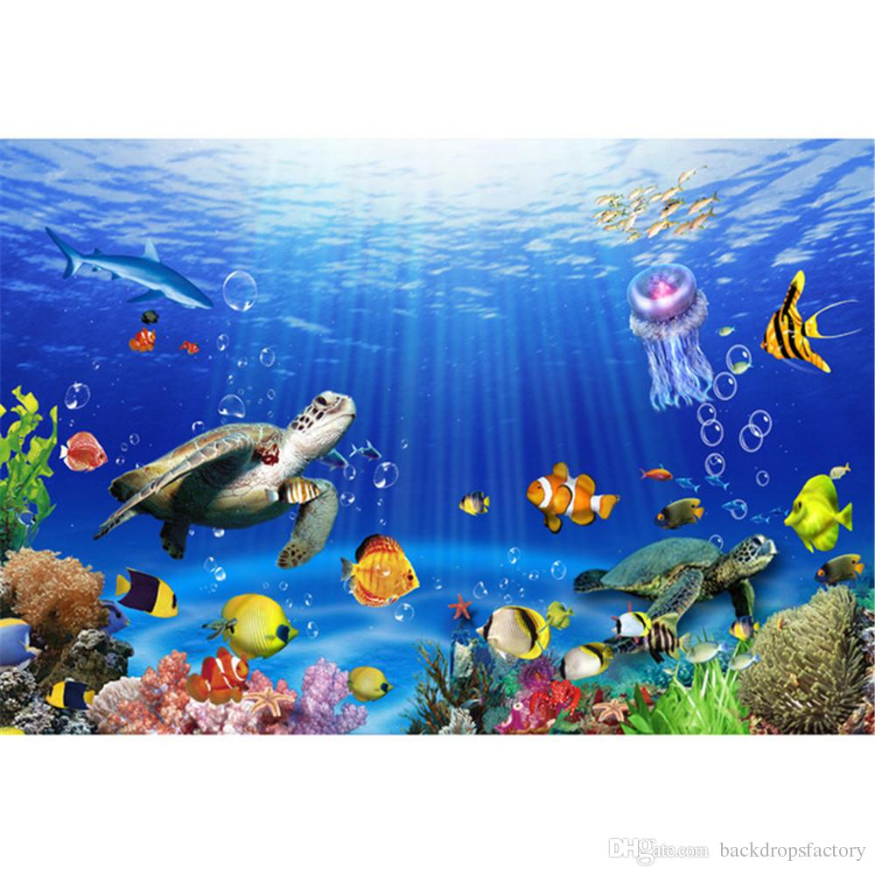 | 29  Speed Soccer* | 30  Yoga | 31  Bubble Show | 1  Amazing Pirate Magic Show | 2  Fun Bus * | Speed Soccer & Fun Bus are Parent Paid Electives*
August 2019
Sunday | Monday | Tuesday | Wednesday | Thursday | Friday | Saturday
4 | 5 | 6 | 7 | 8 | 9 | 10
Barnyard  Palooza  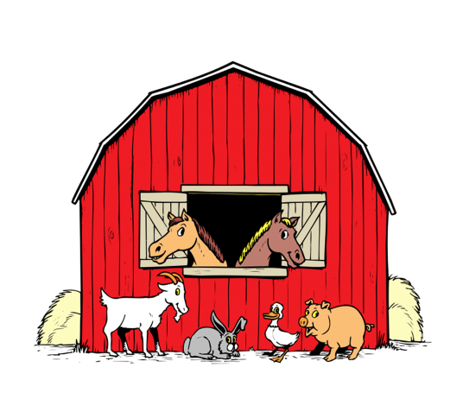 | Speed Soccer* | Music | Petting Farm | Line Dancing | Fun Bus *
11 | 12 | 13 | 14 | 15 | 16 | 17
Ooey Gooey Science | Speed Soccer* | Yoga | Slime Time | 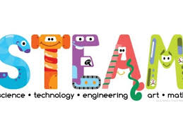 | Fun Bus *
18 | 19 | 20 | 21 | 22 | 23 | 24
Aloha  Summer  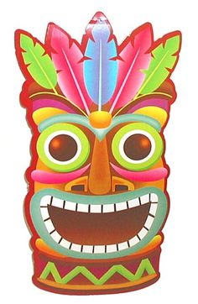 | Speed Soccer* | Music |  | Hawaiian  Luau | Fun Bus *
25 | 26 | 27 | 28 | 29 | 30
 | CLOSED | CLOSED | CLOSED | CLOSED | CLOSED

