July *Special Guest* 2020
Weekly Theme | Monday | Tuesday | Wednesday | Thursday | Friday | Saturday
 | Welcome!29 | 30 | 1 | 2 | 3 | 4
Stars & Stripes | 1st Day of Summer Camp |  | Scavenger Hunt |  | CLOSED
5 | 6 | 7 | 8 | 9 | 10 | 11
Creative Campers | Speed Soccer* | 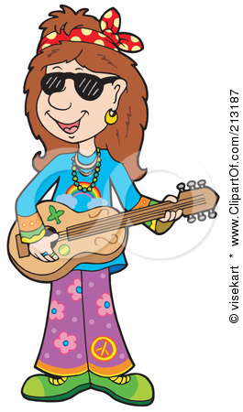  Music | Miss Kaity’s Kreations  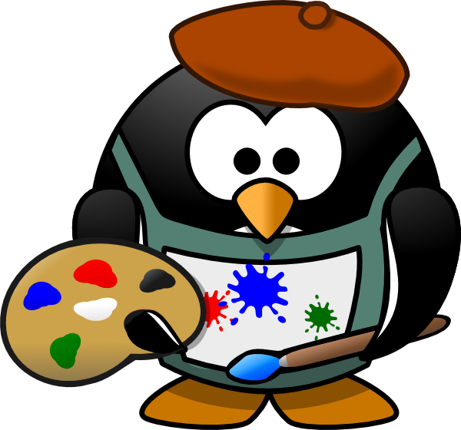 | Miss Kaity’s Kreations | Fun Bus *  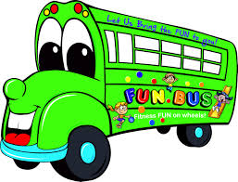
12 | 13 | 14 | 15 | 16 | 17 | 18
Mission Impossible | Speed Soccer * | 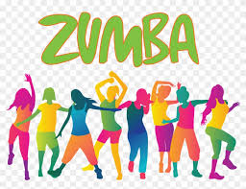 | What’s Out There? Exhibit | Mission Control S.T.E.A.M | Fun Bus *
19 | 20 | 21 | 22 | 23 | 24 | 25
Diggin’ Dinos | Speed Soccer* | Music | 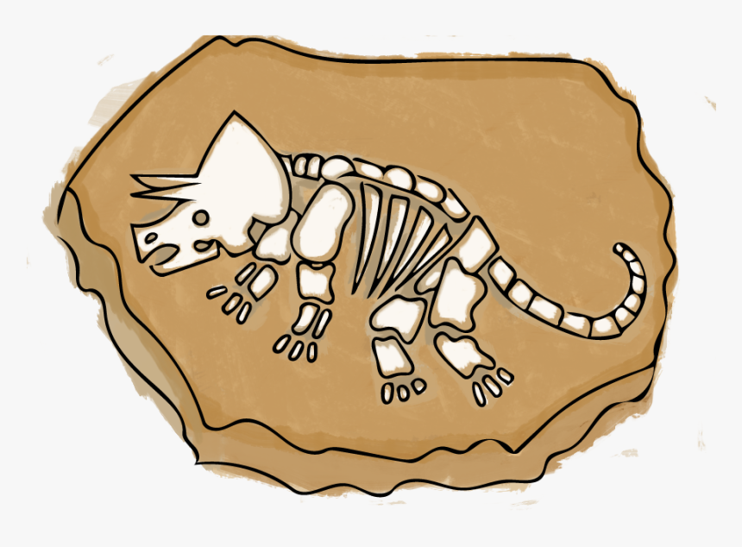  Dinosaurs Rock Exhibit | Fossil Fun  S.T.E.A.M | Fun Bus *
26  Moovin’  & Groovin’  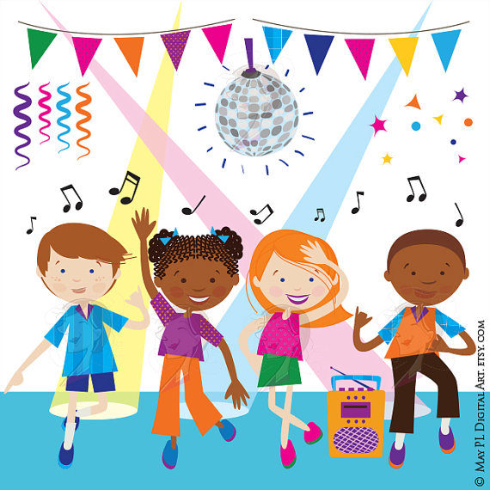 | 27  Speed Soccer* | 28 | 29  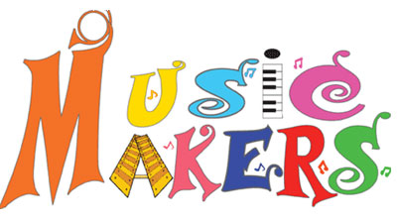 | 30  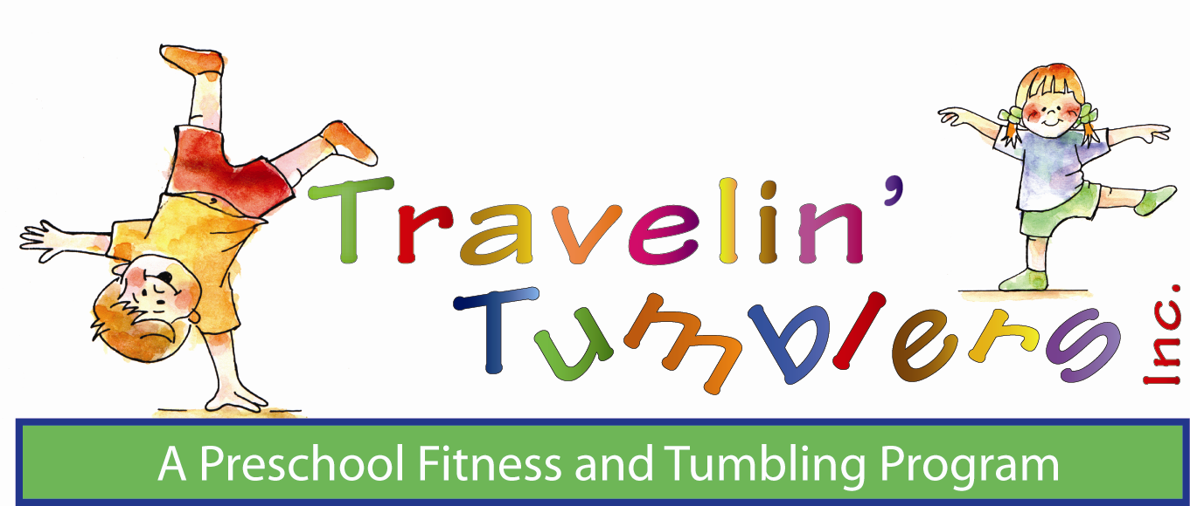 | 31  Fun Bus * | Speed Soccer & Fun Bus are Parent Paid Electives*
August 2020
Weekly Theme | Monday | Tuesday | Wednesday | Thursday | Friday | Saturday
2 | 3 | 4 | 5 | 6 | 7 | 8
Steam Ahead  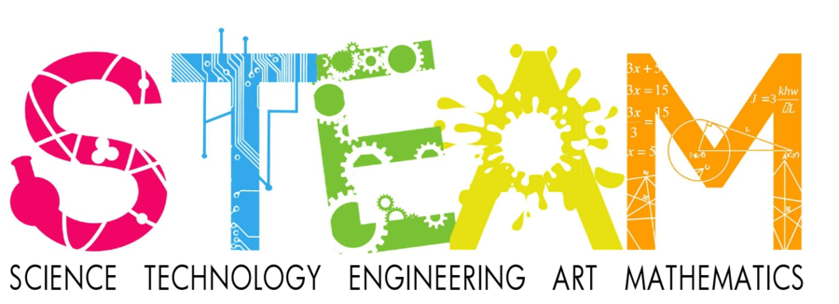 | Speed Soccer* |  | Bubble Show | Cool  Coastal Science  S.T.E.A.M. | Fun Bus *
9 | 10 | 11 | 12 | 13 | 14 | 15
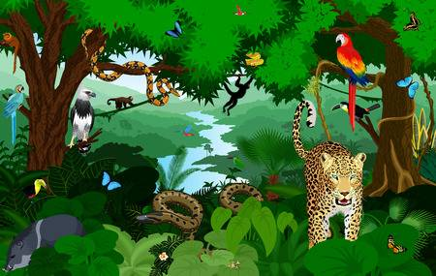  Rainforest  Adventure | Speed Soccer* | 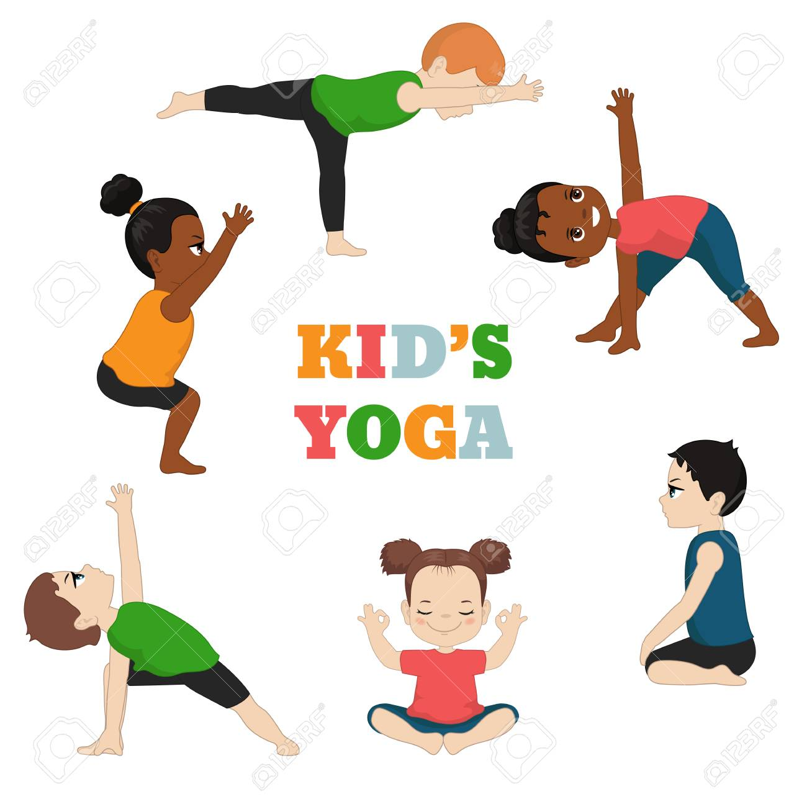 | Outragehiss Pets | Safari Puppet Show | Fun Bus *
16 | 17 | 18 | 19 | 20 | 21 | 22
Celebration of Nations | Speed Soccer* |  | Music of the Earth Assembly | Hawaiian  Luau | Fun Bus *
23 | 24 | 25 | 26 | 27 | 28
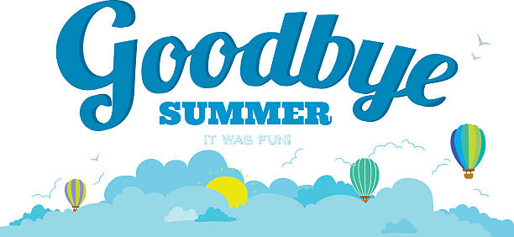 | CLOSED | CLOSED | CLOSED | CLOSED | CLOSED

We think our Special Guests are FUN-Tastic. Here is some information and links to check them out!

What’s Out There? Using the Starlab Portable Planetarium System, the Universe is coming to VECC. The children will enter “space” through the opening in the Starlab. They will observe the stars, planets, the moon and other celestial objects as they appear in the evening sky. Check out the website to see how “out of this world” this special guest is! https://starstogo.net/index.html

Bubble Show Jay Jay the Bubble Guy will bring science and magic together in his performance. He will put the children inside a MEGA bubble, create a bubble wall, and balance bubbles one on top of the other. The children will learn about cause and effect through this engaging show. Jay Jay’s performance will surely make science “pop” for the kiddos. Check out his website for more information http://www.jayjaytheballoonguy.com/dj.html

OutrageHISS Pets With Outragehisss…Pets live animal presentations, the children will have the opportunity to meet exotic animals from all over the world! A Cavy, African Bull Frog, sugar glider, and Macaw are a few that will be visiting VECC. A close encounter on the wild side is exciting for all in attendance! To get a sneak peek of some of the animals, click the link https://outragehissspets.com

Dinosaurs Rock Exhibit Dinosaurs Rock and so does this special guest! The gym will be transformed into a museum with an interactive display. As the children participate in this hands-on activity, they will be awed as they uncover genuine dinosaur bones, shark teeth, ammonites, petrified wood and more. Best of all, they will be taking some fossils home for the start of their own collection. The children will surely “dig” this special guest. Click the link for some more information http://dinosaursrockprograms.com

Music of the Earth Assembly An unforgettable multi-cultural journey with exotic instruments from around the globe! Guided by mesmerizing sounds of world cultures, we travel to other times and places- learning about our fellow humans and our Planter. Connecting with Nature, the Environment, and our Imagination. http://journeyswithsound.com/reviews.html

THE CHILDREN'S SCHOOL OF YOGA Our mission is to be a child's first yoga teacher in a fun, age appropriate way. Our goal is for the child to continue practicing yoga into their adult life. We feel that if a child learns just one pose, or one breathing technique, or one meditation that they can incorporate into their daily life, then we have completed our mission. https://thechildrensschoolofyogarockland.com/

Zumba by The Glass Slipper Combining movement music community and a healthy lifestyle for children. Theses fitness classes are rocking, high-energy dance parties packed with specially choreographed, kid-friendly, routines and all the music love!
http://www.theglasslippers.com/home.html

Travelin’ Tumblers Using lively music, innovative gymnastics equipment and energetic instructors, Traveling Tumblers boost children’s fitness levels and self-esteem through diverse & enriching physical activities. Traveling Tumbler instructors get the children moving and having fun. Check out their website for some videos. https://travelintumblers.com

Put some STEAM into your Preschool with High Touch High Tech!High Touch High Tech of Northern New Jersey continues to nurture budding young minds with innovative early childhood programs designed to challenge & amaze preschool age children. These programs encourage your students to expand their thinking and problem-solving skills with many opportunities for both individual and collaborative projects. During Mission Impossible, Dino Diggers, and STEAM Ahead, High Touch High Tech will provide opportunities to introduce the campers to science and nature in a fun, engaging way! http://sciencemadefunnnj.net/preschool.cfm

